**Introduction**



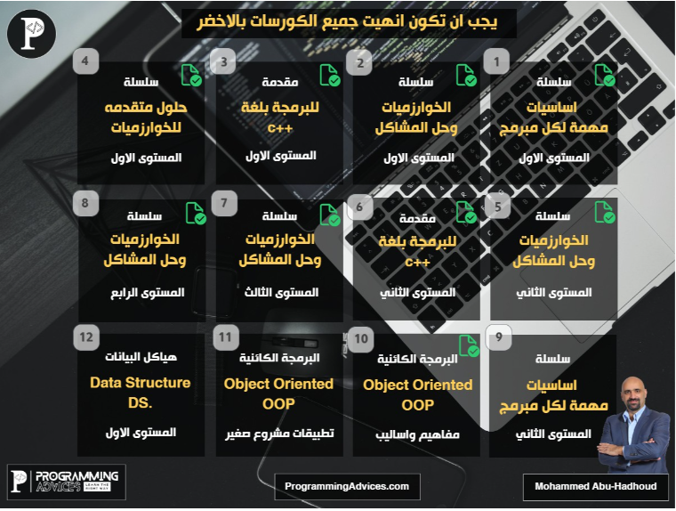

**Telegram Group for This Course**

<https://t.me/+eoBRYv6zhLRmMGJk>

**Utility Library: Requirements.**

قبل كده عملنا كلاس ال string وكلاس ال date

هنعمل دلوقتي utility library

هناخد كل ال functions اللي عملناها قبل كده زي ال random number ونحطهم في library ونخليهم كلهم static

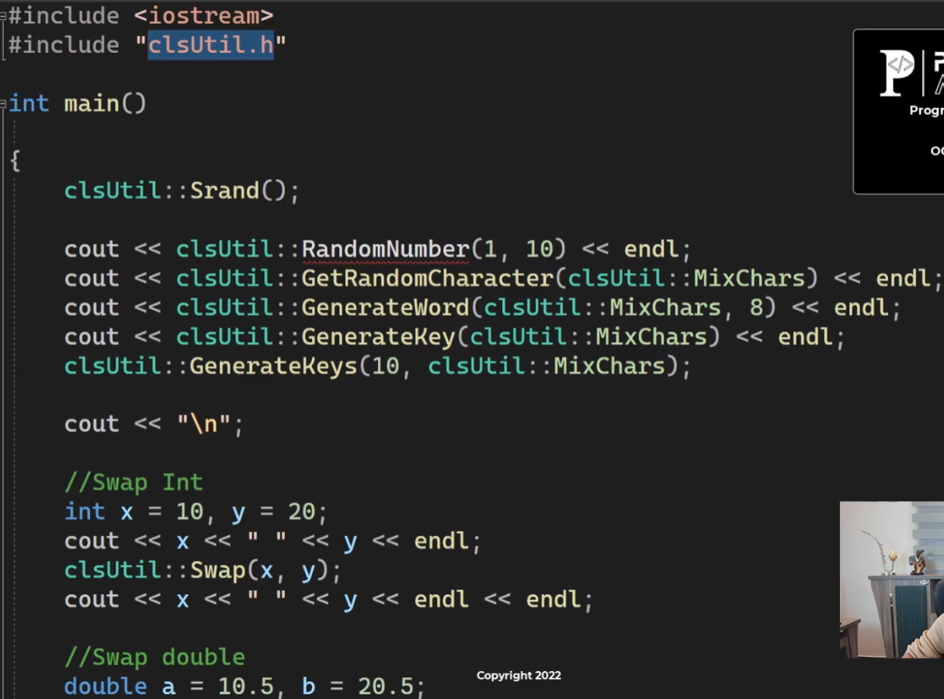

في ال get random character عمل enum عشان يختار مابين انه يطلعله capital letter او small letter او digits او حاجه منهم اللي هيا ال mix

في ال generate word انت بتختار عايز طول الكلمة قد ايه وبيبدأ يطلعلك حروف عشوائيه بعدد الحروف

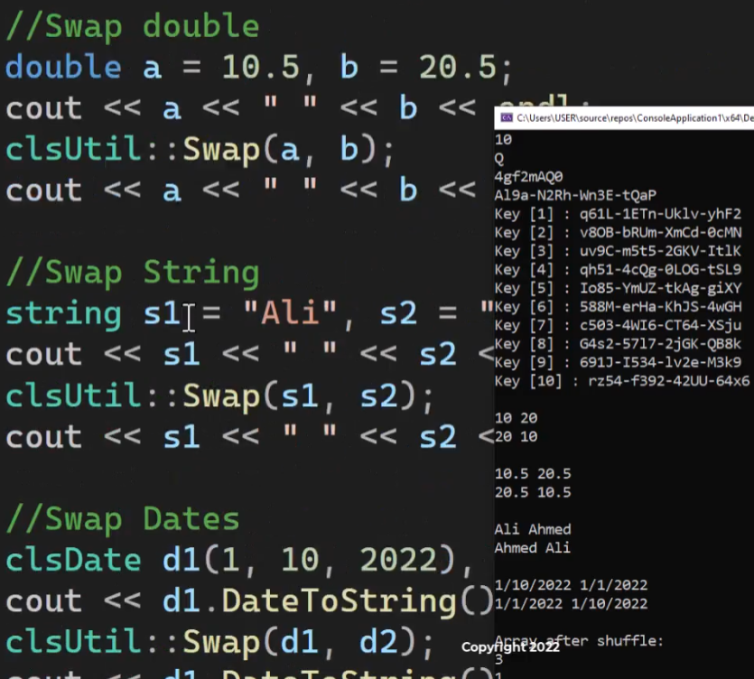

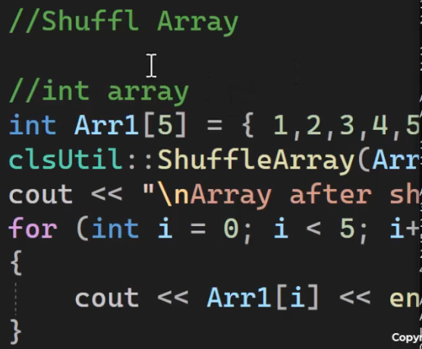

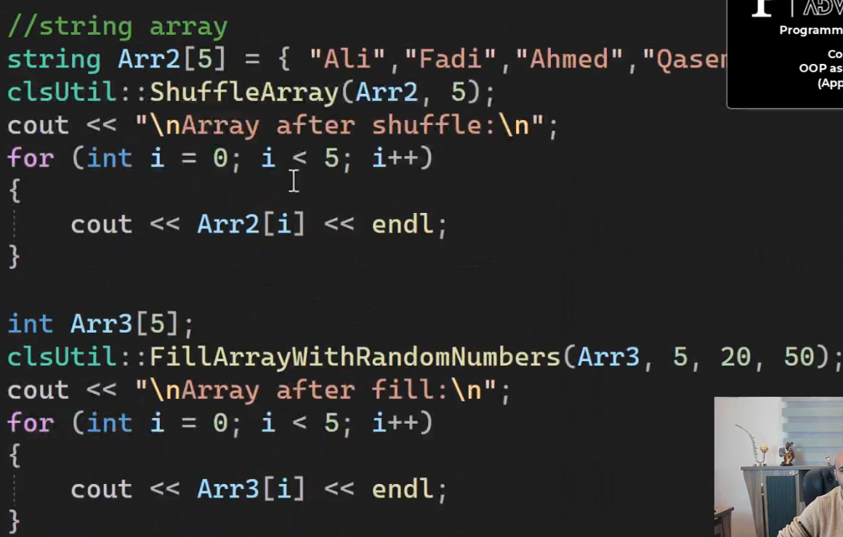

fillArrayWithRandomNumbers بياخد ال array وال length وعايز الأرقام تكون من كام لكام

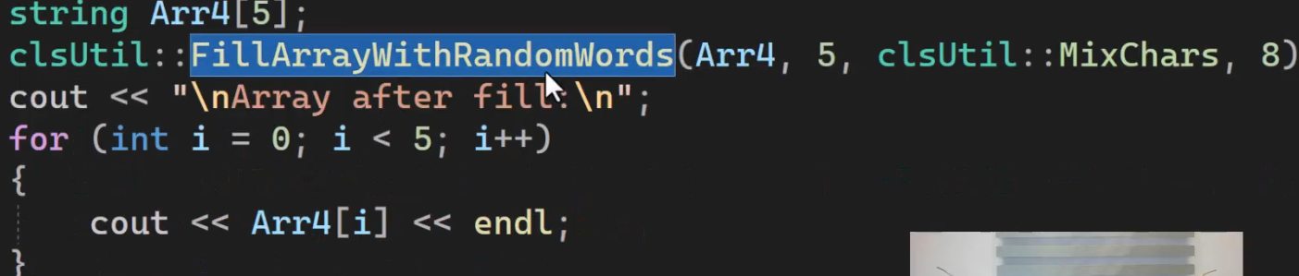

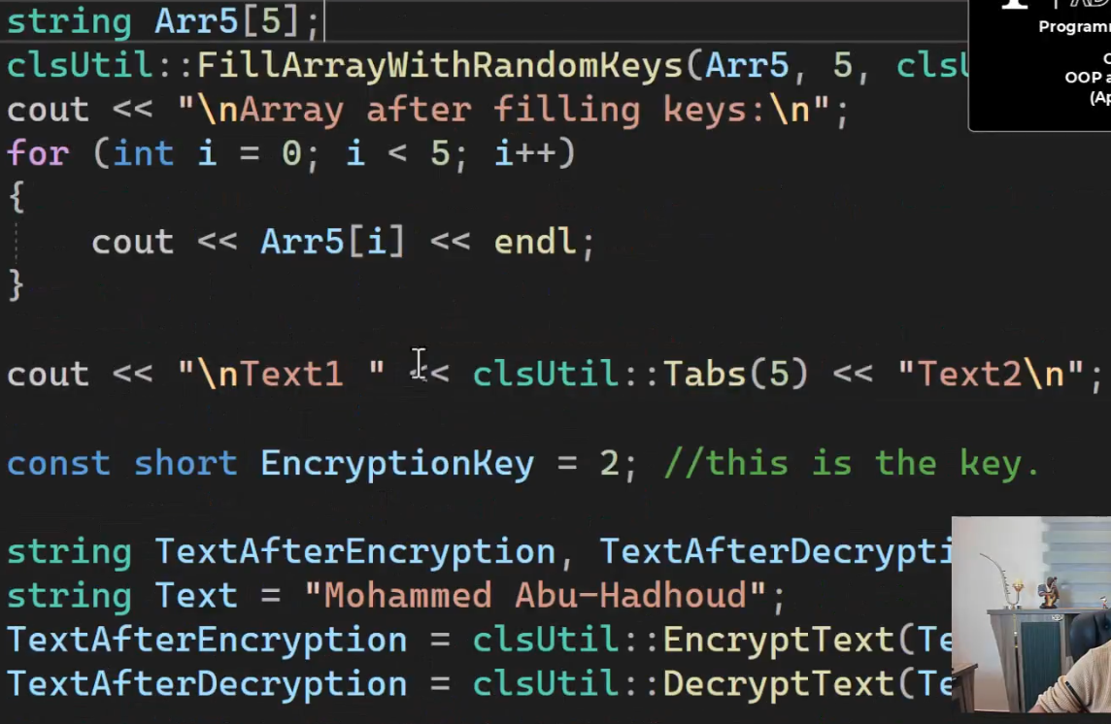

ال tabs بتديها عدد ال tabs اللي عايز تطبعها (ال tabs اللي هيا ال "\t")

وكمل بقي علي باقي ال functions

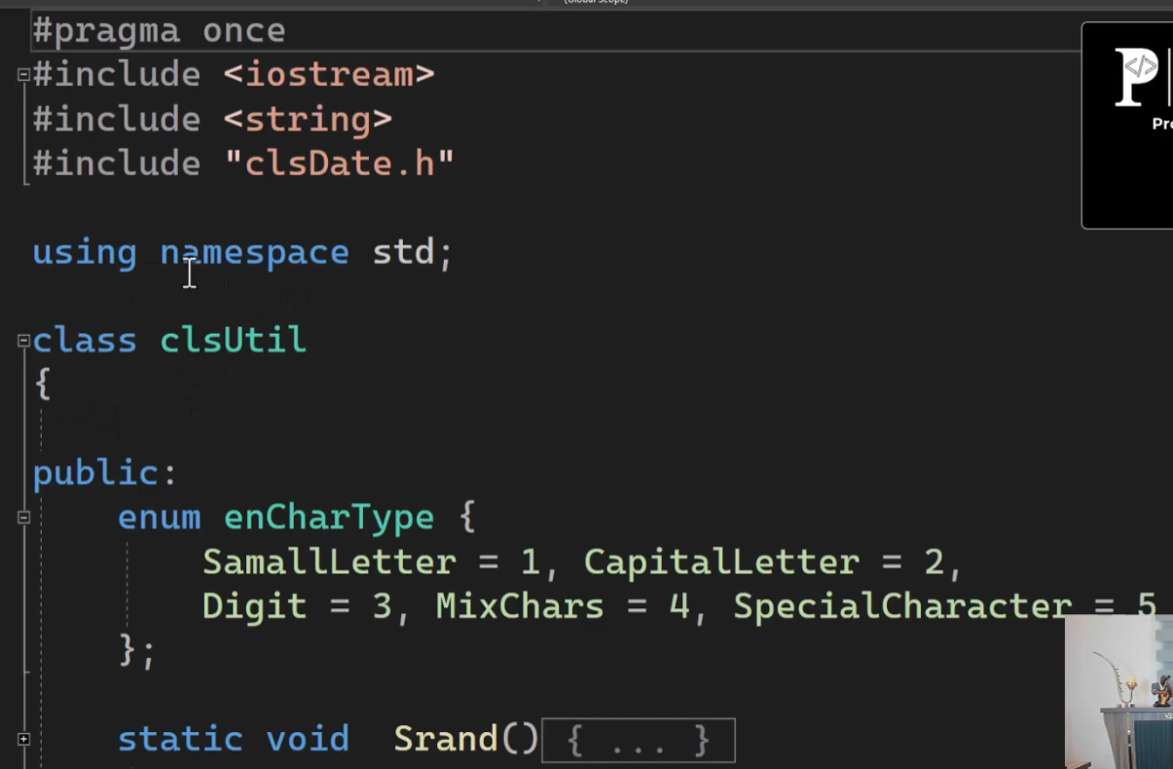

**Utility Library: Solution**

|  |  |
| --- | --- |
| ده ال utility class | //ProgrammingAdvices.com  //Mohammed Abu-Hadhoud  #pragma once  #include <iostream>  #include <string>  #include "clsDate.h"  using namespace std;  class clsUtil  {  public:  enum enCharType {  SamallLetter = 1, CapitalLetter = 2,  Digit = 3, MixChars = 4, SpecialCharacter = 5  };  static void Srand()  {  //Seeds the random number generator in C++, called only once  srand((unsigned)time(NULL));  }  static int RandomNumber(int From, int To)  {  //Function to generate a random number  int randNum = rand() % (To - From + 1) + From;  return randNum;  }  static char GetRandomCharacter(enCharType CharType)  {  //updated this method to accept mixchars  if (CharType == MixChars)  {  //Capital/Samll/Digits only  CharType = (enCharType)RandomNumber(1, 3);  }  switch (CharType)  {  case enCharType::SamallLetter:  {  return char(RandomNumber(97, 122));  break;  }  case enCharType::CapitalLetter:  {  return char(RandomNumber(65, 90));  break;  }  case enCharType::SpecialCharacter:  {  return char(RandomNumber(33, 47));  break;  }  case enCharType::Digit:  {  return char(RandomNumber(48, 57));  break;  }  defualt:  {  return char(RandomNumber(65, 90));  break;  }  }  }  static string GenerateWord(enCharType CharType, short Length)  {  string Word;  for (int i = 1; i <= Length; i++)  {  Word = Word + GetRandomCharacter(CharType);  }  return Word;  }  static string GenerateKey(enCharType CharType = CapitalLetter)  {  string Key = "";  Key = GenerateWord(CharType, 4) + "-";  Key = Key + GenerateWord(CharType, 4) + "-";  Key = Key + GenerateWord(CharType, 4) + "-";  Key = Key + GenerateWord(CharType, 4);  return Key;  }  static void GenerateKeys(short NumberOfKeys, enCharType CharType)  {  for (int i = 1; i <= NumberOfKeys; i++)  {  cout << "Key [" << i << "] : ";  cout << GenerateKey(CharType) << endl;  }  }  static void FillArrayWithRandomNumbers(int arr[100], int arrLength, int From, int To)  {  for (int i = 0; i < arrLength; i++)  arr[i] = RandomNumber(From, To);  }  static void FillArrayWithRandomWords(string arr[100], int arrLength, enCharType CharType, short Wordlength)  {  for (int i = 0; i < arrLength; i++)  arr[i] = GenerateWord(CharType, Wordlength);  }  static void FillArrayWithRandomKeys(string arr[100], int arrLength, enCharType CharType)  {  for (int i = 0; i < arrLength; i++)  arr[i] = GenerateKey(CharType);  }  static void Swap(int& A, int& B)  {  int Temp;  Temp = A;  A = B;  B = Temp;  }  static void Swap(double& A, double& B)  {  double Temp;  Temp = A;  A = B;  B = Temp;  }  static void Swap(bool& A, bool& B)  {  bool Temp;  Temp = A;  A = B;  B = Temp;  }  static void Swap(char& A, char& B)  {  char Temp;  Temp = A;  A = B;  B = Temp;  }  static void Swap(string& A, string& B)  {  string Temp;  Temp = A;  A = B;  B = Temp;  }  static void Swap(clsDate& A, clsDate& B)  {  clsDate::SwapDates(A, B);  }  static void ShuffleArray(int arr[100], int arrLength)  {  for (int i = 0; i < arrLength; i++)  {  Swap(arr[RandomNumber(1, arrLength) - 1], arr[RandomNumber(1, arrLength) - 1]);  }  }  static void ShuffleArray(string arr[100], int arrLength)  {  for (int i = 0; i < arrLength; i++)  {  Swap(arr[RandomNumber(1, arrLength) - 1], arr[RandomNumber(1, arrLength) - 1]);  }  }  static string Tabs(short NumberOfTabs)  {  string t = "";  for (int i = 1; i < NumberOfTabs; i++)  {  t = t + "\t";  cout << t;  }  return t;  }  static string EncryptText(string Text, short EncryptionKey)  {  for (int i = 0; i <= Text.length(); i++)  {  Text[i] = char((int)Text[i] + EncryptionKey);  }  return Text;  }  static string DecryptText(string Text, short EncryptionKey)  {  for (int i = 0; i <= Text.length(); i++)  {  Text[i] = char((int)Text[i] - EncryptionKey);  }  return Text;  }  }; |
| ده ال date class | //ProgrammingAdivces.com  //Mohammed Abu-Hadhoud  #pragma warning(disable : 4996)  #pragma once  #include<iostream>  #include<string>  #include "clsString.h"  using namespace std;  class clsDate  {  private:  short _Day = 1;  short _Month = 1;  short _Year = 1900;  public:  clsDate()  {  time_t t = time(0);  tm* now = localtime(&t);  _Day = now->tm_mday;  _Month = now->tm_mon + 1;  _Year = now->tm_year + 1900;  }  clsDate(string sDate)  {  vector <string> vDate;  vDate = clsString::Split(sDate, "/");  _Day = stoi(vDate[0]);  _Month = stoi(vDate[1]);  _Year = stoi(vDate[2]);  }  clsDate(short Day, short Month, short Year)  {  _Day = Day;  _Month = Month;  _Year = Year;  }  clsDate(short DateOrderInYear, short Year)  {  //This will construct a date by date order in year  clsDate Date1 = GetDateFromDayOrderInYear(DateOrderInYear, Year);  _Day = Date1.Day;  _Month = Date1.Month;  _Year = Date1.Year;  }  void SetDay(short Day) {  _Day = Day;  }  short GetDay() {  return _Day;  }  __declspec(property(get = GetDay, put = SetDay)) short Day;  void SetMonth(short Month) {  _Month = Month;  }  short GetMonth() {  return _Month;  }  __declspec(property(get = GetMonth, put = SetMonth)) short Month;  void SetYear(short Year) {  _Year = Year;  }  short GetYear() {  return _Year;  }  __declspec(property(get = GetYear, put = SetYear)) short Year;  void Print()  {  cout << DateToString() << endl;  }  static clsDate GetSystemDate()  {  //system date  time_t t = time(0);  tm* now = localtime(&t);  short Day, Month, Year;  Year = now->tm_year + 1900;  Month = now->tm_mon + 1;  Day = now->tm_mday;  return clsDate(Day, Month, Year);  }  static bool IsValidDate(clsDate Date)  {  if (Date.Day < 1 || Date.Day>31)  return false;  if (Date.Month < 1 || Date.Month>12)  return false;  if (Date.Month == 2)  {  if (isLeapYear(Date.Year))  {  if (Date.Day > 29)  return false;  }  else  {  if (Date.Day > 28)  return false;  }  }  short DaysInMonth = NumberOfDaysInAMonth(Date.Month, Date.Year);  if (Date.Day > DaysInMonth)  return false;  return true;  }  bool IsValid()  {  return IsValidDate(*this);  }  static string DateToString(clsDate Date)  {  return to_string(Date.Day) + "/" + to_string(Date.Month) + "/" + to_string(Date.Year);  }  string DateToString()  {  return DateToString(*this);  }  static bool isLeapYear(short Year)  {  // if year is divisible by 4 AND not divisible by 100  // OR if year is divisible by 400  // then it is a leap year  return (Year % 4 == 0 && Year % 100 != 0) || (Year % 400 == 0);  }  bool isLeapYear()  {  return isLeapYear(_Year);  }  static short NumberOfDaysInAYear(short Year)  {  return isLeapYear(Year) ? 365 : 364;  }  short NumberOfDaysInAYear()  {  return NumberOfDaysInAYear(_Year);  }  static short NumberOfHoursInAYear(short Year)  {  return NumberOfDaysInAYear(Year) * 24;  }  short NumberOfHoursInAYear()  {  return NumberOfHoursInAYear(_Year);  }  static int NumberOfMinutesInAYear(short Year)  {  return NumberOfHoursInAYear(Year) * 60;  }  int NumberOfMinutesInAYear()  {  return NumberOfMinutesInAYear(_Year);  }  static int NumberOfSecondsInAYear(short Year)  {  return NumberOfMinutesInAYear(Year) * 60;  }  int NumberOfSecondsInAYear()  {  return NumberOfSecondsInAYear();  }  static short NumberOfDaysInAMonth(short Month, short Year)  {  if (Month < 1 || Month>12)  return 0;  int days[12] = { 31,28,31,30,31,30,31,31,30,31,30,31 };  return (Month == 2) ? (isLeapYear(Year) ? 29 : 28) : days[Month - 1];  }  short NumberOfDaysInAMonth()  {  return NumberOfDaysInAMonth(_Month, _Year);  }  static short NumberOfHoursInAMonth(short Month, short Year)  {  return NumberOfDaysInAMonth(Month, Year) * 24;  }  short NumberOfHoursInAMonth()  {  return NumberOfDaysInAMonth(_Month, _Year) * 24;  }  static int NumberOfMinutesInAMonth(short Month, short Year)  {  return NumberOfHoursInAMonth(Month, Year) * 60;  }  int NumberOfMinutesInAMonth()  {  return NumberOfHoursInAMonth(_Month, _Year) * 60;  }  static int NumberOfSecondsInAMonth(short Month, short Year)  {  return NumberOfMinutesInAMonth(Month, Year) * 60;  }  int NumberOfSecondsInAMonth()  {  return NumberOfMinutesInAMonth(_Month, _Year) * 60;  }  static short DayOfWeekOrder(short Day, short Month, short Year)  {  short a, y, m;  a = (14 - Month) / 12;  y = Year - a;  m = Month + (12 * a) - 2;  // Gregorian:  //0:sun, 1:Mon, 2:Tue...etc  return (Day + y + (y / 4) - (y / 100) + (y / 400) + ((31 * m) / 12)) % 7;  }  short DayOfWeekOrder()  {  return DayOfWeekOrder(_Day, _Month, _Year);  }  static string DayShortName(short DayOfWeekOrder)  {  string arrDayNames[] = { "Sun","Mon","Tue","Wed","Thu","Fri","Sat" };  return arrDayNames[DayOfWeekOrder];  }  static string DayShortName(short Day, short Month, short Year)  {  string arrDayNames[] = { "Sun","Mon","Tue","Wed","Thu","Fri","Sat" };  return arrDayNames[DayOfWeekOrder(Day, Month, Year)];  }  string DayShortName()  {  string arrDayNames[] = { "Sun","Mon","Tue","Wed","Thu","Fri","Sat" };  return arrDayNames[DayOfWeekOrder(_Day, _Month, _Year)];  }  static string MonthShortName(short MonthNumber)  {  string Months[12] = { "Jan", "Feb", "Mar",  "Apr", "May", "Jun",  "Jul", "Aug", "Sep",  "Oct", "Nov", "Dec"  };  return (Months[MonthNumber - 1]);  }  string MonthShortName()  {  return MonthShortName(_Month);  }  static void PrintMonthCalendar(short Month, short Year)  {  int NumberOfDays;  // Index of the day from 0 to 6  int current = DayOfWeekOrder(1, Month, Year);  NumberOfDays = NumberOfDaysInAMonth(Month, Year);  // Print the current month name  printf("\n _______________%s_______________\n\n",  MonthShortName(Month).c_str());  // Print the columns  printf(" Sun Mon Tue Wed Thu Fri Sat\n");  // Print appropriate spaces  int i;  for (i = 0; i < current; i++)  printf(" ");  for (int j = 1; j <= NumberOfDays; j++)  {  printf("%5d", j);  if (++i == 7)  {  i = 0;  printf("\n");  }  }  printf("\n _________________________________\n");  }  void PrintMonthCalendar()  {  PrintMonthCalendar(_Month, _Year);  }  static void PrintYearCalendar(int Year)  {  printf("\n _________________________________\n\n");  printf(" Calendar - %d\n", Year);  printf(" _________________________________\n");  for (int i = 1; i <= 12; i++)  {  PrintMonthCalendar(i, Year);  }  return;  }  void PrintYearCalendar()  {  printf("\n _________________________________\n\n");  printf(" Calendar - %d\n", _Year);  printf(" _________________________________\n");  for (int i = 1; i <= 12; i++)  {  PrintMonthCalendar(i, _Year);  }  return;  }  static short DaysFromTheBeginingOfTheYear(short Day, short Month, short Year)  {  short TotalDays = 0;  for (int i = 1; i <= Month - 1; i++)  {  TotalDays += NumberOfDaysInAMonth(i, Year);  }  TotalDays += Day;  return TotalDays;  }  short DaysFromTheBeginingOfTheYear()  {  short TotalDays = 0;  for (int i = 1; i <= _Month - 1; i++)  {  TotalDays += NumberOfDaysInAMonth(i, _Year);  }  TotalDays += _Day;  return TotalDays;  }  static clsDate GetDateFromDayOrderInYear(short DateOrderInYear, short Year)  {  clsDate Date;  short RemainingDays = DateOrderInYear;  short MonthDays = 0;  Date.Year = Year;  Date.Month = 1;  while (true)  {  MonthDays = NumberOfDaysInAMonth(Date.Month, Year);  if (RemainingDays > MonthDays)  {  RemainingDays -= MonthDays;  Date.Month++;  }  else  {  Date.Day = RemainingDays;  break;  }  }  return Date;  }  void AddDays(short Days)  {  short RemainingDays = Days + DaysFromTheBeginingOfTheYear(_Day, _Month, _Year);  short MonthDays = 0;  _Month = 1;  while (true)  {  MonthDays = NumberOfDaysInAMonth(_Month, _Year);  if (RemainingDays > MonthDays)  {  RemainingDays -= MonthDays;  _Month++;  if (_Month > 12)  {  _Month = 1;  _Year++;  }  }  else  {  _Day = RemainingDays;  break;  }  }  }  static bool IsDate1BeforeDate2(clsDate Date1, clsDate Date2)  {  return (Date1.Year < Date2.Year) ? true : ((Date1.Year == Date2.Year) ? (Date1.Month < Date2.Month ? true : (Date1.Month == Date2.Month ? Date1.Day < Date2.Day : false)) : false);  }  bool IsDateBeforeDate2(clsDate Date2)  {  //note: *this sends the current object :-)  return IsDate1BeforeDate2(*this, Date2);  }  static bool IsDate1EqualDate2(clsDate Date1, clsDate Date2)  {  return (Date1.Year == Date2.Year) ? ((Date1.Month == Date2.Month) ? ((Date1.Day == Date2.Day) ? true : false) : false) : false;  }  bool IsDateEqualDate2(clsDate Date2)  {  return IsDate1EqualDate2(*this, Date2);  }  static bool IsLastDayInMonth(clsDate Date)  {  return (Date.Day == NumberOfDaysInAMonth(Date.Month, Date.Year));  }  bool IsLastDayInMonth()  {  return IsLastDayInMonth(*this);  }  static bool IsLastMonthInYear(short Month)  {  return (Month == 12);  }  static clsDate AddOneDay(clsDate Date)  {  if (IsLastDayInMonth(Date))  {  if (IsLastMonthInYear(Date.Month))  {  Date.Month = 1;  Date.Day = 1;  Date.Year++;  }  else  {  Date.Day = 1;  Date.Month++;  }  }  else  {  Date.Day++;  }  return Date;  }  void AddOneDay()  {  *this = AddOneDay(*this);  }  static void SwapDates(clsDate& Date1, clsDate& Date2)  {  clsDate TempDate;  TempDate = Date1;  Date1 = Date2;  Date2 = TempDate;  }  static int GetDifferenceInDays(clsDate Date1, clsDate Date2, bool IncludeEndDay = false)  {  //this will take care of negative diff  int Days = 0;  short SawpFlagValue = 1;  if (!IsDate1BeforeDate2(Date1, Date2))  {  //Swap Dates  SwapDates(Date1, Date2);  SawpFlagValue = -1;  }  while (IsDate1BeforeDate2(Date1, Date2))  {  Days++;  Date1 = AddOneDay(Date1);  }  return IncludeEndDay ? ++Days * SawpFlagValue : Days * SawpFlagValue;  }  int GetDifferenceInDays(clsDate Date2, bool IncludeEndDay = false)  {  return GetDifferenceInDays(*this, Date2, IncludeEndDay);  }  static short CalculateMyAgeInDays(clsDate DateOfBirth)  {  return GetDifferenceInDays(DateOfBirth, clsDate::GetSystemDate(), true);  }  //above no need to have nonstatic function for the object because it does not depend on any data from it.  static clsDate IncreaseDateByOneWeek(clsDate& Date)  {  for (int i = 1; i <= 7; i++)  {  Date = AddOneDay(Date);  }  return Date;  }  void IncreaseDateByOneWeek()  {  IncreaseDateByOneWeek(*this);  }  clsDate IncreaseDateByXWeeks(short Weeks, clsDate& Date)  {  for (short i = 1; i <= Weeks; i++)  {  Date = IncreaseDateByOneWeek(Date);  }  return Date;  }  void IncreaseDateByXWeeks(short Weeks)  {  IncreaseDateByXWeeks(Weeks, *this);  }  clsDate IncreaseDateByOneMonth(clsDate& Date)  {  if (Date.Month == 12)  {  Date.Month = 1;  Date.Year++;  }  else  {  Date.Month++;  }  //last check day in date should not exceed max days in the current month  // example if date is 31/1/2022 increasing one month should not be 31/2/2022, it should  // be 28/2/2022  short NumberOfDaysInCurrentMonth = NumberOfDaysInAMonth(Date.Month, Date.Year);  if (Date.Day > NumberOfDaysInCurrentMonth)  {  Date.Day = NumberOfDaysInCurrentMonth;  }  return Date;  }  void IncreaseDateByOneMonth()  {  IncreaseDateByOneMonth(*this);  }  clsDate IncreaseDateByXDays(short Days, clsDate& Date)  {  for (short i = 1; i <= Days; i++)  {  Date = AddOneDay(Date);  }  return Date;  }  void IncreaseDateByXDays(short Days)  {  IncreaseDateByXDays(Days, *this);  }  clsDate IncreaseDateByXMonths(short Months, clsDate& Date)  {  for (short i = 1; i <= Months; i++)  {  Date = IncreaseDateByOneMonth(Date);  }  return Date;  }  void IncreaseDateByXMonths(short Months)  {  IncreaseDateByXMonths(Months, *this);  }  static clsDate IncreaseDateByOneYear(clsDate& Date)  {  Date.Year++;  return Date;  }  void IncreaseDateByOneYear()  {  IncreaseDateByOneYear(*this);  }  clsDate IncreaseDateByXYears(short Years, clsDate& Date)  {  Date.Year += Years;  return Date;  }  void IncreaseDateByXYears(short Years)  {  IncreaseDateByXYears(Years);  }  clsDate IncreaseDateByOneDecade(clsDate& Date)  {  //Period of 10 years  Date.Year += 10;  return Date;  }  void IncreaseDateByOneDecade()  {  IncreaseDateByOneDecade(*this);  }  clsDate IncreaseDateByXDecades(short Decade, clsDate& Date)  {  Date.Year += Decade * 10;  return Date;  }  void IncreaseDateByXDecades(short Decade)  {  IncreaseDateByXDecades(Decade, *this);  }  clsDate IncreaseDateByOneCentury(clsDate& Date)  {  //Period of 100 years  Date.Year += 100;  return Date;  }  void IncreaseDateByOneCentury()  {  IncreaseDateByOneCentury(*this);  }  clsDate IncreaseDateByOneMillennium(clsDate& Date)  {  //Period of 1000 years  Date.Year += 1000;  return Date;  }  clsDate IncreaseDateByOneMillennium()  {  IncreaseDateByOneMillennium(*this);  }  static clsDate DecreaseDateByOneDay(clsDate Date)  {  if (Date.Day == 1)  {  if (Date.Month == 1)  {  Date.Month = 12;  Date.Day = 31;  Date.Year--;  }  else  {  Date.Month--;  Date.Day = NumberOfDaysInAMonth(Date.Month, Date.Year);  }  }  else  {  Date.Day--;  }  return Date;  }  void DecreaseDateByOneDay()  {  DecreaseDateByOneDay(*this);  }  static clsDate DecreaseDateByOneWeek(clsDate& Date)  {  for (int i = 1; i <= 7; i++)  {  Date = DecreaseDateByOneDay(Date);  }  return Date;  }  void DecreaseDateByOneWeek()  {  DecreaseDateByOneWeek(*this);  }  static clsDate DecreaseDateByXWeeks(short Weeks, clsDate& Date)  {  for (short i = 1; i <= Weeks; i++)  {  Date = DecreaseDateByOneWeek(Date);  }  return Date;  }  void DecreaseDateByXWeeks(short Weeks)  {  DecreaseDateByXWeeks(Weeks, *this);  }  static clsDate DecreaseDateByOneMonth(clsDate& Date)  {  if (Date.Month == 1)  {  Date.Month = 12;  Date.Year--;  }  else  Date.Month--;  //last check day in date should not exceed max days in the current month  // example if date is 31/3/2022 decreasing one month should not be 31/2/2022, it should  // be 28/2/2022  short NumberOfDaysInCurrentMonth = NumberOfDaysInAMonth(Date.Month, Date.Year);  if (Date.Day > NumberOfDaysInCurrentMonth)  {  Date.Day = NumberOfDaysInCurrentMonth;  }  return Date;  }  void DecreaseDateByOneMonth()  {  DecreaseDateByOneMonth(*this);  }  static clsDate DecreaseDateByXDays(short Days, clsDate& Date)  {  for (short i = 1; i <= Days; i++)  {  Date = DecreaseDateByOneDay(Date);  }  return Date;  }  void DecreaseDateByXDays(short Days)  {  DecreaseDateByXDays(Days, *this);  }  static clsDate DecreaseDateByXMonths(short Months, clsDate& Date)  {  for (short i = 1; i <= Months; i++)  {  Date = DecreaseDateByOneMonth(Date);  }  return Date;  }  void DecreaseDateByXMonths(short Months)  {  DecreaseDateByXMonths(Months, *this);  }  static clsDate DecreaseDateByOneYear(clsDate& Date)  {  Date.Year--;  return Date;  }  void DecreaseDateByOneYear()  {  DecreaseDateByOneYear(*this);  }  static clsDate DecreaseDateByXYears(short Years, clsDate& Date)  {  Date.Year -= Years;  return Date;  }  void DecreaseDateByXYears(short Years)  {  DecreaseDateByXYears(Years, *this);  }  static clsDate DecreaseDateByOneDecade(clsDate& Date)  {  //Period of 10 years  Date.Year -= 10;  return Date;  }  void DecreaseDateByOneDecade()  {  DecreaseDateByOneDecade(*this);  }  static clsDate DecreaseDateByXDecades(short Decades, clsDate& Date)  {  Date.Year -= Decades * 10;  return Date;  }  void DecreaseDateByXDecades(short Decades)  {  DecreaseDateByXDecades(Decades, *this);  }  static clsDate DecreaseDateByOneCentury(clsDate& Date)  {  //Period of 100 years  Date.Year -= 100;  return Date;  }  void DecreaseDateByOneCentury()  {  DecreaseDateByOneCentury(*this);  }  static clsDate DecreaseDateByOneMillennium(clsDate& Date)  {  //Period of 1000 years  Date.Year -= 1000;  return Date;  }  void DecreaseDateByOneMillennium()  {  DecreaseDateByOneMillennium(*this);  }  static short IsEndOfWeek(clsDate Date)  {  return DayOfWeekOrder(Date.Day, Date.Month, Date.Year) == 6;  }  short IsEndOfWeek()  {  return IsEndOfWeek(*this);  }  static bool IsWeekEnd(clsDate Date)  {  //Weekends are Fri and Sat  short DayIndex = DayOfWeekOrder(Date.Day, Date.Month, Date.Year);  return (DayIndex == 5 || DayIndex == 6);  }  bool IsWeekEnd()  {  return IsWeekEnd(*this);  }  static bool IsBusinessDay(clsDate Date)  {  //Weekends are Sun,Mon,Tue,Wed and Thur  /*  short DayIndex = DayOfWeekOrder(Date.Day, Date.Month, Date.Year);  return (DayIndex >= 5 && DayIndex <= 4);  */  //shorter method is to invert the IsWeekEnd: this will save updating code.  return !IsWeekEnd(Date);  }  bool IsBusinessDay()  {  return IsBusinessDay(*this);  }  static short DaysUntilTheEndOfWeek(clsDate Date)  {  return 6 - DayOfWeekOrder(Date.Day, Date.Month, Date.Year);  }  short DaysUntilTheEndOfWeek()  {  return DaysUntilTheEndOfWeek(*this);  }  static short DaysUntilTheEndOfMonth(clsDate Date1)  {  clsDate EndOfMontDate;  EndOfMontDate.Day = NumberOfDaysInAMonth(Date1.Month, Date1.Year);  EndOfMontDate.Month = Date1.Month;  EndOfMontDate.Year = Date1.Year;  return GetDifferenceInDays(Date1, EndOfMontDate, true);  }  short DaysUntilTheEndOfMonth()  {  return DaysUntilTheEndOfMonth(*this);  }  static short DaysUntilTheEndOfYear(clsDate Date1)  {  clsDate EndOfYearDate;  EndOfYearDate.Day = 31;  EndOfYearDate.Month = 12;  EndOfYearDate.Year = Date1.Year;  return GetDifferenceInDays(Date1, EndOfYearDate, true);  }  short DaysUntilTheEndOfYear()  {  return DaysUntilTheEndOfYear(*this);  }  //i added this method to calculate business days between 2 days  static short CalculateBusinessDays(clsDate DateFrom, clsDate DateTo)  {  short Days = 0;  while (IsDate1BeforeDate2(DateFrom, DateTo))  {  if (IsBusinessDay(DateFrom))  Days++;  DateFrom = AddOneDay(DateFrom);  }  return Days;  }  static short CalculateVacationDays(clsDate DateFrom, clsDate DateTo)  {  /*short Days = 0;  while (IsDate1BeforeDate2(DateFrom, DateTo))  {  if (IsBusinessDay(DateFrom))  Days++;  DateFrom = AddOneDay(DateFrom);  }*/  return CalculateBusinessDays(DateFrom, DateTo);  }  //above method is eough , no need to have method for the object  static clsDate CalculateVacationReturnDate(clsDate DateFrom, short VacationDays)  {  short WeekEndCounter = 0;  for (short i = 1; i <= VacationDays; i++)  {  if (IsWeekEnd(DateFrom))  WeekEndCounter++;  DateFrom = AddOneDay(DateFrom);  }  //to add weekends  for (short i = 1; i <= WeekEndCounter; i++)  DateFrom = AddOneDay(DateFrom);  return DateFrom;  }  static bool IsDate1AfterDate2(clsDate Date1, clsDate Date2)  {  return (!IsDate1BeforeDate2(Date1, Date2) && !IsDate1EqualDate2(Date1, Date2));  }  bool IsDateAfterDate2(clsDate Date2)  {  return IsDate1AfterDate2(*this, Date2);  }  enum enDateCompare { Before = -1, Equal = 0, After = 1 };  static enDateCompare CompareDates(clsDate Date1, clsDate Date2)  {  if (IsDate1BeforeDate2(Date1, Date2))  return enDateCompare::Before;  if (IsDate1EqualDate2(Date1, Date2))  return enDateCompare::Equal;  /* if (IsDate1AfterDate2(Date1,Date2))  return enDateCompare::After;*/  //this is faster  return enDateCompare::After;  }  enDateCompare CompareDates(clsDate Date2)  {  return CompareDates(*this, Date2);  }  }; |
| ده ال main class | //ProgrammingAdvices.com  //Mohammed Abu-Hadhoud  #include <iostream>  #include "clsUtil.h"  int main()  {  clsUtil::Srand();  cout << clsUtil::RandomNumber(1, 10) << endl;  cout << clsUtil::GetRandomCharacter(clsUtil::CapitalLetter) << endl;  cout << clsUtil::GenerateWord(clsUtil::MixChars, 8) << endl;  cout << clsUtil::GenerateKey(clsUtil::MixChars) << endl;  clsUtil::GenerateKeys(10, clsUtil::MixChars);  cout << "\n";  //Swap Int  int x = 10, y = 20;  cout << x << " " << y << endl;  clsUtil::Swap(x, y);  cout << x << " " << y << endl << endl;  //Swap double  double a = 10.5, b = 20.5;  cout << a << " " << b << endl;  clsUtil::Swap(a, b);  cout << a << " " << b << endl << endl;  //Swap String  string s1 = "Ali", s2 = "Ahmed";  cout << s1 << " " << s2 << endl;  clsUtil::Swap(s1, s2);  cout << s1 << " " << s2 << endl << endl;  //Swap Dates  clsDate d1(1, 10, 2022), d2(1, 1, 2022);  cout << d1.DateToString() << " " << d2.DateToString() << endl;  clsUtil::Swap(d1, d2);  cout << d1.DateToString() << " " << d2.DateToString() << endl;  //Shuffl Array  //int array  int Arr1[5] = { 1,2,3,4,5 };  clsUtil::ShuffleArray(Arr1, 5);  cout << "\nArray after shuffle:\n";  for (int i = 0; i < 5; i++)  {  cout << Arr1[i] << endl;  }  //string array  string Arr2[5] = { "Ali","Fadi","Ahmed","Qasem","Khalid" };  clsUtil::ShuffleArray(Arr2, 5);  cout << "\nArray after shuffle:\n";  for (int i = 0; i < 5; i++)  {  cout << Arr2[i] << endl;  }  int Arr3[5];  clsUtil::FillArrayWithRandomNumbers(Arr3, 5, 20, 50);  cout << "\nArray after fill:\n";  for (int i = 0; i < 5; i++)  {  cout << Arr3[i] << endl;  }  string Arr4[5];  clsUtil::FillArrayWithRandomWords(Arr4, 5, clsUtil::MixChars, 8);  cout << "\nArray after fill:\n";  for (int i = 0; i < 5; i++)  {  cout << Arr4[i] << endl;  }  string Arr5[5];  clsUtil::FillArrayWithRandomKeys(Arr5, 5, clsUtil::MixChars);  cout << "\nArray after filling keys:\n";  for (int i = 0; i < 5; i++)  {  cout << Arr5[i] << endl;  }  cout << "\nText1 " << clsUtil::Tabs(5) << "Text2\n";  const short EncryptionKey = 2; //this is the key.  string TextAfterEncryption, TextAfterDecryption;  string Text = "Mohammed Abu-Hadhoud";  TextAfterEncryption = clsUtil::EncryptText(Text, EncryptionKey);  TextAfterDecryption = clsUtil::DecryptText(TextAfterEncryption, EncryptionKey);  cout << "\nText Before Encryption : ";  cout << Text << endl;  cout << "Text After Encryption : ";  cout << TextAfterEncryption << endl;  cout << "Text After Decryption : ";  cout << TextAfterDecryption << endl;  system("pause>0");  return 0;  } |

**Input & Validation Library (Requirements)**

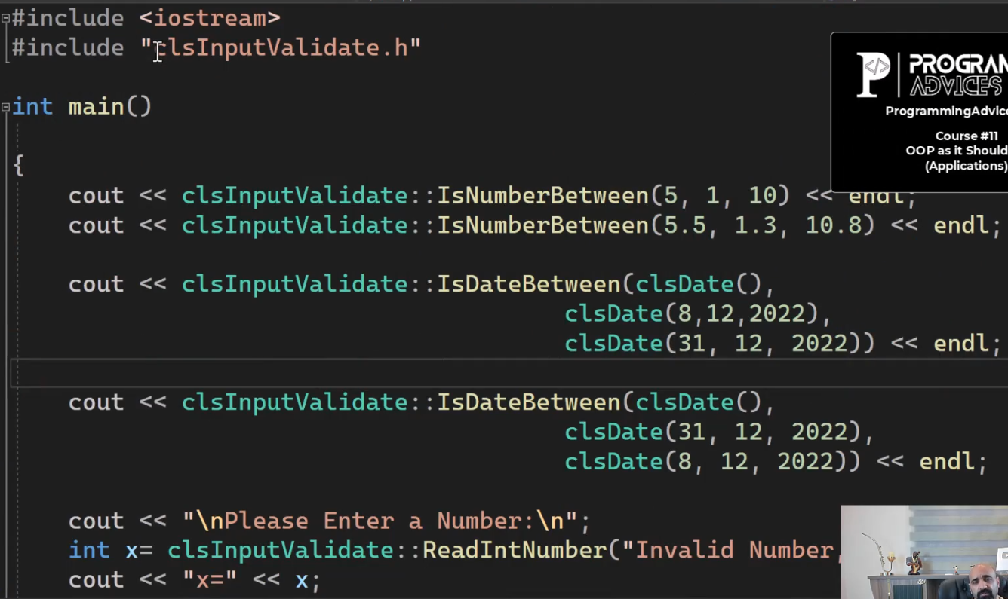

فيها static functions

والتزم باسامي ال functions عشان لما تستخدمها بعد كده

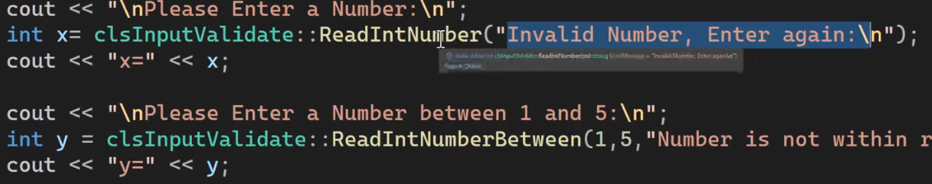

readIntNumber بتاخد منك رسالة الخطأ

ReadIntNumberBetween لو عايز اليوزر يدخل قيمه من رقم كذا لرقم كذا

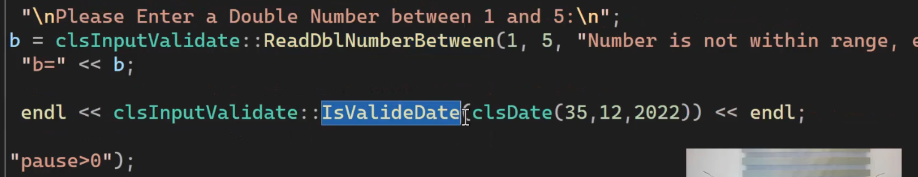

**Input & Validation Library (Solution)**

|  |  |
| --- | --- |
| ده ال main | #include <iostream>  #include "clsInputValidate.h"  int main()  {  cout << clsInputValidate::IsNumberBetween(5, 1, 10) << endl;  cout << clsInputValidate::IsNumberBetween(5.5, 1.3, 10.8) << endl;  cout << clsInputValidate::IsDateBetween(clsDate(),  clsDate(8, 12, 2022),  clsDate(31, 12, 2022)) << endl;  cout << clsInputValidate::IsDateBetween(clsDate(),  clsDate(31, 12, 2022),  clsDate(8, 12, 2022)) << endl;  cout << "\nPlease Enter a Number:\n";  int x = clsInputValidate::ReadIntNumber("Invalid Number, Enter again:\n");  cout << "x=" << x;  cout << "\nPlease Enter a Number between 1 and 5:\n";  int y = clsInputValidate::ReadIntNumberBetween(1, 5, "Number is not within range, enter again:\n");  cout << "y=" << y;  cout << "\nPlease Enter a Double Number:\n";  double a = clsInputValidate::ReadDblNumber("Invalid Number, Enter again:\n");  cout << "a=" << a;  cout << "\nPlease Enter a Double Number between 1 and 5:\n";  double b = clsInputValidate::ReadDblNumberBetween(1, 5, "Number is not within range, enter again:\n");  cout << "b=" << b;  cout << endl << clsInputValidate::IsValideDate(clsDate(35, 12, 2022)) << endl;  system("pause>0");  return 0;  } |
| ده كلاس ال validate | //ProgrammingAdivces.com  //Mohammed Abu-Hadhoud  #pragma once  #include <iostream>  #include <string>  #include "clsString.h"  #include "clsDate.h"  class clsInputValidate  {  public:  static bool IsNumberBetween(short Number, short From, short To)  {  if (Number >= From && Number <= To)  return true;  else  return false;  }  static bool IsNumberBetween(int Number, int From, int To)  {  if (Number >= From && Number <= To)  return true;  else  return false;  }  static bool IsNumberBetween(float Number, float From, float To)  {  if (Number >= From && Number <= To)  return true;  else  return false;  }  static bool IsNumberBetween(double Number, double From, double To)  {  if (Number >= From && Number <= To)  return true;  else  return false;  }  static bool IsDateBetween(clsDate Date, clsDate From, clsDate To)  {  //Date>=From && Date<=To  if ((clsDate::IsDate1AfterDate2(Date, From) || clsDate::IsDate1EqualDate2(Date, From))  &&  (clsDate::IsDate1BeforeDate2(Date, To) || clsDate::IsDate1EqualDate2(Date, To))  )  {  return true;  }  //Date>=To && Date<=From  if ((clsDate::IsDate1AfterDate2(Date, To) || clsDate::IsDate1EqualDate2(Date, To))  &&  (clsDate::IsDate1BeforeDate2(Date, From) || clsDate::IsDate1EqualDate2(Date, From))  )  {  return true;  }  return false;  }  static int ReadIntNumber(string ErrorMessage = "Invalid Number, Enter again\n")  {  int Number;  while (!(cin >> Number)) {  cin.clear();  cin.ignore(numeric_limits<streamsize>::max(), '\n');  cout << ErrorMessage;  }  return Number;  }  static int ReadIntNumberBetween(int From, int To, string ErrorMessage = "Number is not within range, Enter again:\n")  {  int Number = ReadIntNumber();  while (!IsNumberBetween(Number, From, To))  {  cout << ErrorMessage;  Number = ReadIntNumber();  }  return Number;  }  static double ReadDblNumber(string ErrorMessage = "Invalid Number, Enter again\n")  {  double Number;  while (!(cin >> Number)) {  cin.clear();  cin.ignore(numeric_limits<streamsize>::max(), '\n');  cout << ErrorMessage;  }  return Number;  }  static double ReadDblNumberBetween(double From, double To, string ErrorMessage = "Number is not within range, Enter again:\n")  {  double Number = ReadDblNumber();  while (!IsNumberBetween(Number, From, To)) {  cout << ErrorMessage;  Number = ReadDblNumber();  }  return Number;  }  static bool IsValideDate(clsDate Date)  {  return clsDate::IsValidDate(Date);  }  }; |

انا حطيت الاكواد الجديده عشان مااكررش في الاكواد وازود مساحه عالفاضي

**Lesson #01 - Find Client**

ده شكل الملف اللي فيه بيانات العملاء

العميل بيتكون من (first name, last name , email, phone number,

account number, pin code, balance)

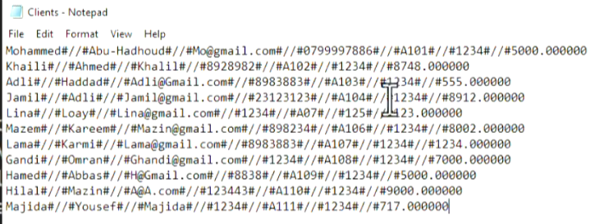

واحنا هنحول ال line ده ل object

الكلاس person فيه الاتي (first name , last name, email , phone) وعامله constructor وproperty set و property get وال decspec وال fullname

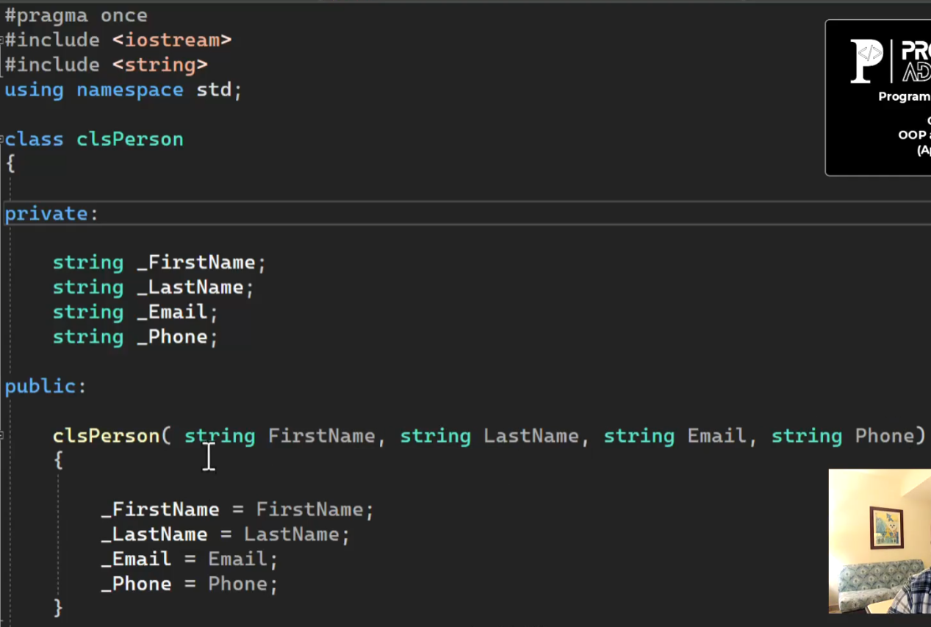

بعد كده عندي كلاس ال clients بيورث من كلاس ال person

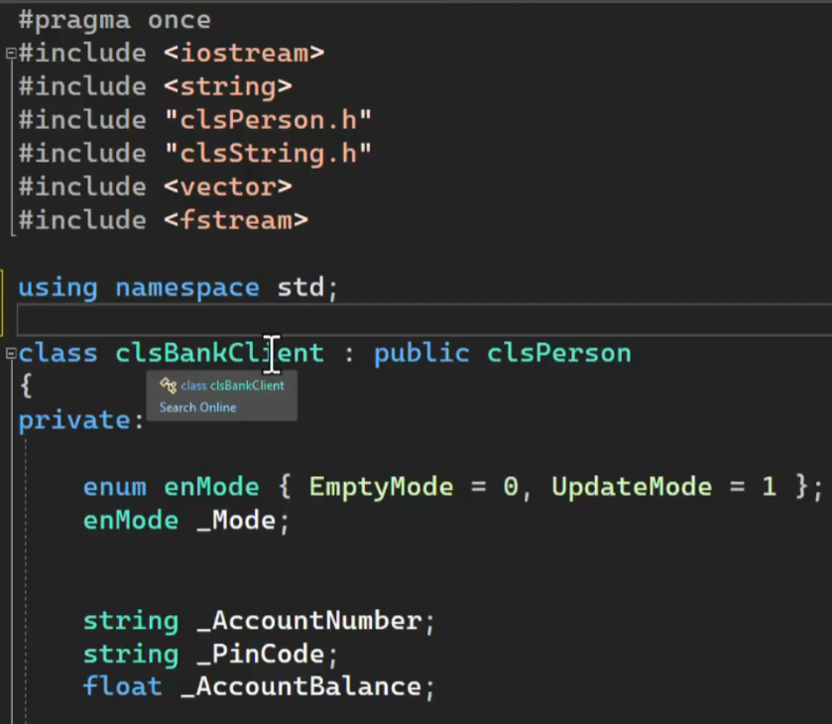

ال mode ده الحاله اللي بيكون فيها ال object يااما بيكون فاضي يااما update وفي الدروس اللي جايه هنضيف عليها

في الدرس ده كل اللي هنعمله هوا find client

وبعرف فيه (account number , pincode , account balance) وبنعملهم constructor بياخد ال mode والمتغيرات بتاعت ال person وبيوديهاله والمتغيرات بتاعت ال client وعاملين set و get

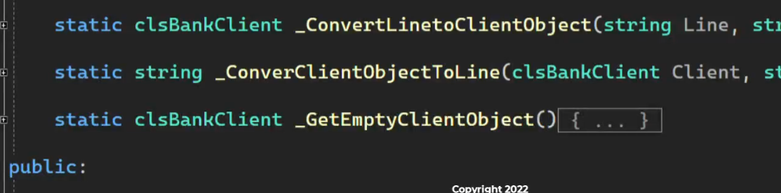

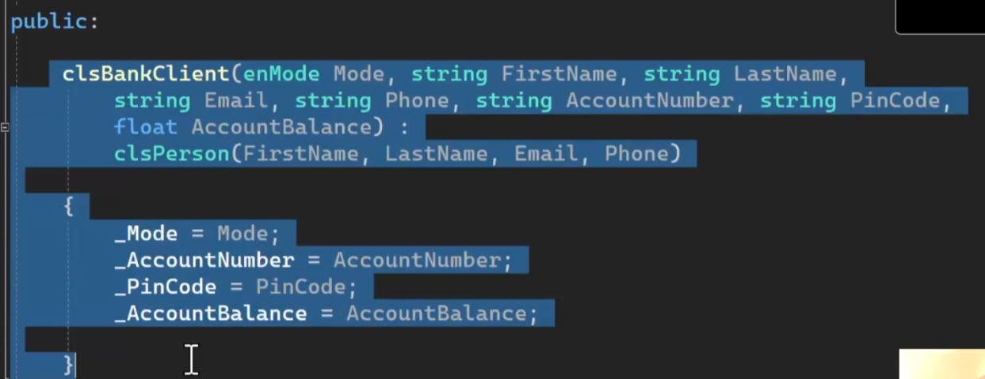

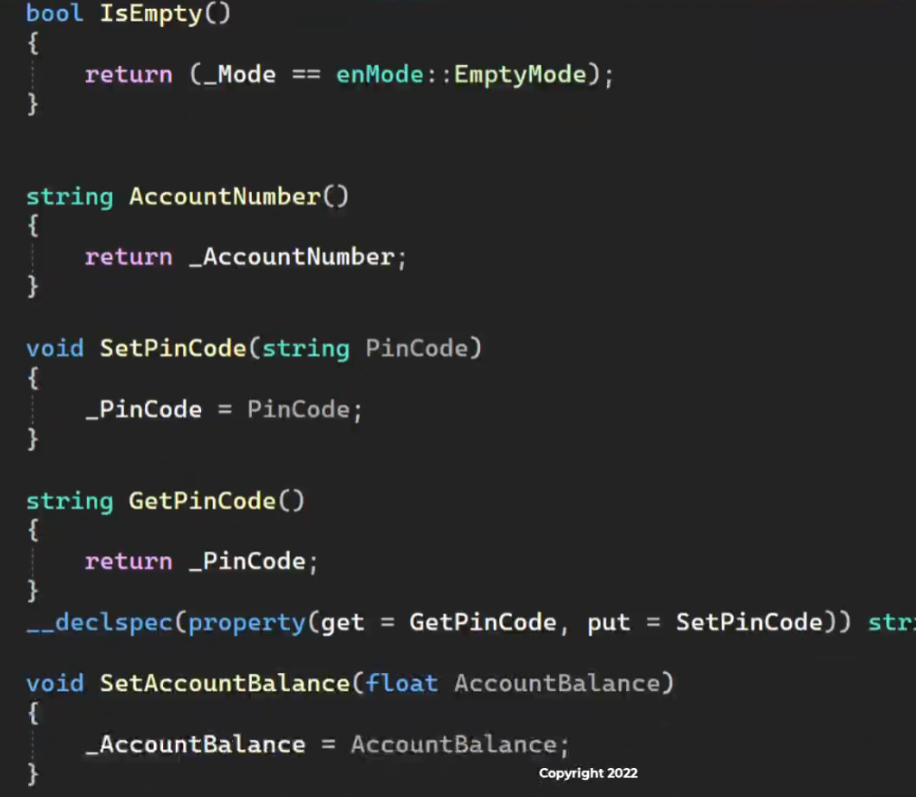

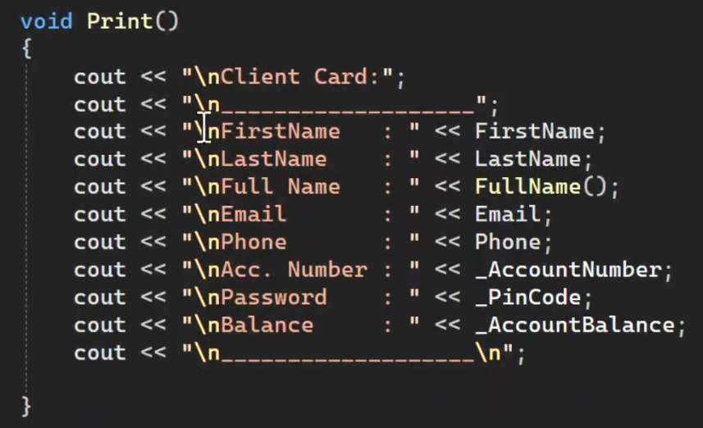

print في ال person و عندي هنا كمان

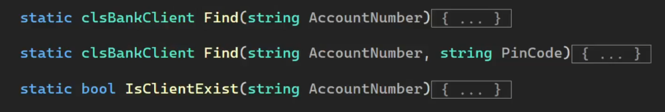

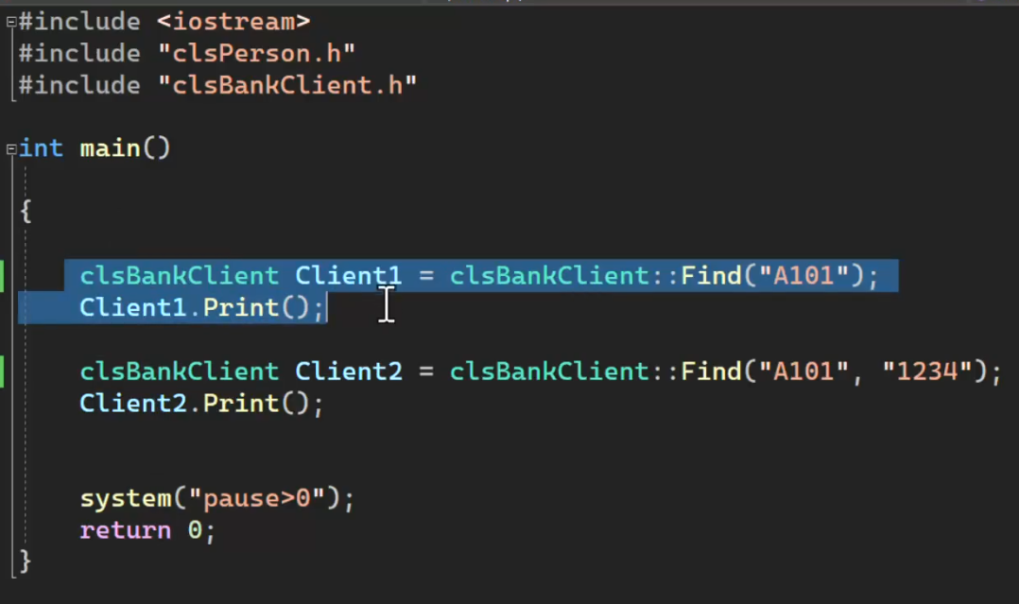

في ال main ماعنديش اكواد عندي سطرين بس

الفكره هنا اني عاوز ادور علي client معين ولو لقيته بملي بياناته في ال object ولو مالقيتهوش هرجعه فاضي

عشان كده هعمل method من النوع static اسمها find وبتاخد رقم الحساب وواحده تانيه بتبحث عن العميل عن طريق رقم الحساب وال pincode بتوعه

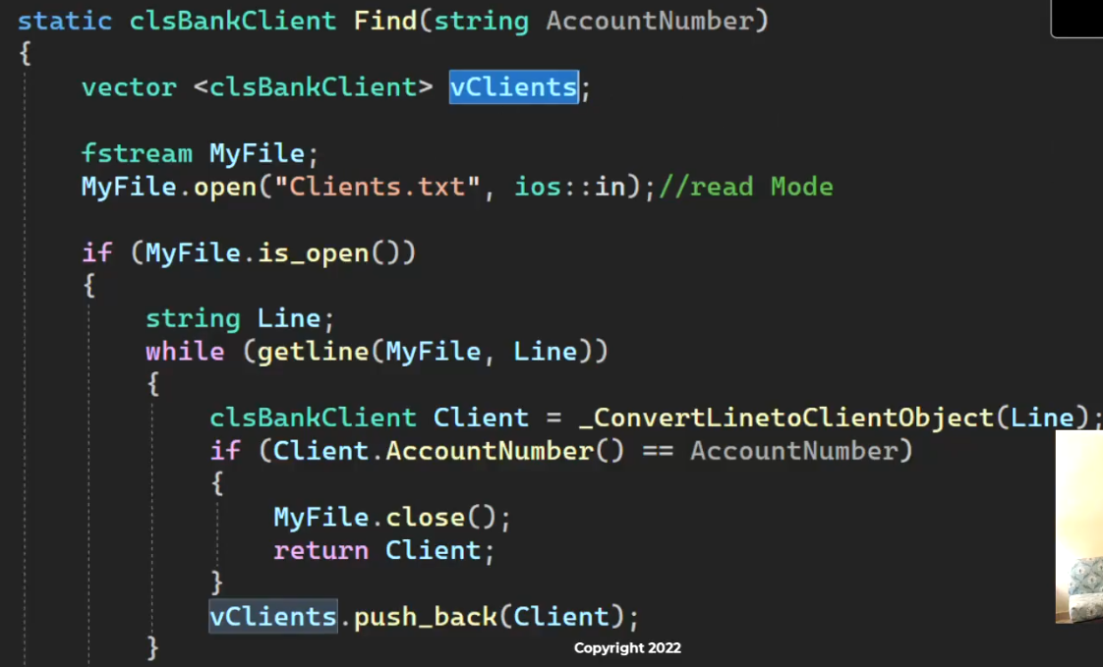

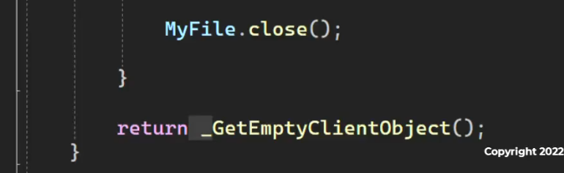

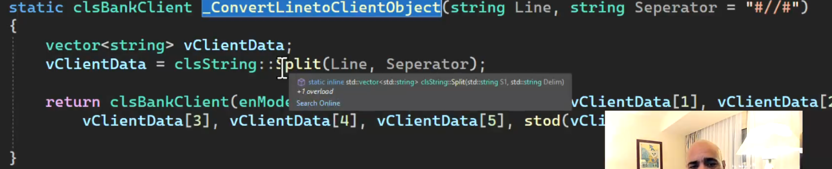

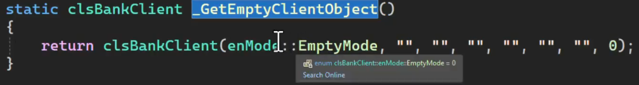

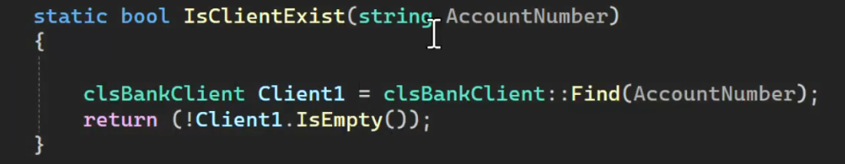

نزل الكود عندك وافهمه وعيده بايدك تاني

|  |  |
| --- | --- |
| ده كود ال person | #pragma once  #include<iostream>  using namespace std;  class clsPerson  {  private:  string _FirstName;  string _LastName;  string _Email;  string _Phone;  public:  //constructors  clsPerson(string FirstName,string LastName,string Email,string Phone) {  this->_FirstName = FirstName;  this->_LastName = LastName;  this->_Email = Email;  this->_Phone = Phone;  }  //setters  void set_FirstName (string FirstName) { this->_FirstName = FirstName; }  void set_LastName (string LastName) { this->_LastName = LastName; }  void set_Email(string Email) { this->_Email = Email; }  void set_Phone(string Phone) { this->_Phone = Phone; }  //getters  string get_FirstName() { return this->_FirstName; }  string get_LastName() { return this->_LastName; }  string get_Email() { return this->_Email; }  string get_Phone() { return this->_Phone; }  string get_FullName() { return this->_FirstName+" "+ this->_LastName; }  //declspec  __declspec(property(get = get_FirstName, put = set_FirstName))string FirstName;  __declspec(property(get = get_LastName, put = set_LastName))string LastName;  __declspec(property(get = get_Email, put = set_Email))string Email;  __declspec(property(get = get_Phone, put = set_Phone))string Phone;  //person functions  void Print()  {  cout << "\nInfo:";  cout << "\n___________________";  cout << "\nFirstName: " << this->_FirstName;  cout << "\nLastName : " << this->_LastName;  cout << "\nFull Name: " << this->get_FullName();  cout << "\nEmail : " << this->_Email;  cout << "\nPhone : " << this->_Phone;  cout << "\n___________________\n";  }  }; |
| ده كود ال client | #pragma once  #include<iostream>  #include"clsPerson.h"  #include"clsString.h"  #include <vector>  #include <string>  #include <fstream>  using namespace std;  class clsBankClient: public clsPerson  {  private:  enum enMode {EmptyMode=0,UpdateMode=1};  //variables  enMode _Mode;  string _AccountNumber;  string _PinCode;  float _AccountBalance;  //other functions  static clsBankClient _ConvertLineToClientObject(string Line,string Seperator="#//#") {  vector<string> vClientData;  vClientData=clsString::Split(Line,Seperator);  return clsBankClient(enMode::UpdateMode, vClientData[0], vClientData[1]  , vClientData[2], vClientData[3], vClientData[4], vClientData[5], stod(vClientData[6]));  }  static string _ConvertClientObjecttoLine(clsBankClient Client,string Seperator="#//#") {  return Client.get_FirstName()  +Seperator+Client.get_LastName()  +Seperator+Client.get_Email()  +Seperator+Client.get_Phone()  +Seperator+Client._AccountNumber  +Seperator+Client._PinCode  +Seperator+to_string(Client._AccountBalance);  }  static clsBankClient _GetEmptyClientObject() {  return clsBankClient(enMode::EmptyMode,"","","","","","",0);  }  public :  //constructors  clsBankClient(enMode Mode,string FirstName, string LastName, string Email, string Phone  , string AccountNumber,string PinCode,float AccountBalance)  :clsPerson(FirstName,LastName,Email,Phone){    this->_Mode = Mode;  this->_AccountNumber = AccountNumber;  this->_PinCode = PinCode;  this->_AccountBalance = AccountBalance;  }  //setters  void set_Mode(enMode Mode) { this->_Mode = Mode; }  void set_AccountNumber(string AccountNumber) { this->_AccountNumber = AccountNumber; }  void set_PinCode(string PinCode) { this->_PinCode = PinCode; }  void set_AccountBalance(float AccountBalance) { this->_AccountBalance = AccountBalance; }  //getters  enMode get_Mode() { return this->_Mode; }  string get_AccountNumber() { return this->_AccountNumber; }  string get_PinCode() { return this->_PinCode; }  float get_AccountBalance() { return this->_AccountBalance; }  //declspec  __declspec(property(get = get_Mode, put = set_Mode))enMode Mode;  __declspec(property(get = get_AccountNumber, put = set_AccountNumber))string AccountNumber;  __declspec(property(get = get_PinCode, put = set_PinCode))string PinCode;  __declspec(property(get = get_AccountBalance, put = set_AccountBalance))float AccountBalance;  //client functions  bool IsEmpty() { return (this->_Mode == enMode::EmptyMode); }  void Print() {  cout << "\nClient Card:";  cout << "\n-------------------";  cout << "\nFirstName :"<<this->get_FirstName();  cout << "\nLastName :"<<this->get_LastName();  cout << "\nFullName :" << this->get_FullName();;  cout << "\nEmail :"<< this->get_Email();  cout << "\nPhone :"<< this->get_Phone();  cout << "\nAcc. Number :"<<this->_AccountNumber;  cout << "\nPassword :"<<this->_PinCode;  cout << "\nBalance :"<<this->_AccountBalance;  cout << "\n-------------------";  }  static clsBankClient Find(string AccountNumber) {  fstream MyFile;  MyFile.open("Clients.txt",ios::in);  if (MyFile.is_open()) {    string Line;  while (getline(MyFile,Line))  {  clsBankClient Client = _ConvertLineToClientObject(Line);  if (Client._AccountNumber == AccountNumber) {  MyFile.close();  return Client;  }  }  return _GetEmptyClientObject();  }  }  static clsBankClient Find(string AccountNumber, string PinCode) {  fstream MyFile;  MyFile.open("Clients.txt", ios::in);  if (MyFile.is_open()) {  string Line;  while (getline(MyFile, Line))  {  clsBankClient Client = _ConvertLineToClientObject(Line);  if (Client._AccountNumber == AccountNumber&&Client._PinCode==PinCode) {  MyFile.close();  return Client;  }  }  return _GetEmptyClientObject();  }  }  static bool IsClientExist(string AccountNumber) {  clsBankClient Client = clsBankClient::Find(AccountNumber);  return (!Client.IsEmpty());  }  }; |
| ده كود ال main | #include <iostream>  #include"clsBankClient.h"  using namespace std;  int main()  {  clsBankClient Client1 = clsBankClient::Find("A101");  Client1.Print();  clsBankClient Client2 = clsBankClient::Find("A101","1234");  Client2.Print();  system("pause>0");  return 0;  } |

**Lesson #2 - Update Client**

هنعمل update لبيانات العميل

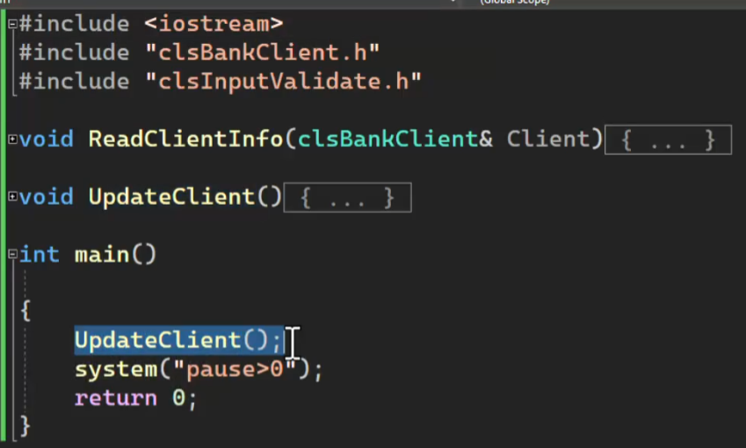

هنستخدم المكتبه بتاعت clsInputValidate عشان نشيك عالقيم اللي اليوزر هيدخلها

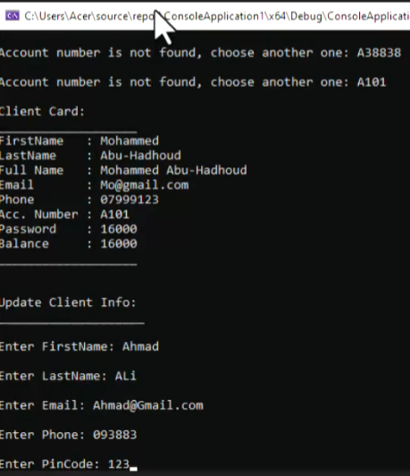

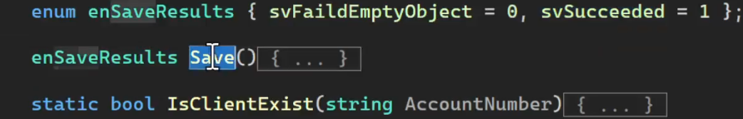

عملنا enum عشان نعرف منها ان كانت عملية الحفظ تمت ولا لا

ال function دي بتحفظ الداتا في ال file وبترجعلك ان كانت العملية تمت ولا لا

عشان بعد كده في ال update يطلعلك رساله ان كانت عملة الحفظ تمت ولا لا

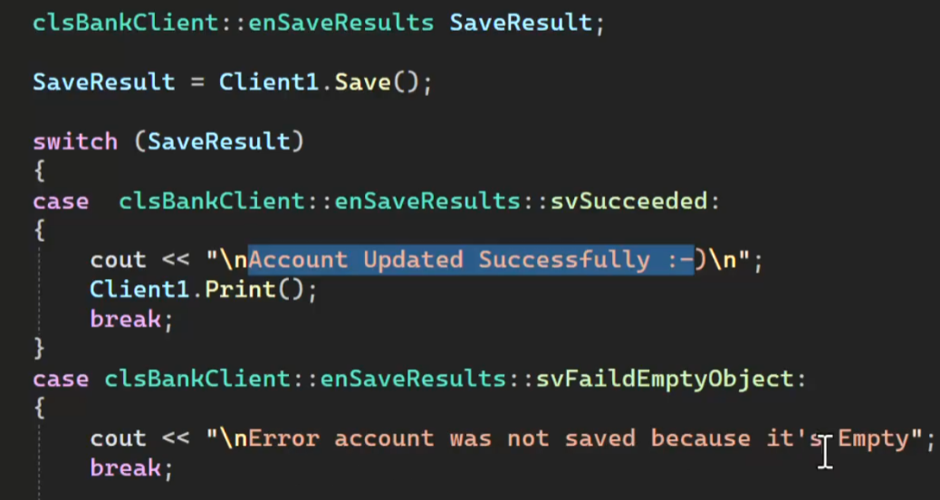

ال saveكل اللي بتعمله هوا انها تشوف ال mode بتاع الكلاس لو كان empty هيرجعلك failed

ولو كان update هيستدعي ال function اللي اسمها update ويرجعلك ان العمليه تمت

ال mode ده كنا بنجيبه من ال constructor

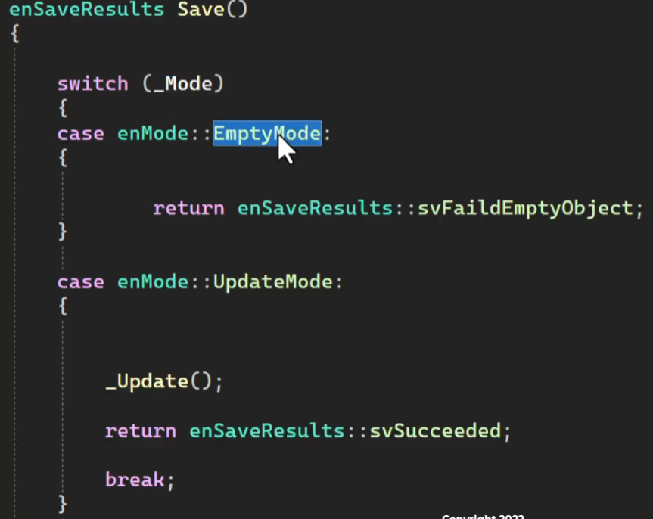

انا دلوقتي المفروض اني دورت علي العميل بال find وبياناته كلها ظهرت عندي بالتالي الكلاس اصبح فيه داتا

ال update function بتقرأ بيانات العملاء من الملف وبتدور علي رقم الحساب وبتستبدل البيانات القديمه بالجديده وتعيد كتابه الداتا في الملف

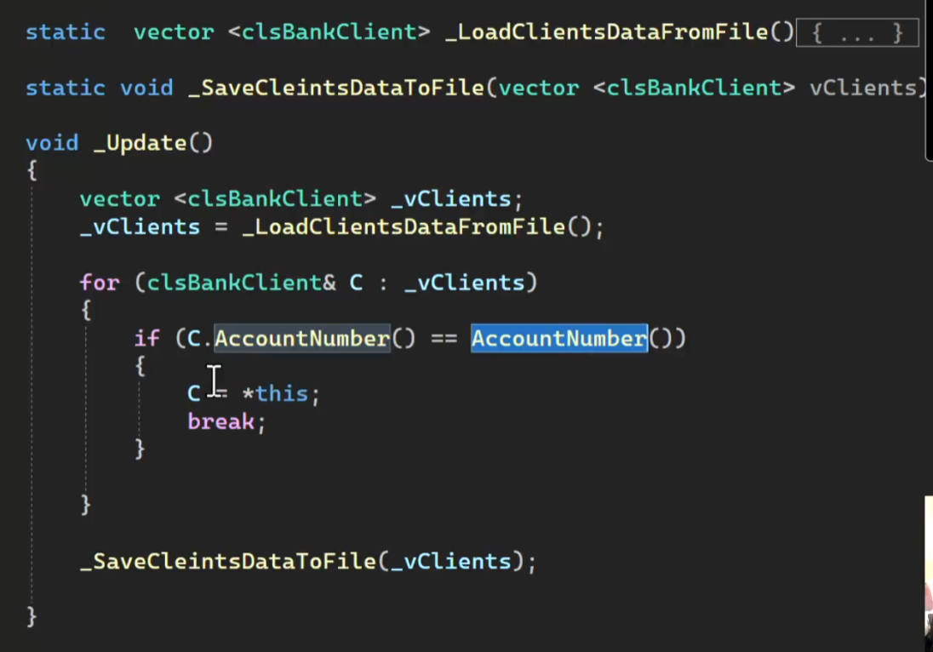

وبيقولك افصل دايما الحاجات الخاصه بال ui عن الداتا نفسها

|  |  |
| --- | --- |
| ده كود ال client | #pragma once  #include<iostream>  #include"clsPerson.h"  #include"clsString.h"  #include <vector>  #include <string>  #include <fstream>  using namespace std;  class clsBankClient:public clsPerson  {  private:  enum enMode {EmptyMode=0,UpdateMode=1};    //variables  enMode _Mode;  string _AccountNumber;  string _PinCode;  float _AccountBalance;  //private client functions  static clsBankClient _ConvertLineToClientObject(string Line,string Seperator="#//#") {  vector<string> vClientData;  vClientData=clsString::Split(Line,Seperator);  return clsBankClient(enMode::UpdateMode, vClientData[0], vClientData[1]  , vClientData[2], vClientData[3], vClientData[4], vClientData[5], stod(vClientData[6]));  }  static string _ConvertClientObjecttoLine(clsBankClient Client,string Seperator="#//#") {  return Client.get_FirstName()  +Seperator+Client.get_LastName()  +Seperator+Client.get_Email()  +Seperator+Client.get_Phone()  +Seperator+Client._AccountNumber  +Seperator+Client._PinCode  +Seperator+to_string(Client._AccountBalance);  }  static clsBankClient _GetEmptyClientObject() {  return clsBankClient(enMode::EmptyMode,"","","","","","",0);  }  static vector<clsBankClient>_LoadClientDataFromFile() {  vector<clsBankClient> vClients;  fstream MyFile;  MyFile.open("Clients.txt",ios::in);    if (MyFile.is_open()) {  string Line;  while (getline(MyFile,Line))  {  clsBankClient Client=_ConvertLineToClientObject(Line);  vClients.push_back(Client);  }  MyFile.close();  }  return vClients;  }  static void _SaveClientsDataToFile(vector<clsBankClient> &vClients) {  fstream MyFile;  MyFile.open("Clients.txt",ios::out);  string DataLine;  if (MyFile.is_open()) {  for (clsBankClient &C:vClients) {  DataLine = _ConvertClientObjecttoLine(C);  MyFile << DataLine << endl;  }  }  MyFile.close();  }  void _Update() {  vector<clsBankClient>_vClients;  _vClients = _LoadClientDataFromFile();  for (clsBankClient &C:_vClients) {  if (C.get_AccountNumber()==get_AccountNumber()) {  C = *this;  break;  }  }  _SaveClientsDataToFile(_vClients);  }  public :  //constructors  clsBankClient(enMode Mode,string FirstName, string LastName, string Email, string Phone  , string AccountNumber,string PinCode,float AccountBalance)  :clsPerson(FirstName,LastName,Email,Phone){    this->_Mode = Mode;  this->_AccountNumber = AccountNumber;  this->_PinCode = PinCode;  this->_AccountBalance = AccountBalance;  }  //setters  void set_Mode(enMode Mode) { this->_Mode = Mode; }  void set_AccountNumber(string AccountNumber) { this->_AccountNumber = AccountNumber; }  void set_PinCode(string PinCode) { this->_PinCode = PinCode; }  void set_AccountBalance(float AccountBalance) { this->_AccountBalance = AccountBalance; }  //getters  enMode get_Mode() { return this->_Mode; }  string get_AccountNumber() { return this->_AccountNumber; }  string get_PinCode() { return this->_PinCode; }  float get_AccountBalance() { return this->_AccountBalance; }  //declspec  __declspec(property(get = get_Mode, put = set_Mode))enMode Mode;  __declspec(property(get = get_AccountNumber, put = set_AccountNumber))string AccountNumber;  __declspec(property(get = get_PinCode, put = set_PinCode))string PinCode;  __declspec(property(get = get_AccountBalance, put = set_AccountBalance))float AccountBalance;  //public client functions  bool IsEmpty() { return (this->_Mode == enMode::EmptyMode); }  void Print() {  cout << "\nClient Card:";  cout << "\n-------------------";  cout << "\nFirstName :"<<this->get_FirstName();  cout << "\nLastName :"<<this->get_LastName();  cout << "\nFullName :" << this->get_FullName();;  cout << "\nEmail :"<< this->get_Email();  cout << "\nPhone :"<< this->get_Phone();  cout << "\nAcc. Number :"<<this->_AccountNumber;  cout << "\nPassword :"<<this->_PinCode;  cout << "\nBalance :"<<this->_AccountBalance;  cout << "\n-------------------";  }  static clsBankClient Find(string AccountNumber) {  fstream MyFile;  MyFile.open("Clients.txt",ios::in);  if (MyFile.is_open()) {    string Line;  while (getline(MyFile,Line))  {  clsBankClient Client = _ConvertLineToClientObject(Line);  if (Client._AccountNumber == AccountNumber) {  MyFile.close();  return Client;  }  }  return _GetEmptyClientObject();  }  }  static clsBankClient Find(string AccountNumber, string PinCode) {  fstream MyFile;  MyFile.open("Clients.txt", ios::in);  if (MyFile.is_open()) {  string Line;  while (getline(MyFile, Line))  {  clsBankClient Client = _ConvertLineToClientObject(Line);  if (Client._AccountNumber == AccountNumber&&Client._PinCode==PinCode) {  MyFile.close();  return Client;  }  }  return _GetEmptyClientObject();  }  }  enum enSaveResults { svFailedEmptyObject = 0, svSucceeded = 1 };  enSaveResults save() {  switch (_Mode)  {  case clsBankClient::EmptyMode:  return enSaveResults::svFailedEmptyObject;  break;  case clsBankClient::UpdateMode:  _Update();  return enSaveResults::svSucceeded;  break;  default:  break;  }  }  static bool IsClientExist(string AccountNumber) {  clsBankClient Client = clsBankClient::Find(AccountNumber);  return (!Client.IsEmpty());  }  }; |
| ده كود ال main | #include <iostream>  #include"clsBankClient.h"  #include "clsInputValidate.h"  using namespace std;  void ReadClientInfo(clsBankClient &Client) {  cout << "\nEnter FirstName: ";  Client.FirstName = clsInputValidate::ReadString();  cout << "\nEnter LastName: ";  Client.LastName = clsInputValidate::ReadString();  cout << "\nEnter Email: ";  Client.Email = clsInputValidate::ReadString();  cout << "\nEnter Phone: ";  Client.Phone = clsInputValidate::ReadString();  cout << "\nEnter PinCode: ";  Client.PinCode = clsInputValidate::ReadString();  cout << "\nEnter AccountBalance: ";  Client.AccountBalance = clsInputValidate::ReadFloatNumber();  }  void UpdateClient() {  string AccountNumber = "";  cout << "\nPlease Enter client Account Number: ";  AccountNumber = clsInputValidate::ReadString();  while (!clsBankClient::IsClientExist(AccountNumber)) {  cout << "\nAccount number is not found, choose another one: ";  AccountNumber = clsInputValidate::ReadString();  }  clsBankClient Client1 = clsBankClient::Find(AccountNumber);  Client1.Print();  cout << "\n\nUpdate Client Info:";  cout << "\n____________________\n";  ReadClientInfo(Client1);  clsBankClient::enSaveResults SaveResult;  SaveResult = Client1.save();  switch (SaveResult)  {  case clsBankClient::svFailedEmptyObject:  cout << "\nError account was not saved because it's Empty";  break;  case clsBankClient::svSucceeded:  cout << "\nAccount Updated Successfully :-)\n";  Client1.Print();  break;  default:  break;  }  }  int main()  {  UpdateClient();  system("pause>0");  return 0;  } |
| ده كود ال person | #pragma once  #include<iostream>  using namespace std;  class clsPerson  {  private:  string _FirstName;  string _LastName;  string _Email;  string _Phone;  public:  //constructors  clsPerson(string FirstName,string LastName,string Email,string Phone) {  this->_FirstName = FirstName;  this->_LastName = LastName;  this->_Email = Email;  this->_Phone = Phone;  }  //setters  void set_FirstName (string FirstName) { this->_FirstName = FirstName; }  void set_LastName (string LastName) { this->_LastName = LastName; }  void set_Email(string Email) { this->_Email = Email; }  void set_Phone(string Phone) { this->_Phone = Phone; }  //getters  string get_FirstName() { return this->_FirstName; }  string get_LastName() { return this->_LastName; }  string get_Email() { return this->_Email; }  string get_Phone() { return this->_Phone; }  string get_FullName() { return this->_FirstName+" "+ this->_LastName; }  //declspec  __declspec(property(get = get_FirstName, put = set_FirstName))string FirstName;  __declspec(property(get = get_LastName, put = set_LastName))string LastName;  __declspec(property(get = get_Email, put = set_Email))string Email;  __declspec(property(get = get_Phone, put = set_Phone))string Phone;  //person functions  void Print()  {  cout << "\nInfo:";  cout << "\n___________________";  cout << "\nFirstName: " << this->_FirstName;  cout << "\nLastName : " << this->_LastName;  cout << "\nFull Name: " << this->get_FullName();  cout << "\nEmail : " << this->_Email;  cout << "\nPhone : " << this->_Phone;  cout << "\n___________________\n";  }  }; |
| ده كود ال validate | //ProgrammingAdivces.com  //Mohammed Abu-Hadhoud  #pragma once  #include <iostream>  #include <string>  #include "clsString.h"  #include "clsDate.h"  class clsInputValidate  {  public:  static bool IsNumberBetween(short Number, short From, short To)  {  if (Number >= From && Number <= To)  return true;  else  return false;  }  static bool IsNumberBetween(int Number, int From, int To)  {  if (Number >= From && Number <= To)  return true;  else  return false;  }  static bool IsNumberBetween(double Number, double From, double To)  {  if (Number >= From && Number <= To)  return true;  else  return false;  }  static bool IsDateBetween(clsDate Date, clsDate From, clsDate To)  {  //Date>=From && Date<=To  if ((clsDate::IsDate1AfterDate2(Date, From) || clsDate::IsDate1EqualDate2(Date, From))  &&  (clsDate::IsDate1BeforeDate2(Date, To) || clsDate::IsDate1EqualDate2(Date, To))  )  {  return true;  }  //Date>=To && Date<=From  if ((clsDate::IsDate1AfterDate2(Date, To) || clsDate::IsDate1EqualDate2(Date, To))  &&  (clsDate::IsDate1BeforeDate2(Date, From) || clsDate::IsDate1EqualDate2(Date, From))  )  {  return true;  }  return false;  }  static int ReadIntNumber(string ErrorMessage = "Invalid Number, Enter again\n")  {  int Number;  while (!(cin >> Number)) {  cin.clear();  cin.ignore(numeric_limits<streamsize>::max(), '\n');  cout << ErrorMessage;  }  return Number;  }  static int ReadIntNumberBetween(int From, int To, string ErrorMessage = "Number is not within range, Enter again:\n")  {  int Number = ReadIntNumber();  while (!IsNumberBetween(Number, From, To))  {  cout << ErrorMessage;  Number = ReadIntNumber();  }  return Number;  }  static double ReadFloatNumber(string ErrorMessage = "Invalid Number, Enter again\n")  {  float Number;  while (!(cin >> Number)) {  cin.clear();  cin.ignore(numeric_limits<streamsize>::max(), '\n');  cout << ErrorMessage;  }  return Number;  }  static double ReadFloatNumberBetween(double From, double To, string ErrorMessage = "Number is not within range, Enter again:\n")  {  float Number = ReadFloatNumber();  while (!IsNumberBetween(Number, From, To)) {  cout << ErrorMessage;  Number = ReadDblNumber();  }  return Number;  }  static double ReadDblNumber(string ErrorMessage = "Invalid Number, Enter again\n")  {  double Number;  while (!(cin >> Number)) {  cin.clear();  cin.ignore(numeric_limits<streamsize>::max(), '\n');  cout << ErrorMessage;  }  return Number;  }  static double ReadDblNumberBetween(double From, double To, string ErrorMessage = "Number is not within range, Enter again:\n")  {  double Number = ReadDblNumber();  while (!IsNumberBetween(Number, From, To)) {  cout << ErrorMessage;  Number = ReadDblNumber();  }  return Number;  }  static bool IsValideDate(clsDate Date)  {  return clsDate::IsValidDate(Date);  }  static string ReadString()  {  string S1 = "";  // Usage of std::ws will extract allthe whitespace character  getline(cin >> ws, S1);  return S1;  }  }; |

**Lesson #3 - Add New Client**

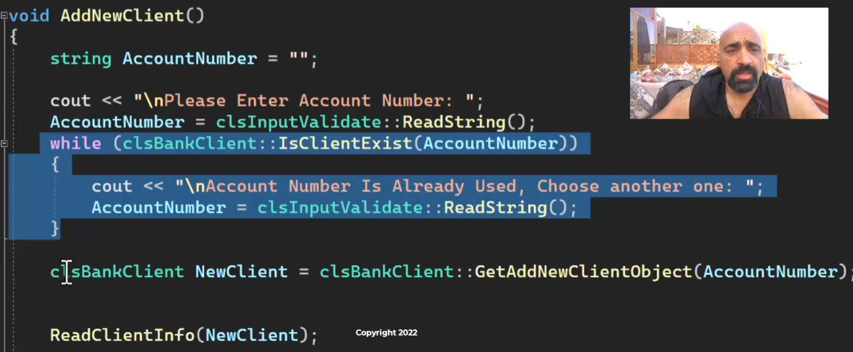

بيخليك تكتب رقم الحساب الأول لو موجود بيقولك انه موجود ولو مش موجود بيعمل object جديد عن طريق ال add new client object وبيديله رقم الحساب

بعدين بيقرا الداتا ويحفظها ويقولك لو عملية الحفظ تمت ولا لا

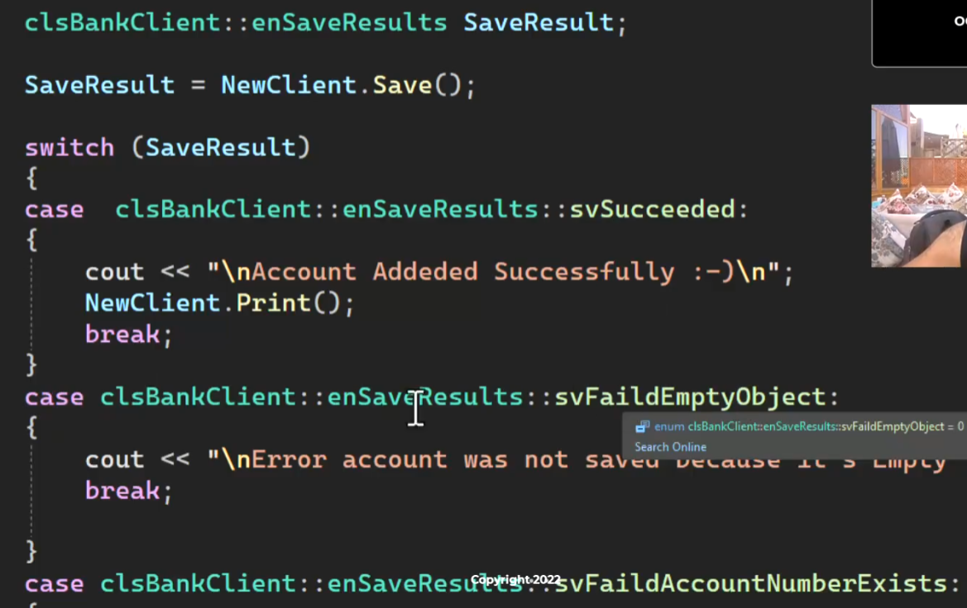

|  |  |
| --- | --- |
| clsBankCient class | #pragma once  #include<iostream>  #include"clsPerson.h"  #include"clsString.h"  #include <vector>  #include <string>  #include <fstream>  using namespace std;  class clsBankClient:public clsPerson  {  private:  enum enMode {EmptyMode=0,UpdateMode=1,AddNewMode=2};    //variables  enMode _Mode;  string _AccountNumber;  string _PinCode;  float _AccountBalance;  //private client functions  static clsBankClient _ConvertLineToClientObject(string Line,string Seperator="#//#") {  vector<string> vClientData;  vClientData=clsString::Split(Line,Seperator);  return clsBankClient(enMode::UpdateMode, vClientData[0], vClientData[1]  , vClientData[2], vClientData[3], vClientData[4], vClientData[5], stod(vClientData[6]));  }  static string _ConvertClientObjecttoLine(clsBankClient Client,string Seperator="#//#") {  return Client.get_FirstName()  +Seperator+Client.get_LastName()  +Seperator+Client.get_Email()  +Seperator+Client.get_Phone()  +Seperator+Client._AccountNumber  +Seperator+Client._PinCode  +Seperator+to_string(Client._AccountBalance);  }  static clsBankClient _GetEmptyClientObject() {  return clsBankClient(enMode::EmptyMode,"","","","","","",0);  }  static vector<clsBankClient>_LoadClientDataFromFile() {  vector<clsBankClient> vClients;  fstream MyFile;  MyFile.open("Clients.txt",ios::in);    if (MyFile.is_open()) {  string Line;  while (getline(MyFile,Line))  {  clsBankClient Client=_ConvertLineToClientObject(Line);  vClients.push_back(Client);  }  MyFile.close();  }  return vClients;  }  void _AddDataLineToFile(string stDataLine) {  fstream MyFile;  MyFile.open("Clients.txt", ios::out | ios::app);  if (MyFile.is_open()) {  MyFile << stDataLine << endl;  MyFile.close();  }  }  static void _SaveClientsDataToFile(vector<clsBankClient> &vClients) {  fstream MyFile;  MyFile.open("Clients.txt",ios::out);  string DataLine;  if (MyFile.is_open()) {  for (clsBankClient &C:vClients) {  DataLine = _ConvertClientObjecttoLine(C);  MyFile << DataLine << endl;  }  }  MyFile.close();  }  void _Update() {  vector<clsBankClient>_vClients;  _vClients = _LoadClientDataFromFile();  for (clsBankClient &C:_vClients) {  if (C.get_AccountNumber()==get_AccountNumber()) {  C = *this;  break;  }  }  _SaveClientsDataToFile(_vClients);  }  void _AddNew() {  _AddDataLineToFile(_ConvertClientObjecttoLine(*this));  }  public :  //constructors  clsBankClient(enMode Mode,string FirstName, string LastName, string Email, string Phone  , string AccountNumber,string PinCode,float AccountBalance)  :clsPerson(FirstName,LastName,Email,Phone){    this->_Mode = Mode;  this->_AccountNumber = AccountNumber;  this->_PinCode = PinCode;  this->_AccountBalance = AccountBalance;  }  //setters  void set_Mode(enMode Mode) { this->_Mode = Mode; }  void set_AccountNumber(string AccountNumber) { this->_AccountNumber = AccountNumber; }  void set_PinCode(string PinCode) { this->_PinCode = PinCode; }  void set_AccountBalance(float AccountBalance) { this->_AccountBalance = AccountBalance; }  //getters  enMode get_Mode() { return this->_Mode; }  string get_AccountNumber() { return this->_AccountNumber; }  string get_PinCode() { return this->_PinCode; }  float get_AccountBalance() { return this->_AccountBalance; }  //declspec  __declspec(property(get = get_Mode, put = set_Mode))enMode Mode;  __declspec(property(get = get_AccountNumber, put = set_AccountNumber))string AccountNumber;  __declspec(property(get = get_PinCode, put = set_PinCode))string PinCode;  __declspec(property(get = get_AccountBalance, put = set_AccountBalance))float AccountBalance;  //public client functions  bool IsEmpty() { return (this->_Mode == enMode::EmptyMode); }  void Print() {  cout << "\nClient Card:";  cout << "\n-------------------";  cout << "\nFirstName :"<<this->get_FirstName();  cout << "\nLastName :"<<this->get_LastName();  cout << "\nFullName :" << this->get_FullName();;  cout << "\nEmail :"<< this->get_Email();  cout << "\nPhone :"<< this->get_Phone();  cout << "\nAcc. Number :"<<this->_AccountNumber;  cout << "\nPassword :"<<this->_PinCode;  cout << "\nBalance :"<<this->_AccountBalance;  cout << "\n-------------------";  }  static clsBankClient Find(string AccountNumber) {  fstream MyFile;  MyFile.open("Clients.txt",ios::in);  if (MyFile.is_open()) {    string Line;  while (getline(MyFile,Line))  {  clsBankClient Client = _ConvertLineToClientObject(Line);  if (Client._AccountNumber == AccountNumber) {  MyFile.close();  return Client;  }  }  return _GetEmptyClientObject();  }  }  static clsBankClient Find(string AccountNumber, string PinCode) {  fstream MyFile;  MyFile.open("Clients.txt", ios::in);  if (MyFile.is_open()) {  string Line;  while (getline(MyFile, Line))  {  clsBankClient Client = _ConvertLineToClientObject(Line);  if (Client._AccountNumber == AccountNumber&&Client._PinCode==PinCode) {  MyFile.close();  return Client;  }  }  return _GetEmptyClientObject();  }  }  enum enSaveResults { svFailedEmptyObject = 0, svSucceeded = 1, svFaildAccountNumberExists=2};  enSaveResults save() {  switch (_Mode)  {  case clsBankClient::EmptyMode:  return enSaveResults::svFailedEmptyObject;  break;  case clsBankClient::UpdateMode:  _Update();  return enSaveResults::svSucceeded;  break;  case clsBankClient::AddNewMode:  if (clsBankClient::IsClientExist(_AccountNumber)) {  return enSaveResults::svFaildAccountNumberExists;  }  else {  _AddNew();  _Mode = enMode::UpdateMode;  return enSaveResults::svSucceeded;  }  break;  default:  break;  }  }  static bool IsClientExist(string AccountNumber) {  clsBankClient Client = clsBankClient::Find(AccountNumber);  return (!Client.IsEmpty());  }  static clsBankClient GetAddNewClientObject(string AccountNumber)  {  return clsBankClient(enMode::AddNewMode, "", "", "", "", AccountNumber, "", 0);  }  }; |
| Main | #include <iostream>  #include"clsBankClient.h"  #include "clsInputValidate.h"  using namespace std;  void ReadClientInfo(clsBankClient &Client) {  cout << "\nEnter FirstName: ";  Client.FirstName = clsInputValidate::ReadString();  cout << "\nEnter LastName: ";  Client.LastName = clsInputValidate::ReadString();  cout << "\nEnter Email: ";  Client.Email = clsInputValidate::ReadString();  cout << "\nEnter Phone: ";  Client.Phone = clsInputValidate::ReadString();  cout << "\nEnter PinCode: ";  Client.PinCode = clsInputValidate::ReadString();  cout << "\nEnter AccountBalance: ";  Client.AccountBalance = clsInputValidate::ReadFloatNumber();  }  void UpdateClient() {  string AccountNumber = "";  cout << "\nPlease Enter client Account Number: ";  AccountNumber = clsInputValidate::ReadString();  while (!clsBankClient::IsClientExist(AccountNumber)) {  cout << "\nAccount number is not found, choose another one: ";  AccountNumber = clsInputValidate::ReadString();  }  clsBankClient Client1 = clsBankClient::Find(AccountNumber);  Client1.Print();  cout << "\n\nUpdate Client Info:";  cout << "\n____________________\n";  ReadClientInfo(Client1);  clsBankClient::enSaveResults SaveResult;  SaveResult = Client1.save();  switch (SaveResult)  {  case clsBankClient::svFailedEmptyObject:  cout << "\nError account was not saved because it's Empty";  break;  case clsBankClient::svSucceeded:  cout << "\nAccount Updated Successfully :-)\n";  Client1.Print();  break;  default:  break;  }  }  void AddNewClient() {  string AccountNumber = "";  cout << "\nPlease Enter Account Number: ";  AccountNumber = clsInputValidate::ReadString();  while (clsBankClient::IsClientExist(AccountNumber))  {  cout << "\nAccount Number Is Already used, Choose another one: ";  AccountNumber = clsInputValidate::ReadString();  }  clsBankClient NewClient = clsBankClient::GetAddNewClientObject(AccountNumber);  ReadClientInfo(NewClient);  clsBankClient::enSaveResults SaveResult;    SaveResult = NewClient.save();  switch (SaveResult)  {  case clsBankClient::svFailedEmptyObject:  cout << "\nError account was not saved because it's Empty";  break;  case clsBankClient::svSucceeded:  cout << "\nAccount Addeded Successfully :-)\n";  NewClient.Print();  break;  case clsBankClient::svFaildAccountNumberExists:  cout << "\nError account was not saved because account number is used!\n";  break;  default:  break;  }  }  int main()  {  AddNewClient();  system("pause>0");  return 0;  } |

**Lesson #4 - Delete Client**

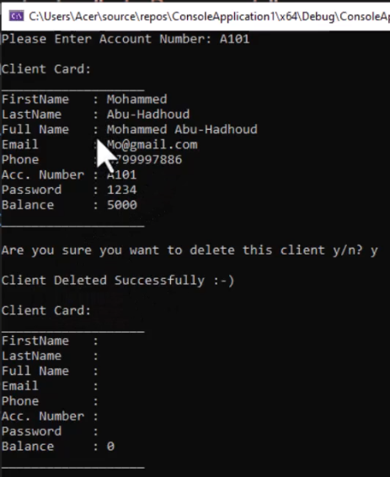

لما بتعمل delete بتفضي ال object وبيمسحه

|  |  |
| --- | --- |
| ده ال client هنعلم عالجديد بس  زودنا متغير bool اسمه mark for delete  هنا زودنا وقلناله انه لو ال mark for delete مش معموله true احفظ الداتا في الملف  وهنا عملنا function اسمها delete بنحمل فيه الدتا من الملف وندور عالعميل اللي رقم حسابه نفس رقم الحساب اللي معانا ولو لقاه بيعمل ال mark for delete بيساوي true  وبعدين بيحفظ البيانات تاني في الملف وبيخلي ال object اللي احنا واقفين عليه فاضي | #pragma once  #include<iostream>  #include"clsPerson.h"  #include"clsString.h"  #include <vector>  #include <string>  #include <fstream>  using namespace std;  class clsBankClient:public clsPerson  {  private:  enum enMode {EmptyMode=0,UpdateMode=1,AddNewMode=2};    //variables  enMode _Mode;  string _AccountNumber;  string _PinCode;  float _AccountBalance;  bool _MarkForDelete=false;  //private client functions  static clsBankClient _ConvertLineToClientObject(string Line,string Seperator="#//#") {  vector<string> vClientData;  vClientData=clsString::Split(Line,Seperator);  return clsBankClient(enMode::UpdateMode, vClientData[0], vClientData[1]  , vClientData[2], vClientData[3], vClientData[4], vClientData[5], stod(vClientData[6]));  }  static string _ConvertClientObjecttoLine(clsBankClient Client,string Seperator="#//#") {  return Client.get_FirstName()  +Seperator+Client.get_LastName()  +Seperator+Client.get_Email()  +Seperator+Client.get_Phone()  +Seperator+Client._AccountNumber  +Seperator+Client._PinCode  +Seperator+to_string(Client._AccountBalance);  }  static clsBankClient _GetEmptyClientObject() {  return clsBankClient(enMode::EmptyMode,"","","","","","",0);  }  static vector<clsBankClient>_LoadClientDataFromFile() {  vector<clsBankClient> vClients;  fstream MyFile;  MyFile.open("Clients.txt",ios::in);    if (MyFile.is_open()) {  string Line;  while (getline(MyFile,Line))  {  clsBankClient Client=_ConvertLineToClientObject(Line);  vClients.push_back(Client);  }  MyFile.close();  }  return vClients;  }  void _AddDataLineToFile(string stDataLine) {  fstream MyFile;  MyFile.open("Clients.txt", ios::out | ios::app);  if (MyFile.is_open()) {  MyFile << stDataLine << endl;  MyFile.close();  }  }  static void _SaveClientsDataToFile(vector<clsBankClient> &vClients) {  fstream MyFile;  MyFile.open("Clients.txt",ios::out);  string DataLine;  if (MyFile.is_open()) {  for (clsBankClient &C:vClients) {  if (C.MarkedForDelete() == false) {  DataLine = _ConvertClientObjecttoLine(C);  MyFile << DataLine << endl;  }  }  }  MyFile.close();  }  void _Update() {  vector<clsBankClient>_vClients;  _vClients = _LoadClientDataFromFile();  for (clsBankClient &C:_vClients) {  if (C.get_AccountNumber()==get_AccountNumber()) {  C = *this;  break;  }  }  _SaveClientsDataToFile(_vClients);  }  void _AddNew() {  _AddDataLineToFile(_ConvertClientObjecttoLine(*this));  }  public :  //constructors  clsBankClient(enMode Mode,string FirstName, string LastName, string Email, string Phone  , string AccountNumber,string PinCode,float AccountBalance)  :clsPerson(FirstName,LastName,Email,Phone){    this->_Mode = Mode;  this->_AccountNumber = AccountNumber;  this->_PinCode = PinCode;  this->_AccountBalance = AccountBalance;  }  //setters  void set_Mode(enMode Mode) { this->_Mode = Mode; }  void set_AccountNumber(string AccountNumber) { this->_AccountNumber = AccountNumber; }  void set_PinCode(string PinCode) { this->_PinCode = PinCode; }  void set_AccountBalance(float AccountBalance) { this->_AccountBalance = AccountBalance; }  //getters  enMode get_Mode() { return this->_Mode; }  string get_AccountNumber() { return this->_AccountNumber; }  string get_PinCode() { return this->_PinCode; }  float get_AccountBalance() { return this->_AccountBalance; }  //declspec  __declspec(property(get = get_Mode, put = set_Mode))enMode Mode;  __declspec(property(get = get_AccountNumber, put = set_AccountNumber))string AccountNumber;  __declspec(property(get = get_PinCode, put = set_PinCode))string PinCode;  __declspec(property(get = get_AccountBalance, put = set_AccountBalance))float AccountBalance;  //public client functions  bool IsEmpty() { return (this->_Mode == enMode::EmptyMode); }  void Print() {  cout << "\nClient Card:";  cout << "\n-------------------";  cout << "\nFirstName :"<<this->get_FirstName();  cout << "\nLastName :"<<this->get_LastName();  cout << "\nFullName :" << this->get_FullName();;  cout << "\nEmail :"<< this->get_Email();  cout << "\nPhone :"<< this->get_Phone();  cout << "\nAcc. Number :"<<this->_AccountNumber;  cout << "\nPassword :"<<this->_PinCode;  cout << "\nBalance :"<<this->_AccountBalance;  cout << "\n-------------------";  }  static clsBankClient Find(string AccountNumber) {  fstream MyFile;  MyFile.open("Clients.txt",ios::in);  if (MyFile.is_open()) {    string Line;  while (getline(MyFile,Line))  {  clsBankClient Client = _ConvertLineToClientObject(Line);  if (Client._AccountNumber == AccountNumber) {  MyFile.close();  return Client;  }  }  return _GetEmptyClientObject();  }  }  static clsBankClient Find(string AccountNumber, string PinCode) {  fstream MyFile;  MyFile.open("Clients.txt", ios::in);  if (MyFile.is_open()) {  string Line;  while (getline(MyFile, Line))  {  clsBankClient Client = _ConvertLineToClientObject(Line);  if (Client._AccountNumber == AccountNumber&&Client._PinCode==PinCode) {  MyFile.close();  return Client;  }  }  return _GetEmptyClientObject();  }  }  enum enSaveResults { svFailedEmptyObject = 0, svSucceeded = 1, svFaildAccountNumberExists=2};  enSaveResults save() {  switch (_Mode)  {  case clsBankClient::EmptyMode:  return enSaveResults::svFailedEmptyObject;  break;  case clsBankClient::UpdateMode:  _Update();  return enSaveResults::svSucceeded;  break;  case clsBankClient::AddNewMode:  if (clsBankClient::IsClientExist(_AccountNumber)) {  return enSaveResults::svFaildAccountNumberExists;  }  else {  _AddNew();  _Mode = enMode::UpdateMode;  return enSaveResults::svSucceeded;  }  break;  default:  break;  }  }  static bool IsClientExist(string AccountNumber) {  clsBankClient Client = clsBankClient::Find(AccountNumber);  return (!Client.IsEmpty());  }  static clsBankClient GetAddNewClientObject(string AccountNumber)  {  return clsBankClient(enMode::AddNewMode, "", "", "", "", AccountNumber, "", 0);  }  bool MarkedForDelete() {  return _MarkForDelete;  }  bool Delete() {  vector<clsBankClient>_vClients;  _vClients = _LoadClientDataFromFile();  for (clsBankClient &C:_vClients)  {  if (C.get_AccountNumber()==_AccountNumber) {  C._MarkForDelete = true;  break;  }  }  _SaveClientsDataToFile(_vClients);  *this=_GetEmptyClientObject();  return true;  }  }; |
| ده ال main  هنا عملنا delete client  وعرفنا فيها متغير هنخزن فيه ال account number  وبعدين بيخلي اليوزر يدخل رقم الحساب ولولقاه  بيدور عليه في الملف وبيطبعه  وبيساله عاوز تحذف ده؟  لو قاله اه  بيشغل ال function اللي اسمها delete | #include <iostream>  #include"clsBankClient.h"  #include "clsInputValidate.h"  using namespace std;  void ReadClientInfo(clsBankClient &Client) {  cout << "\nEnter FirstName: ";  Client.FirstName = clsInputValidate::ReadString();  cout << "\nEnter LastName: ";  Client.LastName = clsInputValidate::ReadString();  cout << "\nEnter Email: ";  Client.Email = clsInputValidate::ReadString();  cout << "\nEnter Phone: ";  Client.Phone = clsInputValidate::ReadString();  cout << "\nEnter PinCode: ";  Client.PinCode = clsInputValidate::ReadString();  cout << "\nEnter AccountBalance: ";  Client.AccountBalance = clsInputValidate::ReadFloatNumber();  }  void UpdateClient() {  string AccountNumber = "";  cout << "\nPlease Enter client Account Number: ";  AccountNumber = clsInputValidate::ReadString();  while (!clsBankClient::IsClientExist(AccountNumber)) {  cout << "\nAccount number is not found, choose another one: ";  AccountNumber = clsInputValidate::ReadString();  }  clsBankClient Client1 = clsBankClient::Find(AccountNumber);  Client1.Print();  cout << "\n\nUpdate Client Info:";  cout << "\n____________________\n";  ReadClientInfo(Client1);  clsBankClient::enSaveResults SaveResult;  SaveResult = Client1.save();  switch (SaveResult)  {  case clsBankClient::svFailedEmptyObject:  cout << "\nError account was not saved because it's Empty";  break;  case clsBankClient::svSucceeded:  cout << "\nAccount Updated Successfully :-)\n";  Client1.Print();  break;  default:  break;  }  }  void AddNewClient() {  string AccountNumber = "";  cout << "\nPlease Enter Account Number: ";  AccountNumber = clsInputValidate::ReadString();  while (clsBankClient::IsClientExist(AccountNumber))  {  cout << "\nAccount Number Is Already used, Choose another one: ";  AccountNumber = clsInputValidate::ReadString();  }  clsBankClient NewClient = clsBankClient::GetAddNewClientObject(AccountNumber);  ReadClientInfo(NewClient);  clsBankClient::enSaveResults SaveResult;    SaveResult = NewClient.save();  switch (SaveResult)  {  case clsBankClient::svFailedEmptyObject:  cout << "\nError account was not saved because it's Empty";  break;  case clsBankClient::svSucceeded:  cout << "\nAccount Addeded Successfully :-)\n";  NewClient.Print();  break;  case clsBankClient::svFaildAccountNumberExists:  cout << "\nError account was not saved because account number is used!\n";  break;  default:  break;  }  }  void DeleteClient() {  string AccountNumber = "";  cout << "\nPlease enter account number: ";  AccountNumber = clsInputValidate::ReadString();  while (!clsBankClient::IsClientExist(AccountNumber)) {  cout << "\nAccount number is not found, please choose another one: ";  AccountNumber = clsInputValidate::ReadString();  }  clsBankClient Client1 = clsBankClient::Find(AccountNumber);  Client1.Print();  cout << "\nAre you sure you want to delete this client y/n? ";  char Answer = 'n';  cin >> Answer;  if (Answer == 'y' || Answer == 'Y') {  if (Client1.Delete()) {  cout << "\nClient Deleted Susseccfully :-)\n";  Client1.Print();  }  else {  cout << "\nError Client Was not Deleted\n";  }  }  }  int main()  {  DeleteClient();  system("pause>0");  return 0;  } |

**Lesson #5 - List Clients**

عاوزين نعمل show client list ودي بتعرضلنا بيانات العملاء كلهم

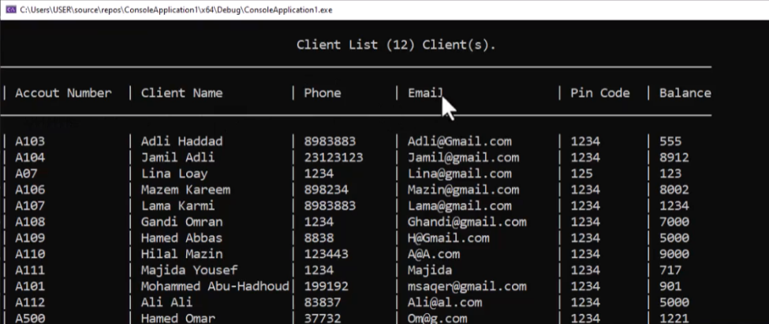

وعاوزين لو مفيش داتا نكتب جملة معينه بدل مانسيبها فاضيه كده

|  |  |
| --- | --- |
| ده كلاس ال clsBankClient  ده كل اللي زودناه | static vector<clsBankClient> GetClientsList() {    return _LoadClientDataFromFile();  } |
| ده ال main  ده كل اللي زودناه جمل طباعة عاديه  ومتنساش تضيف المكتبه iomanip | void PrintClientRecordLine(clsBankClient Client)  {  cout << "| " << setw(15) << left << Client.get_AccountNumber();  cout << "| " << setw(20) << left << Client.get_FullName();  cout << "| " << setw(12) << left << Client.Phone;  cout << "| " << setw(20) << left << Client.Email;  cout << "| " << setw(10) << left << Client.PinCode;  cout << "| " << setw(12) << left << Client.AccountBalance;  }  void ShowClientsList()  {  vector <clsBankClient> vClients = clsBankClient::GetClientsList();  cout << "\n\t\t\t\t\tClient List (" << vClients.size() << ") Client(s).";  cout << "\n_______________________________________________________";  cout << "_________________________________________\n" << endl;  cout << "| " << left << setw(15) << "Accout Number";  cout << "| " << left << setw(20) << "Client Name";  cout << "| " << left << setw(12) << "Phone";  cout << "| " << left << setw(20) << "Email";  cout << "| " << left << setw(10) << "Pin Code";  cout << "| " << left << setw(12) << "Balance";  cout << "\n_______________________________________________________";  cout << "_________________________________________\n" << endl;  if (vClients.size() == 0)  cout << "\t\t\t\tNo Clients Available In the System!";  else  for (clsBankClient Client : vClients)  {  PrintClientRecordLine(Client);  cout << endl;  }  cout << "\n_______________________________________________________";  cout << "_________________________________________\n" << endl;  } |

**Lesson #6 - Total Balances**

عاوزين نطبع جدول فيه اسم العميل ورقم الحساب والرصيد بتاعه

وفي الاخر نحسب مجموع الارصده بالحروف والأرقام

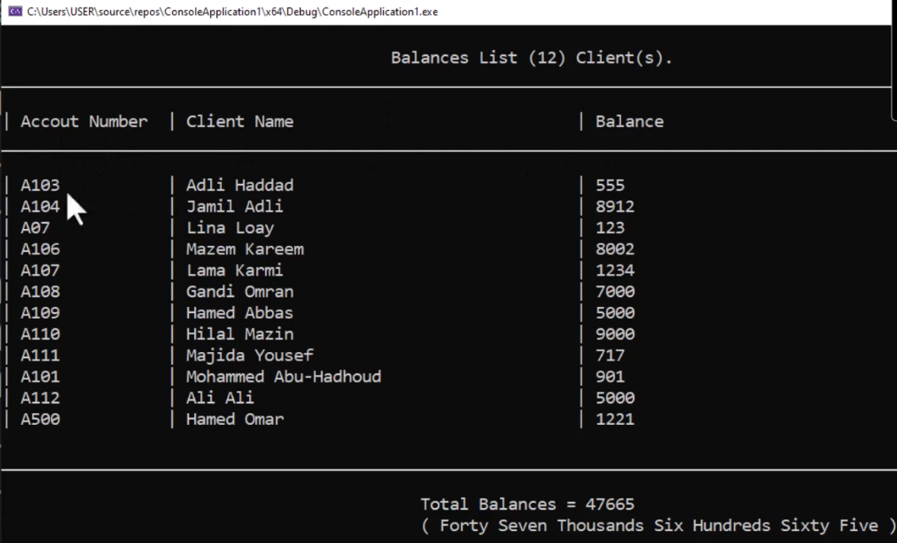

|  |  |
| --- | --- |
| جينا في كلاس ال util وزودنا ال function دي | static string NumberToText(int Number) {  if (Number == 0) {  return ";";  }  if (Number>=1&&Number<=19) {  string arr[] = { "", "One","Two","Three","Four","Five","Six","Seven",  "Eight","Nine","Ten","Eleven","Twelve","Thirteen","Fourteen",  "Fifteen","Sixteen","Seventeen","Eighteen","Nineteen" };  return arr[Number] + " ";  }  if (Number>=20&&Number<=99) {  string arr[] = { "","","Twenty","Thirty","Forty","Fifty","Sixty","Seventy","Eighty","Ninety" };  return arr[Number / 10] + " " + NumberToText(Number%10);  }  if (Number >= 100 && Number <= 199)  {  return "One Hundred " + NumberToText(Number % 100);  }  if (Number >= 200 && Number <= 999)  {  return NumberToText(Number / 100) + "Hundreds " + NumberToText(Number % 100);  }  if (Number >= 1000 && Number <= 1999)  {  return "One Thousand " + NumberToText(Number % 1000);  }  if (Number >= 2000 && Number <= 999999)  {  return NumberToText(Number / 1000) + "Thousands " + NumberToText(Number % 1000);  }  if (Number >= 1000000 && Number <= 1999999)  {  return "One Million " + NumberToText(Number % 1000000);  }  if (Number >= 2000000 && Number <= 999999999)  {  return NumberToText(Number / 1000000) + "Millions " + NumberToText(Number % 1000000);  }  if (Number >= 1000000000 && Number <= 1999999999)  {  return "One Billion " + NumberToText(Number % 1000000000);  }  else  {  return NumberToText(Number / 1000000000) + "Billions " + NumberToText(Number % 1000000000);  }  } |
| في كلاس ال client زودنا ال function دي  يدوب بيلف عالعملاء يجمع الارصده ويرجعهالك | static double GetTotalBalances() {  vector<clsBankClient>vClients = GetClientsList();  double TotalBalances = 0;  for (clsBankClient &C:vClients) {  TotalBalances += C.AccountBalance;  }  return TotalBalances;  } |
| وده الكود اللي في ال main مجرد جمل طباعه | #include <iostream>  #include "clsBankClient.h"  #include "clsInputValidate.h"  #include <iomanip>  #include "clsUtil.h"  void PrintClientRecordBalanceLine(clsBankClient Client)  {  cout << "| " << setw(15) << left << Client.get_AccountNumber();  cout << "| " << setw(40) << left << Client.get_FullName();  cout << "| " << setw(12) << left << Client.AccountBalance;  }  void ShowTotalBalances()  {  vector <clsBankClient> vClients = clsBankClient::GetClientsList();  cout << "\n\t\t\t\t\tBalances List (" << vClients.size() << ") Client(s).";  cout << "\n_______________________________________________________";  cout << "_________________________________________\n" << endl;  cout << "| " << left << setw(15) << "Accout Number";  cout << "| " << left << setw(40) << "Client Name";  cout << "| " << left << setw(12) << "Balance";  cout << "\n_______________________________________________________";  cout << "_________________________________________\n" << endl;  double TotalBalances = clsBankClient::GetTotalBalances();  if (vClients.size() == 0)  cout << "\t\t\t\tNo Clients Available In the System!";  else  for (clsBankClient Client : vClients)  {  PrintClientRecordBalanceLine(Client);  cout << endl;  }  cout << "\n_______________________________________________________";  cout << "_________________________________________\n" << endl;  cout << "\t\t\t\t\t Total Balances = " << TotalBalances << endl;  cout << "\t\t\t\t\t ( " << clsUtil::NumberToText(TotalBalances) << ")";  }  int main()  {  ShowTotalBalances();  system("pause>0");  return 0;  } |

**Lesson 7 - Main Screen**

من هنا هنبدأ نشتغل عال ui اللي هوا ال user interface او واجهة المستخدم

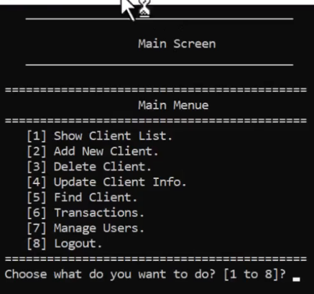

احنا لسه مااشتغلناش علي اكواد الشاشات التانيه فعايزين لما نختار رقم تطلع الشاشه دي

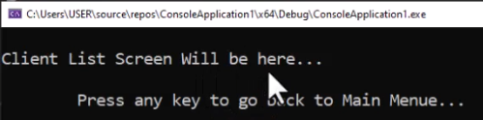

اول حاجه هنعملها هوا كلاس هيكون مشترك بين كل الشاشات والشاشات التانيه هتورث منه

وظيفته انه يعرض ال header بتاع كل شاشه بدل ماتكرر الكود بتاعك هيكون فيه function بتاخد منك العنوان وتعرضه

|  |
| --- |
| #pragma once  #include<iostream>  using namespace std;  class clsScreen  {  protected:  static void _DrawScreenHeader(string Title,string SubTitle) {    cout << "\t\t\t\t\t______________________________________";  cout << "\n\n\t\t\t\t\t " << Title;  if (SubTitle != "")  {  cout << "\n\t\t\t\t\t " << SubTitle;  }  cout << "\n\t\t\t\t\t______________________________________\n\n";  }  }; |

ده كود كلاس ال input validate

|  |
| --- |
| //ProgrammingAdivces.com  //Mohammed Abu-Hadhoud  #pragma once  #include <iostream>  #include <string>  #include "clsString.h"  #include "clsDate.h"  class clsInputValidate  {  public:  static bool IsNumberBetween(int Number, int From, int To)  {  if (Number >= From && Number <= To)  return true;  else  return false;  }  static bool IsNumberBetween(double Number, double From, double To)  {  if (Number >= From && Number <= To)  return true;  else  return false;  }  static bool IsDateBetween(clsDate Date, clsDate From, clsDate To)  {  //Date>=From && Date<=To  if ((clsDate::IsDate1AfterDate2(Date, From) || clsDate::IsDate1EqualDate2(Date, From))  &&  (clsDate::IsDate1BeforeDate2(Date, To) || clsDate::IsDate1EqualDate2(Date, To))  )  {  return true;  }  //Date>=To && Date<=From  if ((clsDate::IsDate1AfterDate2(Date, To) || clsDate::IsDate1EqualDate2(Date, To))  &&  (clsDate::IsDate1BeforeDate2(Date, From) || clsDate::IsDate1EqualDate2(Date, From))  )  {  return true;  }  return false;  }  static short ReadShortNumber(string ErrorMessage = "Invalid Number, Enter again\n")  {  short Number;  while (!(cin >> Number)) {  cin.clear();  cin.ignore(numeric_limits<streamsize>::max(), '\n');  cout << ErrorMessage;  }  return Number;  }  static int ReadIntNumber(string ErrorMessage = "Invalid Number, Enter again\n")  {  int Number;  while (!(cin >> Number)) {  cin.clear();  cin.ignore(numeric_limits<streamsize>::max(), '\n');  cout << ErrorMessage;  }  return Number;  }  static short ReadShortNumberBetween(short From, short To, string ErrorMessage = "Number is not within range, Enter again:\n")  {  int Number = ReadShortNumber();  while (!IsNumberBetween(Number, From, To))  {  cout << ErrorMessage;  Number = ReadShortNumber();  }  return Number;  }  static int ReadIntNumberBetween(int From, int To, string ErrorMessage = "Number is not within range, Enter again:\n")  {  int Number = ReadIntNumber();  while (!IsNumberBetween(Number, From, To))  {  cout << ErrorMessage;  Number = ReadIntNumber();  }  return Number;  }  static double ReadFloatNumber(string ErrorMessage = "Invalid Number, Enter again\n")  {  float Number;  while (!(cin >> Number)) {  cin.clear();  cin.ignore(numeric_limits<streamsize>::max(), '\n');  cout << ErrorMessage;  }  return Number;  }  static double ReadFloatNumberBetween(double From, double To, string ErrorMessage = "Number is not within range, Enter again:\n")  {  float Number = ReadFloatNumber();  while (!IsNumberBetween(Number, From, To)) {  cout << ErrorMessage;  Number = ReadDblNumber();  }  return Number;  }  static double ReadDblNumber(string ErrorMessage = "Invalid Number, Enter again\n")  {  double Number;  while (!(cin >> Number)) {  cin.clear();  cin.ignore(numeric_limits<streamsize>::max(), '\n');  cout << ErrorMessage;  }  return Number;  }  static double ReadDblNumberBetween(double From, double To, string ErrorMessage = "Number is not within range, Enter again:\n")  {  double Number = ReadDblNumber();  while (!IsNumberBetween(Number, From, To)) {  cout << ErrorMessage;  Number = ReadDblNumber();  }  return Number;  }  static bool IsValideDate(clsDate Date)  {  return clsDate::IsValidDate(Date);  }  static string ReadString()  {  string S1 = "";  // Usage of std::ws will extract allthe whitespace character  getline(cin >> ws, S1);  return S1;  }  }; |

بعد كده هنيجي لكود الشاشه الرئيسيه والكود هوا نفسه اللي كنا عاملينه قبل كده

بس هنيجي عند كل function خاصه بشاشه معينه وهنحط الكود ده

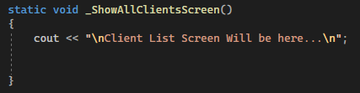

|  |
| --- |
| #pragma once  #include <iostream>  #include "clsScreen.h"  #include "clsInputValidate.h"  #include <iomanip>  using namespace std;  class clsMainScreen :protected clsScreen  {  private:  enum enMainMenueOptions {  eListClients = 1, eAddNewClient = 2, eDeleteClient = 3,  eUpdateClient = 4, eFindClient = 5, eShowTransactionsMenue = 6,  eManageUsers = 7, eExit = 8  };  static short _ReadMainMenueOption()  {  cout << setw(37) << left << "" << "Choose what do you want to do? [1 to 8]? ";  short Choice = clsInputValidate::ReadShortNumberBetween(1, 8, "Enter Number between 1 to 8? ");  return Choice;  }  static void _GoBackToMainMenue()  {  cout << setw(37) << left << "" << "\n\tPress any key to go back to Main Menue...\n";  system("pause>0");  ShowMainMenue();  }  static void _ShowAllClientsScreen()  {  cout << "\nClient List Screen Will be here...\n";  }  static void _ShowAddNewClientsScreen()  {  cout << "\nAdd New Client Screen Will be here...\n";  }  static void _ShowDeleteClientScreen()  {  cout << "\nDelete Client Screen Will be here...\n";  }  static void _ShowUpdateClientScreen()  {  cout << "\nUpdate Client Screen Will be here...\n";  }  static void _ShowFindClientScreen()  {  cout << "\nFind Client Screen Will be here...\n";  }  static void _ShowTransactionsMenue()  {  cout << "\nTransactions Menue Will be here...\n";  }  static void _ShowManageUsersMenue()  {  cout << "\nUsers Menue Will be here...\n";  }  static void _ShowEndScreen()  {  cout << "\nEnd Screen Will be here...\n";  }  static void _PerfromMainMenueOption(enMainMenueOptions MainMenueOption)  {  switch (MainMenueOption)  {  case enMainMenueOptions::eListClients:  {  system("cls");  _ShowAllClientsScreen();  _GoBackToMainMenue();  break;  }  case enMainMenueOptions::eAddNewClient:  system("cls");  _ShowAddNewClientsScreen();  _GoBackToMainMenue();  break;  case enMainMenueOptions::eDeleteClient:  system("cls");  _ShowDeleteClientScreen();  _GoBackToMainMenue();  break;  case enMainMenueOptions::eUpdateClient:  system("cls");  _ShowUpdateClientScreen();  _GoBackToMainMenue();  break;  case enMainMenueOptions::eFindClient:  system("cls");  _ShowFindClientScreen();  _GoBackToMainMenue();  break;  case enMainMenueOptions::eShowTransactionsMenue:  system("cls");  _ShowTransactionsMenue();  _GoBackToMainMenue();  break;  case enMainMenueOptions::eManageUsers:  system("cls");  _ShowManageUsersMenue();  _GoBackToMainMenue();  break;  case enMainMenueOptions::eExit:  system("cls");  _ShowEndScreen();  //Login();  break;  }  }  public:  static void ShowMainMenue()  {  system("cls");  _DrawScreenHeader("\t\tMain Screen","");  cout << setw(37) << left << "" << "===========================================\n";  cout << setw(37) << left << "" << "\t\t\tMain Menue\n";  cout << setw(37) << left << "" << "===========================================\n";  cout << setw(37) << left << "" << "\t[1] Show Client List.\n";  cout << setw(37) << left << "" << "\t[2] Add New Client.\n";  cout << setw(37) << left << "" << "\t[3] Delete Client.\n";  cout << setw(37) << left << "" << "\t[4] Update Client Info.\n";  cout << setw(37) << left << "" << "\t[5] Find Client.\n";  cout << setw(37) << left << "" << "\t[6] Transactions.\n";  cout << setw(37) << left << "" << "\t[7] Manage Users.\n";  cout << setw(37) << left << "" << "\t[8] Logout.\n";  cout << setw(37) << left << "" << "===========================================\n";  _PerfromMainMenueOption((enMainMenueOptions)_ReadMainMenueOption());  }  }; |

وفي ال main هنشغل الشاشه

|  |
| --- |
| #include <iostream>  #include "clsMainScreen.h"  int main()  {  clsMainScreen::ShowMainMenue();  system("pause>0");  return 0;  } |

**Lesson 8 - List Clients Screen**

هنا هنعمل الشاشه بتاعت show client list

هنعمل كلاس خاص بالشاشه دي وبعدين نروح نشغلها من الشاشه الرئيسيه

ده الكود بتاع الشاشه

|  |
| --- |
| #pragma once  #include <iostream>  #include "clsScreen.h"  #include "clsBankClient.h"  #include <iomanip>  class clsClientListScreen :protected clsScreen  {  private:  static void PrintClientRecordLine(clsBankClient Client)  {  cout << setw(8) << left << "" << "| " << setw(15) << left << Client.get_AccountNumber();  cout << "| " << setw(20) << left << Client.get_FullName();  cout << "| " << setw(12) << left << Client.Phone;  cout << "| " << setw(20) << left << Client.Email;  cout << "| " << setw(10) << left << Client.PinCode;  cout << "| " << setw(12) << left << Client.AccountBalance;  }  public:  static void ShowClientsList()  {  vector <clsBankClient> vClients = clsBankClient::GetClientsList();  string Title = "\t Client List Screen";  string SubTitle = "\t (" + to_string(vClients.size()) + ") Client(s).";  _DrawScreenHeader(Title, SubTitle);  cout << setw(8) << left << "" << "\n\t_______________________________________________________";  cout << "_________________________________________\n" << endl;  cout << setw(8) << left << "" << "| " << left << setw(15) << "Accout Number";  cout << "| " << left << setw(20) << "Client Name";  cout << "| " << left << setw(12) << "Phone";  cout << "| " << left << setw(20) << "Email";  cout << "| " << left << setw(10) << "Pin Code";  cout << "| " << left << setw(12) << "Balance";  cout << setw(8) << left << "" << "\n\t_______________________________________________________";  cout << "_________________________________________\n" << endl;  if (vClients.size() == 0)  cout << "\t\t\t\tNo Clients Available In the System!";  else  for (clsBankClient Client : vClients)  {  PrintClientRecordLine(Client);  cout << endl;  }  cout << setw(8) << left << "" << "\n\t_______________________________________________________";  cout << "_________________________________________\n" << endl;  }  }; |

وده التعديل اللي عملناه في الشاشه الرئيسيه

|  |
| --- |
| static void _ShowAllClientsScreen()  {  // cout << "\nClient List Screen Will be here...\n";  clsClientListScreen::ShowClientsList();  } |

**Lesson 9 - Add New Client Screen**

هنعمل الشاشه بتاعت اضافه عميل جديد

ال function بتاعت الطباعه اللي ي كلاس ال client شيلناها وحطيناها هنا عشان نفسل الاكواد الخاصه بال ui عن الاكواد الخاصه بالداتا

|  |
| --- |
| #pragma once  #include <iostream>  #include "clsScreen.h"  #include "clsBankClient.h"  #include "clsInputValidate.h"  #include <iomanip>  class clsAddNewClientScreen : protected clsScreen  {  private:  static void _ReadClientInfo(clsBankClient& Client)  {  cout << "\nEnter FirstName: ";  Client.FirstName = clsInputValidate::ReadString();  cout << "\nEnter LastName: ";  Client.LastName = clsInputValidate::ReadString();  cout << "\nEnter Email: ";  Client.Email = clsInputValidate::ReadString();  cout << "\nEnter Phone: ";  Client.Phone = clsInputValidate::ReadString();  cout << "\nEnter PinCode: ";  Client.PinCode = clsInputValidate::ReadString();  cout << "\nEnter Account Balance: ";  Client.AccountBalance = clsInputValidate::ReadFloatNumber();  }  static void _PrintClient(clsBankClient Client)  {  cout << "\nClient Card:";  cout << "\n___________________";  cout << "\nFirstName : " << Client.FirstName;  cout << "\nLastName : " << Client.LastName;  cout << "\nFull Name : " << Client.get_FullName();  cout << "\nEmail : " << Client.Email;  cout << "\nPhone : " << Client.Phone;  cout << "\nAcc. Number : " << Client.get_AccountNumber();  cout << "\nPassword : " << Client.PinCode;  cout << "\nBalance : " << Client.AccountBalance;  cout << "\n___________________\n";  }  public:  static void ShowAddNewClientScreen()  {  _DrawScreenHeader("\t Add New Client Screen","");  string AccountNumber = "";  cout << "\nPlease Enter Account Number: ";  AccountNumber = clsInputValidate::ReadString();  while (clsBankClient::IsClientExist(AccountNumber))  {  cout << "\nAccount Number Is Already Used, Choose another one: ";  AccountNumber = clsInputValidate::ReadString();  }  clsBankClient NewClient = clsBankClient::GetAddNewClientObject(AccountNumber);  _ReadClientInfo(NewClient);  clsBankClient::enSaveResults SaveResult;  SaveResult = NewClient.save();  switch (SaveResult)  {  case clsBankClient::enSaveResults::svSucceeded:  {  cout << "\nAccount Addeded Successfully :-)\n";  _PrintClient(NewClient);  break;  }  case clsBankClient::enSaveResults::svFailedEmptyObject:  {  cout << "\nError account was not saved because it's Empty";  break;  }  case clsBankClient::enSaveResults::svFaildAccountNumberExists:  {  cout << "\nError account was not saved because account number is used!\n";  break;  }  }  }  }; |

وده التعديل اللي عملناه في كود الشاشه الرئيسيه

|  |
| --- |
| static void _ShowAddNewClientsScreen()  {  // cout << "\nAdd New Client Screen Will be here...\n";  clsAddNewClientScreen::ShowAddNewClientScreen();  } |

**Lesson 10 - Delete Client Screen**

شاشة الحذف

|  |
| --- |
| #pragma once  #include <iostream>  #include "clsScreen.h"  #include "clsPerson.h"  #include "clsBankClient.h"  #include "clsInputValidate.h"  class clsDeleteClientScreen :protected clsScreen  {  private:  static void _PrintClient(clsBankClient Client)  {  cout << "\nClient Card:";  cout << "\n___________________";  cout << "\nFirstName : " << Client.FirstName;  cout << "\nLastName : " << Client.LastName;  cout << "\nFull Name : " << Client.get_FullName();  cout << "\nEmail : " << Client.Email;  cout << "\nPhone : " << Client.Phone;  cout << "\nAcc. Number : " << Client.get_AccountNumber();  cout << "\nPassword : " << Client.PinCode;  cout << "\nBalance : " << Client.AccountBalance;  cout << "\n___________________\n";  }  public:  static void ShowDeleteClientScreen()  {  _DrawScreenHeader("\tDelete Client Screen","");  string AccountNumber = "";  cout << "\nPlease Enter Account Number: ";  AccountNumber = clsInputValidate::ReadString();  while (!clsBankClient::IsClientExist(AccountNumber))  {  cout << "\nAccount number is not found, choose another one: ";  AccountNumber = clsInputValidate::ReadString();  }  clsBankClient Client1 = clsBankClient::Find(AccountNumber);  _PrintClient(Client1);  cout << "\nAre you sure you want to delete this client y/n? ";  char Answer = 'n';  cin >> Answer;  if (Answer == 'y' || Answer == 'Y')  {  if (Client1.Delete())  {  cout << "\nClient Deleted Successfully :-)\n";  _PrintClient(Client1);  }  else  {  cout << "\nError Client Was not Deleted\n";  }  }  }  }; |

وده التعديل اللي عملناه في كود الشاشه الرئيسيه

|  |
| --- |
| static void _ShowDeleteClientScreen()  {  //cout << "\nDelete Client Screen Will be here...\n";  clsDeleteClientScreen::ShowDeleteClientScreen();  } |

**Lesson 11 - Update Client Screen**

شاشة ال update

|  |
| --- |
| #pragma once  #include <iostream>  #include "clsScreen.h"  #include "clsPerson.h"  #include "clsBankClient.h"  #include "clsInputValidate.h"  class clsUpdateClientScreen :protected clsScreen  {  private:  static void _PrintClient(clsBankClient Client)  {  cout << "\nClient Card:";  cout << "\n___________________";  cout << "\nFirstName : " << Client.FirstName;  cout << "\nLastName : " << Client.LastName;  cout << "\nFull Name : " << Client.get_FullName();  cout << "\nEmail : " << Client.Email;  cout << "\nPhone : " << Client.Phone;  cout << "\nAcc. Number : " << Client.get_AccountNumber();  cout << "\nPassword : " << Client.PinCode;  cout << "\nBalance : " << Client.AccountBalance;  cout << "\n___________________\n";  }  static void ReadClientInfo(clsBankClient& Client)  {  cout << "\nEnter FirstName: ";  Client.FirstName = clsInputValidate::ReadString();  cout << "\nEnter LastName: ";  Client.LastName = clsInputValidate::ReadString();  cout << "\nEnter Email: ";  Client.Email = clsInputValidate::ReadString();  cout << "\nEnter Phone: ";  Client.Phone = clsInputValidate::ReadString();  cout << "\nEnter PinCode: ";  Client.PinCode = clsInputValidate::ReadString();  cout << "\nEnter Account Balance: ";  Client.AccountBalance = clsInputValidate::ReadFloatNumber();  }  public:  static void ShowUpdateClientScreen()  {  _DrawScreenHeader("\tUpdate Client Screen","");  string AccountNumber = "";  cout << "\nPlease Enter client Account Number: ";  AccountNumber = clsInputValidate::ReadString();  while (!clsBankClient::IsClientExist(AccountNumber))  {  cout << "\nAccount number is not found, choose another one: ";  AccountNumber = clsInputValidate::ReadString();  }  clsBankClient Client1 = clsBankClient::Find(AccountNumber);  _PrintClient(Client1);  cout << "\nAre you sure you want to update this client y/n? ";  char Answer = 'n';  cin >> Answer;  if (Answer == 'y' || Answer == 'Y')  {  cout << "\n\nUpdate Client Info:";  cout << "\n____________________\n";  ReadClientInfo(Client1);  clsBankClient::enSaveResults SaveResult;  SaveResult = Client1.save();  switch (SaveResult)  {  case clsBankClient::enSaveResults::svSucceeded:  {  cout << "\nAccount Updated Successfully :-)\n";  _PrintClient(Client1);  break;  }  case clsBankClient::enSaveResults::svFailedEmptyObject:  {  cout << "\nError account was not saved because it's Empty";  break;  }  }  }  }  }; |

وده التعديل اللي عملناه في كود الشاشه الرئيسيه

|  |
| --- |
| static void _ShowUpdateClientScreen()  {  //cout << "\nUpdate Client Screen Will be here...\n";  clsUpdateClientScreen::ShowUpdateClientScreen();  } |

**Lesson 12 - Find Client Screen**

شاشة البحث

|  |
| --- |
| #pragma once  #include <iostream>  #include "clsScreen.h"  #include "clsPerson.h"  #include "clsBankClient.h"  #include "clsInputValidate.h"  class clsFindClientScreen :protected clsScreen  {  private:  static void _PrintClient(clsBankClient Client)  {  cout << "\nClient Card:";  cout << "\n___________________";  cout << "\nFirstName : " << Client.FirstName;  cout << "\nLastName : " << Client.LastName;  cout << "\nFull Name : " << Client.get_FullName();  cout << "\nEmail : " << Client.Email;  cout << "\nPhone : " << Client.Phone;  cout << "\nAcc. Number : " << Client.get_AccountNumber();  cout << "\nPassword : " << Client.PinCode;  cout << "\nBalance : " << Client.AccountBalance;  cout << "\n___________________\n";  }  public:  static void ShowFindClientScreen()  {  _DrawScreenHeader("\tFind Client Screen","");  string AccountNumber;  cout << "\nPlease Enter Account Number: ";  AccountNumber = clsInputValidate::ReadString();  while (!clsBankClient::IsClientExist(AccountNumber))  {  cout << "\nAccount number is not found, choose another one: ";  AccountNumber = clsInputValidate::ReadString();  }  clsBankClient Client1 = clsBankClient::Find(AccountNumber);  if (!Client1.IsEmpty())  {  cout << "\nClient Found :-)\n";  }  else  {  cout << "\nClient Was not Found :-(\n";  }  _PrintClient(Client1);  }  }; |

وده التعديل اللي عملناه في كود الشاشه الرئيسيه

|  |
| --- |
| static void _ShowFindClientScreen()  {  // cout << "\nFind Client Screen Will be here...\n";  clsFindClientScreen::ShowFindClientScreen();  } |

**Lesson 13 - Transactions Screen**

هنا هنعمل ال sub menu بتاعت ال transactions

ده الكود بتاع ال transaction menu

|  |
| --- |
| #pragma once  #include <iostream>  #include "clsScreen.h"  #include "clsInputValidate.h"  #include <iomanip>  using namespace std;  class clsTransactionsScreen :protected clsScreen  {  private:  enum enTransactionsMenueOptions {  eDeposit = 1, eWithdraw = 2,  eShowTotalBalance = 3, eShowMainMenue = 4  };  static short ReadTransactionsMenueOption()  {  cout << setw(37) << left << "" << "Choose what do you want to do? [1 to 4]? ";  short Choice = clsInputValidate::ReadShortNumberBetween(1, 4, "Enter Number between 1 to 4? ");  return Choice;  }  static void _ShowDepositScreen()  {  cout << "\n Deposit Screen will be here.\n";  }  static void _ShowWithdrawScreen()  {  cout << "\n Withdraw Screen will be here.\n";  }  static void _ShowTotalBalancesScreen()  {  cout << "\n Balances Screen will be here.\n";  }  static void _GoBackToTransactionsMenue()  {  cout << "\n\nPress any key to go back to Transactions Menue...";  system("pause>0");  ShowTransactionsMenue();  }  static void _PerformTransactionsMenueOption(enTransactionsMenueOptions TransactionsMenueOption)  {  switch (TransactionsMenueOption)  {  case enTransactionsMenueOptions::eDeposit:  {  system("cls");  _ShowDepositScreen();  _GoBackToTransactionsMenue();  break;  }  case enTransactionsMenueOptions::eWithdraw:  {  system("cls");  _ShowWithdrawScreen();  _GoBackToTransactionsMenue();  break;  }  case enTransactionsMenueOptions::eShowTotalBalance:  {  system("cls");  _ShowTotalBalancesScreen();  _GoBackToTransactionsMenue();  break;  }  case enTransactionsMenueOptions::eShowMainMenue:  {  //do nothing here the main screen will handle it :-) ;  }  }  }  public:  static void ShowTransactionsMenue()  {  system("cls");  _DrawScreenHeader("\t Transactions Screen","");  cout << setw(37) << left << "" << "===========================================\n";  cout << setw(37) << left << "" << "\t\t Transactions Menue\n";  cout << setw(37) << left << "" << "===========================================\n";  cout << setw(37) << left << "" << "\t[1] Deposit.\n";  cout << setw(37) << left << "" << "\t[2] Withdraw.\n";  cout << setw(37) << left << "" << "\t[3] Total Balances.\n";  cout << setw(37) << left << "" << "\t[4] Main Menue.\n";  cout << setw(37) << left << "" << "===========================================\n";  _PerformTransactionsMenueOption((enTransactionsMenueOptions)ReadTransactionsMenueOption());  }  }; |

وده التعديل اللي عملناه في كود الشاشه الرئيسيه

|  |
| --- |
| static void _ShowTransactionsMenue()  {  // cout << "\nTransactions Menue Will be here...\n";  clsTransactionsScreen::ShowTransactionsMenue();  } |

**Lesson 14 - Deposit Screen**

هنعمل ال deposit screen اللي في ال transactions menu

بنفس الطرق اللي فاتت

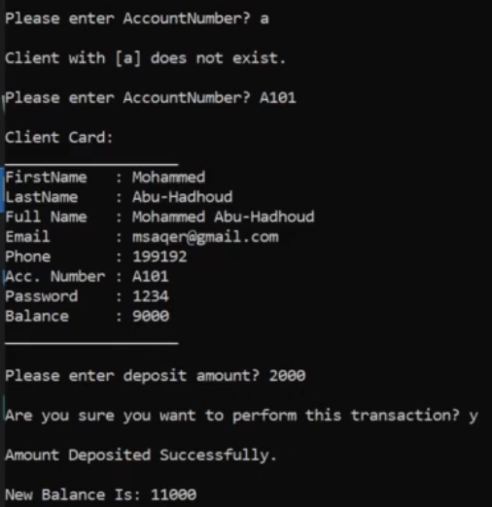

قبل مانعمل الشاشه هندخل علي كلاس ال client ونحط فيه function خاصه بالايداع لانها خاصه بالداتا ملهاش علاقه بال ui

فجينا جوه كلاس ال client وزودنا عليه عملية الإيداع والسحب

|  |
| --- |
| void Deposit(double Amount)  {  _AccountBalance += Amount;  save();  }  void Withdraw(double Amount)  {  _AccountBalance -= Amount;  save();  } |

ده الكود بتاع ال deposit screen

|  |
| --- |
| #pragma once  #include <iostream>  #include "clsScreen.h"  #include "clsBankClient.h"  #include "clsInputValidate.h"  class clsDepositScreen : protected clsScreen  {  private:  static void _PrintClient(clsBankClient Client)  {  cout << "\nClient Card:";  cout << "\n___________________";  cout << "\nFirstName : " << Client.FirstName;  cout << "\nLastName : " << Client.LastName;  cout << "\nFull Name : " << Client.get_FullName();  cout << "\nEmail : " << Client.Email;  cout << "\nPhone : " << Client.Phone;  cout << "\nAcc. Number : " << Client.get_AccountNumber();  cout << "\nPassword : " << Client.PinCode;  cout << "\nBalance : " << Client.AccountBalance;  cout << "\n___________________\n";  }  static string _ReadAccountNumber()  {  string AccountNumber = "";  cout << "\nPlease enter AccountNumber? ";  cin >> AccountNumber;  return AccountNumber;  }  public:  static void ShowDepositScreen()  {  _DrawScreenHeader("\t Deposit Screen","");  string AccountNumber = _ReadAccountNumber();  while (!clsBankClient::IsClientExist(AccountNumber))  {  cout << "\nClient with [" << AccountNumber << "] does not exist.\n";  AccountNumber = _ReadAccountNumber();  }  clsBankClient Client1 = clsBankClient::Find(AccountNumber);  _PrintClient(Client1);  double Amount = 0;  cout << "\nPlease enter deposit amount? ";  Amount = clsInputValidate::ReadDblNumber();  cout << "\nAre you sure you want to perform this transaction? ";  char Answer = 'n';  cin >> Answer;  if (Answer == 'Y' || Answer == 'y')  {  Client1.Deposit(Amount);  cout << "\nAmount Deposited Successfully.\n";  cout << "\nNew Balance Is: " << Client1.AccountBalance;  }  else  {  cout << "\nOperation was cancelled.\n";  }  }  }; |

وده التعديل اللي عملناه في شاشة ال transactions

|  |
| --- |
| static void _ShowDepositScreen()  {  //cout << "\n Deposit Screen will be here.\n";  clsDepositScreen::ShowDepositScreen();  } |

**Lesson 15 - Withdraw Screen**

هنعمل تعديل علي ال function بتاعت ال withdrow بحيث انه مايقدرش يسحب اكتر من رصيده

|  |
| --- |
| bool Withdraw(double Amount)  {  if (Amount > _AccountBalance)  {  return false;  }  else  {  _AccountBalance -= Amount;  save();  return true;  }  } |

ده الكود بتاع شاشة السحب

|  |
| --- |
| #pragma once  #include <iostream>  #include "clsScreen.h"  #include "clsBankClient.h"  #include "clsInputValidate.h"  class clsWithdrawScreen : protected clsScreen  {  private:  static void _PrintClient(clsBankClient Client)  {  cout << "\nClient Card:";  cout << "\n___________________";  cout << "\nFirstName : " << Client.FirstName;  cout << "\nLastName : " << Client.LastName;  cout << "\nFull Name : " << Client.get_FullName();  cout << "\nEmail : " << Client.Email;  cout << "\nPhone : " << Client.Phone;  cout << "\nAcc. Number : " << Client.get_AccountNumber();  cout << "\nPassword : " << Client.PinCode;  cout << "\nBalance : " << Client.AccountBalance;  cout << "\n___________________\n";  }  static string _ReadAccountNumber()  {  string AccountNumber = "";  cout << "\nPlease enter AccountNumber? ";  cin >> AccountNumber;  return AccountNumber;  }  public:  static void ShowWithdrawScreen()  {  _DrawScreenHeader("\t Withdraw Screen","");  string AccountNumber = _ReadAccountNumber();  while (!clsBankClient::IsClientExist(AccountNumber))  {  cout << "\nClient with [" << AccountNumber << "] does not exist.\n";  AccountNumber = _ReadAccountNumber();  }  clsBankClient Client1 = clsBankClient::Find(AccountNumber);  _PrintClient(Client1);  double Amount = 0;  cout << "\nPlease enter Withdraw amount? ";  Amount = clsInputValidate::ReadDblNumber();  cout << "\nAre you sure you want to perform this transaction? ";  char Answer = 'n';  cin >> Answer;  if (Answer == 'Y' || Answer == 'y')  {  if (Client1.Withdraw(Amount))  {  cout << "\nAmount Withdrew Successfully.\n";  cout << "\nNew Balance Is: " << Client1.AccountBalance;  }  else  {  cout << "\nCannot withdraw, Insuffecient Balance!\n";  cout << "\nAmout to withdraw is: " << Amount;  cout << "\nYour Balance is: " << Client1.AccountBalance;  }  }  else  {  cout << "\nOperation was cancelled.\n";  }  }  }; |

وده التعديل علي شاشة ال transactions

|  |
| --- |
| static void _ShowWithdrawScreen()  {  //cout << "\n Withdraw Screen will be here.\n";  clsWithdrawScreen::ShowWithdrawScreen();  } |

**Lesson 16 - Total Balances Screen**

ده كود شاشه ال total balances

|  |
| --- |
| #pragma once  #include <iostream>  #include "clsScreen.h"  #include "clsBankClient.h"  #include <iomanip>  #include "clsUtil.h"  class clsTotalBalancesScreen : protected clsScreen  {  private:  static void PrintClientRecordBalanceLine(clsBankClient Client)  {  cout << setw(25) << left << "" << "| " << setw(15) << left << Client.get_AccountNumber();  cout << "| " << setw(40) << left << Client.get_FullName();  cout << "| " << setw(12) << left << Client.AccountBalance;  }  public:  static void ShowTotalBalances()  {  vector <clsBankClient> vClients = clsBankClient::GetClientsList();  string Title = "\t Balances List Screen";  string SubTitle = "\t (" + to_string(vClients.size()) + ") Client(s).";  _DrawScreenHeader(Title, SubTitle);  cout << setw(25) << left << "" << "\n\t\t_______________________________________________________";  cout << "__________________________\n" << endl;  cout << setw(25) << left << "" << "| " << left << setw(15) << "Accout Number";  cout << "| " << left << setw(40) << "Client Name";  cout << "| " << left << setw(12) << "Balance";  cout << setw(25) << left << "" << "\t\t_______________________________________________________";  cout << "__________________________\n" << endl;  double TotalBalances = clsBankClient::GetTotalBalances();  if (vClients.size() == 0)  cout << "\t\t\t\tNo Clients Available In the System!";  else  for (clsBankClient Client : vClients)  {  PrintClientRecordBalanceLine(Client);  cout << endl;  }  cout << setw(25) << left << "" << "\n\t\t_______________________________________________________";  cout << "__________________________\n" << endl;  cout << setw(8) << left << "" << "\t\t\t\t\t\t\t Total Balances = " << TotalBalances << endl;  cout << setw(8) << left << "" << "\t\t\t\t ( " << clsUtil::NumberToText(TotalBalances) << ")";  }  }; |

وده التعديل علي شاشة ال transactions

|  |
| --- |
| static void _ShowTotalBalancesScreen()  {  // cout << "\n Balances Screen will be here.\n";  clsTotalBalancesScreen::ShowTotalBalances();  } |

**Lesson 17 - Manage Users Screen**

هنعمل القايمه بتاعت ال manage users

ده الكود بتاع الشاشه manage users

|  |
| --- |
| #pragma once  #include <iostream>  #include "clsScreen.h"  #include "clsInputValidate.h"  #include <iomanip>  using namespace std;  class clsManageUsersScreen :protected clsScreen  {  private:  enum enManageUsersMenueOptions {  eListUsers = 1, eAddNewUser = 2, eDeleteUser = 3,  eUpdateUser = 4, eFindUser = 5, eMainMenue = 6  };  static short ReadManageUsersMenueOption()  {  cout << setw(37) << left << "" << "Choose what do you want to do? [1 to 6]? ";  short Choice = clsInputValidate::ReadShortNumberBetween(1, 6, "Enter Number between 1 to 6? ");  return Choice;  }  static void _GoBackToManageUsersMenue()  {  cout << "\n\nPress any key to go back to Manage Users Menue...";  system("pause>0");  ShowManageUsersMenue();  }  static void _ShowListUsersScreen()  {  cout << "\nList Users Screen Will Be Here.\n";  }  static void _ShowAddNewUserScreen()  {  cout << "\nAdd New User Screen Will Be Here.\n";  }  static void _ShowDeleteUserScreen()  {  cout << "\nDelete User Screen Will Be Here.\n";  }  static void _ShowUpdateUserScreen()  {  cout << "\nUpdate User Screen Will Be Here.\n";  }  static void _ShowFindUserScreen()  {  cout << "\nFind User Screen Will Be Here.\n";  }  static void _PerformManageUsersMenueOption(enManageUsersMenueOptions ManageUsersMenueOption)  {  switch (ManageUsersMenueOption)  {  case enManageUsersMenueOptions::eListUsers:  {  system("cls");  _ShowListUsersScreen();  _GoBackToManageUsersMenue();  break;  }  case enManageUsersMenueOptions::eAddNewUser:  {  system("cls");  _ShowAddNewUserScreen();  _GoBackToManageUsersMenue();  break;  }  case enManageUsersMenueOptions::eDeleteUser:  {  system("cls");  _ShowDeleteUserScreen();  _GoBackToManageUsersMenue();  break;  }  case enManageUsersMenueOptions::eUpdateUser:  {  system("cls");  _ShowUpdateUserScreen();  _GoBackToManageUsersMenue();  break;  }  case enManageUsersMenueOptions::eFindUser:  {  system("cls");  _ShowFindUserScreen();  _GoBackToManageUsersMenue();  break;  }  case enManageUsersMenueOptions::eMainMenue:  {  //do nothing here the main screen will handle it :-) ;  }  }  }  public:  static void ShowManageUsersMenue()  {  system("cls");  _DrawScreenHeader("\t Manage Users Screen","");  cout << setw(37) << left << "" << "===========================================\n";  cout << setw(37) << left << "" << "\t\t Manage Users Menue\n";  cout << setw(37) << left << "" << "===========================================\n";  cout << setw(37) << left << "" << "\t[1] List Users.\n";  cout << setw(37) << left << "" << "\t[2] Add New User.\n";  cout << setw(37) << left << "" << "\t[3] Delete User.\n";  cout << setw(37) << left << "" << "\t[4] Update User.\n";  cout << setw(37) << left << "" << "\t[5] Find User.\n";  cout << setw(37) << left << "" << "\t[6] Main Menue.\n";  cout << setw(37) << left << "" << "===========================================\n";  _PerformManageUsersMenueOption((enManageUsersMenueOptions)ReadManageUsersMenueOption());  }  }; |

وده التعديل علي الشاشه الرئيسيه

|  |
| --- |
| static void _ShowManageUsersMenue()  {  // cout << "\nUsers Menue Will be here...\n";  clsManageUsersScreen::ShowManageUsersMenue();  } |

**Lesson 18 - Prepare User Class**

هنعمل كلاس اليوزر وبيورث من ال person وبنعمله بنفس الطريقه بتاعت الكلاس بتاع ال client

ده كلاس اليوزر

|  |
| --- |
| #pragma once  #include<iostream>  #include<fstream>  #include"clsPerson.h"  #include"clsString.h"  #include <string>  using namespace std;  class clsUser:public clsPerson  {  private:  enum enMode {EmptyMode=0,UpdateMode=1,AddMode=2};  enMode _Mode;  string _UserName;  string _PassWord;  int _Permissions;  bool _MarkedForDelete = false;  //private functions  static clsUser _ConvertLineToUserObject(string Line,string Seperator="#//#") {  vector<string>vUserData =clsString::Split(Line,Seperator);  clsUser User(enMode::UpdateMode, vUserData[0],vUserData[1], vUserData[2], vUserData[3], vUserData[4], vUserData[5], stoi(vUserData[6]));  return User;  }  static string _ConvertFromUserObjectToLine(clsUser User, string Seperaor = "#//#") {  return User.FirstName + Seperaor  + User.LastName + Seperaor  + User.Email + Seperaor  + User.Phone + Seperaor  + User.UserName + Seperaor  + User.PassWord + Seperaor  + to_string(User.Permissions);  }  static vector<clsUser> _LoadUsersDataFromFile() {  vector<clsUser>vUsers;  fstream MyFile;  MyFile.open("Users.txt",ios::in);  if (MyFile.is_open()) {  string Line = "";  while (getline(MyFile,Line)) {  vUsers.push_back(_ConvertLineToUserObject(Line));  }  MyFile.close();  }  return vUsers;  }  static void _SaveUsersDataToFile(vector<clsUser>vUsers) {  fstream MyFile;  MyFile.open("Users.txt", ios::out);  if (MyFile.is_open()) {  for (clsUser &User:vUsers) {  if (User._MarkedForDelete==false) {  MyFile << _ConvertFromUserObjectToLine(User) << endl;  }  }  MyFile.close();  }  }  static void _AddDataLineToFile(string stDataLine) {  fstream MyFile;  MyFile.open("Users.txt", ios::out | ios::app);  if (MyFile.is_open()) {  MyFile << stDataLine << endl;  MyFile.close();  }  }  void _Update() {  vector<clsUser>vUsers = _LoadUsersDataFromFile();  for (clsUser &User:vUsers) {  if (User.UserName==UserName) {  User = *this;  break;  }  }  _SaveUsersDataToFile(vUsers);  }  void _AddNew() {  _AddDataLineToFile(_ConvertFromUserObjectToLine(*this));  }  static clsUser _GetEmptyUserObject() {  return clsUser(enMode::EmptyMode, "", "", "", "", "", "", 0);  }  public:  //Constructor  clsUser(enMode Mode,string FirstName,string LastName,string Email, string Phone,string UserName  ,string Password,int Permissions):clsPerson(FirstName,LastName,Email,Phone) {    this->_Mode = Mode;  this->_UserName = UserName;  this->_PassWord = Password;  this->_Permissions = Permissions;  }  //check Functions  bool IsEmpty() {  return (_Mode == enMode::EmptyMode);  }  bool MarkedForDelete() {  return _MarkedForDelete;  }  static bool IsUserExist(string UserName)  {  clsUser User = clsUser::Find(UserName);  return (!User.IsEmpty());  }  //setters  void set_UserName(string UserName) {  this->_UserName = UserName;  }  void set_PassWord(string PassWord) {  this->_PassWord = PassWord;  }  void set_Permissions(int Permissions) {  this->_Permissions = Permissions;  }  //Getters  string get_UserName() { return _UserName; }  string get_PassWord() { return _PassWord; }  int get_Permissions() { return _Permissions; }  //declspec  _declspec(property(get = get_UserName, put = set_UserName))string UserName;  _declspec(property(get = get_PassWord, put = set_PassWord))string PassWord;  _declspec(property(get = get_Permissions, put = set_Permissions))int Permissions;  //public functions  static clsUser Find(string UserName) {  fstream MyFile;  MyFile.open("Users.txt", ios::in);    if (MyFile.is_open()) {  string Line = "";  while (getline(MyFile,Line)) {  clsUser User = _ConvertLineToUserObject(Line);  if (User.UserName==UserName) {  MyFile.close();  return User;  }  }  MyFile.close();  }  return _GetEmptyUserObject();  }  static clsUser Find(string UserName,string PassWord) {  fstream MyFile;  MyFile.open("Users.txt", ios::in);  if (MyFile.is_open()) {  string Line = "";  while (getline(MyFile, Line)) {  clsUser User = _ConvertLineToUserObject(Line);  if (User.UserName == UserName&&User.PassWord==PassWord) {  MyFile.close();  return User;  }  }  MyFile.close();  }  return _GetEmptyUserObject();  }  enum enSaveResults { svFaildEmptyObject = 0, svSucceeded = 1, svFaildUserExists = 2 };  enSaveResults Save() {  switch (_Mode)  {  case clsUser::EmptyMode:  if (IsEmpty()) {  return svFaildEmptyObject;  }  break;  case clsUser::UpdateMode:  _Update();  return svSucceeded;  break;  case clsUser::AddMode:  if (clsUser::IsUserExist(this->UserName)) {  return enSaveResults::svFaildUserExists;  }  else {  _AddNew();  this->_Mode = UpdateMode;  return svSucceeded;  }  break;  default:  break;  }  }  bool Delete() {  vector<clsUser>vUsers=_LoadUsersDataFromFile();  for (clsUser& U : vUsers)  {  if (U.UserName == _UserName)  {  U._MarkedForDelete = true;  break;  }  }  _SaveUsersDataToFile(vUsers);  *this = _GetEmptyUserObject();  return true;  }  static clsUser GetAddNewUserObject(string UserName)  {  return clsUser(enMode::AddMode, "", "", "", "", UserName, "", 0);  }  static vector <clsUser> GetUsersList()  {  return _LoadUsersDataFromFile();  }  }; |

**Lesson 19 - List Users Screen**

هنعمل الشاشه بتاعت list users

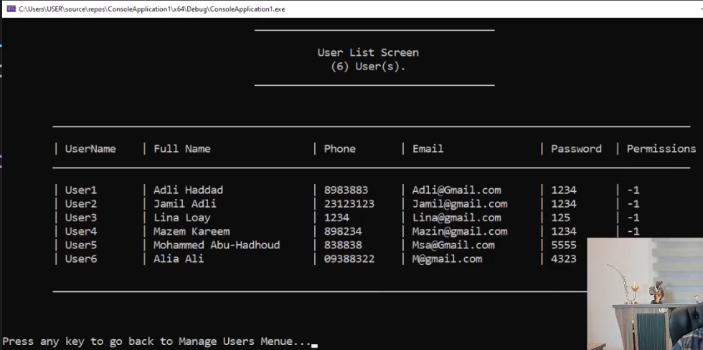

ده الكود بتاع شاشة ال list users

|  |
| --- |
| #pragma once  #include <iostream>  #include "clsScreen.h"  #include "clsUser.h"  #include <iomanip>  class clsListUsersScreen :protected clsScreen  {  private:  static void _PrintUserRecordLine(clsUser User)  {  cout << setw(8) << left << "" << "| " << setw(12) << left << User.UserName;  cout << "| " << setw(25) << left << User.get_FullName();  cout << "| " << setw(12) << left << User.Phone;  cout << "| " << setw(20) << left << User.Email;  cout << "| " << setw(10) << left << User.PassWord;  cout << "| " << setw(12) << left << User.Permissions;  }  public:  static void ShowUsersList()  {  vector <clsUser> vUsers = clsUser::GetUsersList();  string Title = "\t User List Screen";  string SubTitle = "\t (" + to_string(vUsers.size()) + ") User(s).";  _DrawScreenHeader(Title, SubTitle);  cout << setw(8) << left << "" << "\n\t_______________________________________________________";  cout << "______________________________________________\n" << endl;  cout << setw(8) << left << "" << "| " << left << setw(12) << "UserName";  cout << "| " << left << setw(25) << "Full Name";  cout << "| " << left << setw(12) << "Phone";  cout << "| " << left << setw(20) << "Email";  cout << "| " << left << setw(10) << "Password";  cout << "| " << left << setw(12) << "Permissions";  cout << setw(8) << left << "" << "\n\t_______________________________________________________";  cout << "______________________________________________\n" << endl;  if (vUsers.size() == 0)  cout << "\t\t\t\tNo Users Available In the System!";  else  for (clsUser User : vUsers)  {  _PrintUserRecordLine(User);  cout << endl;  }  cout << setw(8) << left << "" << "\n\t_______________________________________________________";  cout << "______________________________________________\n" << endl;  }  }; |

وده التعديل علي شاشة ال manage user

|  |
| --- |
| static void _ShowListUsersScreen()  {  //cout << "\nList Users Screen Will Be Here.\n";  clsListUsersScreen::ShowUsersList();  } |

**Lesson 20 - Add New User Screen**

ده التعديل اللي هنعمله علي كلاس اليوزر في ال public

ده عشان اللي هيدخل الداتا يختار منهم

|  |
| --- |
| enum enPermissions {  eAll = -1, pListClients = 1, pAddNewClient = 2, pDeleteClient = 4,  pUpdateClients = 8, pFindClient = 16, pTranactions = 32, pManageUsers = 64  }; |

ده كود شاشة ال add new user

|  |
| --- |
| #pragma once  #include <iostream>  #include "clsScreen.h"  #include "clsUser.h"  #include "clsInputValidate.h"  #include <iomanip>  class clsAddNewUserScreen : protected clsScreen  {  private:  static void _ReadUserInfo(clsUser& User)  {  cout << "\nEnter FirstName: ";  User.FirstName = clsInputValidate::ReadString();  cout << "\nEnter LastName: ";  User.LastName = clsInputValidate::ReadString();  cout << "\nEnter Email: ";  User.Email = clsInputValidate::ReadString();  cout << "\nEnter Phone: ";  User.Phone = clsInputValidate::ReadString();  cout << "\nEnter Password: ";  User.PassWord = clsInputValidate::ReadString();  cout << "\nEnter Permission: ";  User.Permissions = _ReadPermissionsToSet();  }  static void _PrintUser(clsUser User)  {  cout << "\nUser Card:";  cout << "\n___________________";  cout << "\nFirstName : " << User.FirstName;  cout << "\nLastName : " << User.LastName;  cout << "\nFull Name : " << User.get_FullName();  cout << "\nEmail : " << User.Email;  cout << "\nPhone : " << User.Phone;  cout << "\nUser Name : " << User.UserName;  cout << "\nPassword : " << User.PassWord;  cout << "\nPermissions : " << User.Permissions;  cout << "\n___________________\n";  }  static int _ReadPermissionsToSet()  {  int Permissions = 0;  char Answer = 'n';  cout << "\nDo you want to give full access? y/n? ";  cin >> Answer;  if (Answer == 'y' || Answer == 'Y')  {  return -1;  }  cout << "\nDo you want to give access to : \n ";  cout << "\nShow Client List? y/n? ";  cin >> Answer;  if (Answer == 'y' || Answer == 'Y')  {  Permissions += clsUser::enPermissions::pListClients;  }  cout << "\nAdd New Client? y/n? ";  cin >> Answer;  if (Answer == 'y' || Answer == 'Y')  {  Permissions += clsUser::enPermissions::pAddNewClient;  }  cout << "\nDelete Client? y/n? ";  cin >> Answer;  if (Answer == 'y' || Answer == 'Y')  {  Permissions += clsUser::enPermissions::pDeleteClient;  }  cout << "\nUpdate Client? y/n? ";  cin >> Answer;  if (Answer == 'y' || Answer == 'Y')  {  Permissions += clsUser::enPermissions::pUpdateClients;  }  cout << "\nFind Client? y/n? ";  cin >> Answer;  if (Answer == 'y' || Answer == 'Y')  {  Permissions += clsUser::enPermissions::pFindClient;  }  cout << "\nTransactions? y/n? ";  cin >> Answer;  if (Answer == 'y' || Answer == 'Y')  {  Permissions += clsUser::enPermissions::pTranactions;  }  cout << "\nManage Users? y/n? ";  cin >> Answer;  if (Answer == 'y' || Answer == 'Y')  {  Permissions += clsUser::enPermissions::pManageUsers;  }  return Permissions;  }  public:  static void ShowAddNewUserScreen()  {  _DrawScreenHeader("\t Add New User Screen","");  string UserName = "";  cout << "\nPlease Enter UserName: ";  UserName = clsInputValidate::ReadString();  while (clsUser::IsUserExist(UserName))  {  cout << "\nUserName Is Already Used, Choose another one: ";  UserName = clsInputValidate::ReadString();  }  clsUser NewUser = clsUser::GetAddNewUserObject(UserName);  _ReadUserInfo(NewUser);  clsUser::enSaveResults SaveResult;  SaveResult = NewUser.Save();  switch (SaveResult)  {  case clsUser::enSaveResults::svSucceeded:  {  cout << "\nUser Addeded Successfully :-)\n";  _PrintUser(NewUser);  break;  }  case clsUser::enSaveResults::svFaildEmptyObject:  {  cout << "\nError User was not saved because it's Empty";  break;  }  case clsUser::enSaveResults::svFaildUserExists:  {  cout << "\nError User was not saved because UserName is used!\n";  break;  }  }  }  }; |

وده التعديل علي شاشة ال manage user

|  |
| --- |
| static void _ShowAddNewUserScreen()  {  // cout << "\nAdd New User Screen Will Be Here.\n";  clsAddNewUserScreen::ShowAddNewUserScreen();  } |

**Lesson 21 - Delete User Screen**

ده الكود بتاع الشاشه

|  |
| --- |
| #pragma once  #include <iostream>  #include "clsScreen.h"  #include "clsPerson.h"  #include "clsUser.h"  #include "clsInputValidate.h"  class clsDeleteUserScreen :protected clsScreen  {  private:  static void _PrintUser(clsUser User)  {  cout << "\nUser Card:";  cout << "\n___________________";  cout << "\nFirstName : " << User.FirstName;  cout << "\nLastName : " << User.LastName;  cout << "\nFull Name : " << User.get_FullName();  cout << "\nEmail : " << User.Email;  cout << "\nPhone : " << User.Phone;  cout << "\nUser Name : " << User.UserName;  cout << "\nPassword : " << User.PassWord;  cout << "\nPermissions : " << User.Permissions;  cout << "\n___________________\n";  }  public:  static void ShowDeleteUserScreen()  {  _DrawScreenHeader("\tDelete User Screen","");  string UserName = "";  cout << "\nPlease Enter UserName: ";  UserName = clsInputValidate::ReadString();  while (!clsUser::IsUserExist(UserName))  {  cout << "\nUser is not found, choose another one: ";  UserName = clsInputValidate::ReadString();  }  clsUser User1 = clsUser::Find(UserName);  _PrintUser(User1);  cout << "\nAre you sure you want to delete this User y/n? ";  char Answer = 'n';  cin >> Answer;  if (Answer == 'y' || Answer == 'Y')  {  if (User1.Delete())  {  cout << "\nUser Deleted Successfully :-)\n";  _PrintUser(User1);  }  else  {  cout << "\nError User Was not Deleted\n";  }  }  }  }; |

وده التعديل علي الشاشه manage users

|  |
| --- |
| static void _ShowDeleteUserScreen()  {  // cout << "\nDelete User Screen Will Be Here.\n";  clsDeleteUserScreen::ShowDeleteUserScreen();  } |

**Lesson 22 - Update User Screen**

ده الكود بتاع الشاشه

|  |
| --- |
| #pragma once  #include <iostream>  #include "clsScreen.h"  #include "clsPerson.h"  #include "clsUser.h"  #include "clsInputValidate.h"  class clsUpdateUserScreen :protected clsScreen  {  private:  static void _ReadUserInfo(clsUser& User)  {  cout << "\nEnter FirstName: ";  User.FirstName = clsInputValidate::ReadString();  cout << "\nEnter LastName: ";  User.LastName = clsInputValidate::ReadString();  cout << "\nEnter Email: ";  User.Email = clsInputValidate::ReadString();  cout << "\nEnter Phone: ";  User.Phone = clsInputValidate::ReadString();  cout << "\nEnter Password: ";  User.PassWord = clsInputValidate::ReadString();  cout << "\nEnter Permission: ";  User.Permissions = _ReadPermissionsToSet();  }  static void _PrintUser(clsUser User)  {  cout << "\nUser Card:";  cout << "\n___________________";  cout << "\nFirstName : " << User.FirstName;  cout << "\nLastName : " << User.LastName;  cout << "\nFull Name : " << User.get_FullName();  cout << "\nEmail : " << User.Email;  cout << "\nPhone : " << User.Phone;  cout << "\nUser Name : " << User.UserName;  cout << "\nPassword : " << User.PassWord;  cout << "\nPermissions : " << User.Permissions;  cout << "\n___________________\n";  }  static int _ReadPermissionsToSet()  {  int Permissions = 0;  char Answer = 'n';  cout << "\nDo you want to give full access? y/n? ";  cin >> Answer;  if (Answer == 'y' || Answer == 'Y')  {  return -1;  }  cout << "\nDo you want to give access to : \n ";  cout << "\nShow Client List? y/n? ";  cin >> Answer;  if (Answer == 'y' || Answer == 'Y')  {  Permissions += clsUser::enPermissions::pListClients;  }  cout << "\nAdd New Client? y/n? ";  cin >> Answer;  if (Answer == 'y' || Answer == 'Y')  {  Permissions += clsUser::enPermissions::pAddNewClient;  }  cout << "\nDelete Client? y/n? ";  cin >> Answer;  if (Answer == 'y' || Answer == 'Y')  {  Permissions += clsUser::enPermissions::pDeleteClient;  }  cout << "\nUpdate Client? y/n? ";  cin >> Answer;  if (Answer == 'y' || Answer == 'Y')  {  Permissions += clsUser::enPermissions::pUpdateClients;  }  cout << "\nFind Client? y/n? ";  cin >> Answer;  if (Answer == 'y' || Answer == 'Y')  {  Permissions += clsUser::enPermissions::pFindClient;  }  cout << "\nTransactions? y/n? ";  cin >> Answer;  if (Answer == 'y' || Answer == 'Y')  {  Permissions += clsUser::enPermissions::pTranactions;  }  cout << "\nManage Users? y/n? ";  cin >> Answer;  if (Answer == 'y' || Answer == 'Y')  {  Permissions += clsUser::enPermissions::pManageUsers;  }  return Permissions;  }  public:  static void ShowUpdateUserScreen()  {  _DrawScreenHeader("\tUpdate User Screen","");  string UserName = "";  cout << "\nPlease Enter User UserName: ";  UserName = clsInputValidate::ReadString();  while (!clsUser::IsUserExist(UserName))  {  cout << "\nAccount number is not found, choose another one: ";  UserName = clsInputValidate::ReadString();  }  clsUser User1 = clsUser::Find(UserName);  _PrintUser(User1);  cout << "\nAre you sure you want to update this User y/n? ";  char Answer = 'n';  cin >> Answer;  if (Answer == 'y' || Answer == 'Y')  {  cout << "\n\nUpdate User Info:";  cout << "\n____________________\n";  _ReadUserInfo(User1);  clsUser::enSaveResults SaveResult;  SaveResult = User1.Save();  switch (SaveResult)  {  case clsUser::enSaveResults::svSucceeded:  {  cout << "\nUser Updated Successfully :-)\n";  _PrintUser(User1);  break;  }  case clsUser::enSaveResults::svFaildEmptyObject:  {  cout << "\nError User was not saved because it's Empty";  break;  }  }  }  }  }; |

وده التعديل علي الشاشه manage users

|  |
| --- |
| static void _ShowUpdateUserScreen()  {  // cout << "\nUpdate User Screen Will Be Here.\n";  clsUpdateUserScreen::ShowUpdateUserScreen();  } |

**Lesson 23 - Find User Screen**

ده الكود بتاع الشاشه

|  |
| --- |
| #pragma once  #include <iostream>  #include "clsScreen.h"  #include "clsPerson.h"  #include "clsUser.h"  #include "clsInputValidate.h"  class clsFindUserScreen :protected clsScreen  {  private:  static void _PrintUser(clsUser User)  {  cout << "\nUser Card:";  cout << "\n___________________";  cout << "\nFirstName : " << User.FirstName;  cout << "\nLastName : " << User.LastName;  cout << "\nFull Name : " << User.get_FullName();  cout << "\nEmail : " << User.Email;  cout << "\nPhone : " << User.Phone;  cout << "\nUserName : " << User.UserName;  cout << "\nPassword : " << User.PassWord;  cout << "\nPermissions : " << User.Permissions;  cout << "\n___________________\n";  }  public:  static void ShowFindUserScreen()  {  _DrawScreenHeader("\t Find User Screen","");  string UserName;  cout << "\nPlease Enter UserName: ";  UserName = clsInputValidate::ReadString();  while (!clsUser::IsUserExist(UserName))  {  cout << "\nUser is not found, choose another one: ";  UserName = clsInputValidate::ReadString();  }  clsUser User1 = clsUser::Find(UserName);  if (!User1.IsEmpty())  {  cout << "\nUser Found :-)\n";  }  else  {  cout << "\nUser Was not Found :-(\n";  }  _PrintUser(User1);  }  }; |

وده التعديل علي الشاشه manage users

|  |
| --- |
| static void _ShowFindUserScreen()  {  //cout << "\nFind User Screen Will Be Here.\n";  clsFindUserScreen::ShowFindUserScreen();  } |

**Lesson 24 - Login**

هنعمل شاشة تسجيل الدخول وهنبدأ بيها البرنامج بدل الشاشه الرئيسيه لو دخل البيانات صح يدور عاليوزر ويعرفه علي مستوي السيستم ككل هيعمله global ولو دخل البيانات غلط هيدخل في while loop لحد مايدخلها صح

عشان تعرف global user بتعمل header file بتعرف فيه object من النوع user واي كلاس محتاجه هيعمل include للملف ده

ده الكود بتاع ال global user (header file)

|  |
| --- |
| #pragma once  #include <iostream>  #include "clsUser.h"  clsUser CurrentUser = clsUser::Find("", ""); |

ده الكود بتاع شاشة ال login

|  |
| --- |
| #pragma once  #include <iostream>  #include "clsScreen.h"  #include "clsUser.h"  #include <iomanip>  #include "clsMainScreen.h"  #include "Global.h"  class clsLoginScreen :protected clsScreen  {  private:  static void _Login()  {  bool LoginFaild = false;  string Username, Password;  do  {  if (LoginFaild)  {  cout << "\nInvlaid Username/Password!\n\n";  }  cout << "Enter Username? ";  cin >> Username;  cout << "Enter Password? ";  cin >> Password;  CurrentUser = clsUser::Find(Username, Password);  LoginFaild = CurrentUser.IsEmpty();  } while (LoginFaild);  clsMainScreen::ShowMainMenue();  }  public:  static void ShowLoginScreen()  {  system("cls");  _DrawScreenHeader("\t Login Screen","");  _Login();  }  }; |

وده التعديل علي ال main

|  |
| --- |
| #include <iostream>  #include "clsLoginScreen.h"  int main()  {  clsLoginScreen::ShowLoginScreen();  system("pause>0");  return 0;  } |

**Lesson 25 - Logout**

ال log out كل اللي بيعمله انه بيفضي ال object اللي معمول global

ده التعديل عالشاشه الرئيسيه

ماتنساش تعمل دي

#include "Global.h"

|  |
| --- |
| /* static void _ShowEndScreen()  {  cout << "\nEnd Screen Will be here...\n";  }*/  static void _Logout()  {  CurrentUser = clsUser::Find("", "");  //then it will go back to main function.  } |
| case enMainMenueOptions::eExit:  system("cls");  _Logout();  //Login();  break; |

**Lesson 26 - Show Login Screen at Logout**

هنا احنا عايزين بدل ماندوس logout ونخرج من البرنامج خالص

لا احنا عايزينه نفتح شاشة الlogin

طيب فيه حد ممكن يقولك اننا نكتب الكود كده

|  |
| --- |
| static void _Logout()  {  CurrentUser = clsUser::Find("", "");  clsLoginScreen::ShowLoginScreen();  //then it will go back to main function.  } |

احنا في الكود اللي فات جينا جوه ال function بتاعت ال logout وشغلنا فيها ال login screen

لو جيت عملت كده البرنامج مش هيشتغل وهيضرب

طيب ليه؟

قالك بسبب حاجه اسمها circular reference ودي ممنوعه في البرمجه

يعني ايه الكلام ده؟

عشان نفهمها تعالي نبص عالمسار اللي بيمشي فيه البرنامج في حالة اننا خلينا البرنامج يقفل لما نعمل ال log out وفي حالة الكود اللي كتبناه

في الأول البرنامج كان بيمشي كده

Main Function >> Login Screen >> Main Menu Screen

>> Logout Function >> Main menu Screen >> Login Screen

>> Main Function

فكان لما بيدخل ينفذ function معينه كان بيرجع تاني لمكانه الأولاني عشان ينفذ بقيت الكود

طيب تعالي بقي نشوف بعد التعديل اللي عملناه

Main Function >> Login Screen >> Main Menu Screen

>> Logout Function >> Login Screen >> Mian Menu Screen >> Logout Function >> Login Screen >> Mian Menu Screen Logout Function >> Login Screen >> Mian Menu Screen

وهكذا الي مالانهايه ومش هيكون فيه نقطة عودة بينتهي فيها البرنامج زي الاول

يعني هتلاقيه بيفتح stacks عمال علي بطال فطبيعي يضرب منك

كمان انت لما وصلت لشاشة ال login وبعدها فتحت القايمة الرئيسيه ال compiler هيكون واقف علي شاشة ال login ومستني الكود اللي جوه القايمة الرئيسيه يخلص عشان ينفذ باقي الكود اللي في شاشة ال login فلما انت تيجي جوه ال logout تطلب منه يرجع يشغل شاشة ال login تاني أصبحت شاشة ال login مستنيه ال logout تخلص واصبح ال logout مستني شاشة ال login تخلص واصبح عندك circular reference

طيب الحل ايه؟

قالك انه الحل انك تعمل while loop في ال main نفسه بحيث انه لما ييجي يوصل للمرحله دي

Main Function >> Login Screen >> Main Menu Screen

>> Logout Function >> Main menu Screen >> Login Screen

>> Main Function

يعيد تشغيل شاشة تسجيل الدخول تاني

زي كده

|  |
| --- |
| #include <iostream>  #include "clsLoginScreen.h"  int main()  {  while (true) { clsLoginScreen::ShowLoginScreen(); }  system("pause>0");  return 0;  } |

**Lesson 27 - Apply Permissions**

هنشتغل علي ال permissions

اول حاجه هنعملها هنروح عند الكلاسuser ونحط الكود ده شرحناه قبل كده

|  |
| --- |
| bool CheckAccessPermission(enPermissions Permission)  {  if (this->Permissions == enPermissions::eAll)  return true;  if ((Permission & this->Permissions) == Permission)  return true;  else  return false;  } |

بعجين احنا عايزين شاشة ال access denied تكون ظاهرة في كل الشاشات لو اليوزر ماعندوش صلاحيه ليها

فبدل مانكتب نفس الكود في كل الشاشات لا احنا هنروح للكلاس screen اللي كل الشاشات بتورث منه ونعدل عليه

هنزود فيه ال function دي

مجرد انه بيشوف لو اليوزر ليه الصلاحيه هيرجع true ولو مالوش صلاحيه هيظهر access denied ويرجع false

|  |
| --- |
| static bool CheckAccessRights(clsUser::enPermissions Permission)  {  if (!CurrentUser.CheckAccessPermission(Permission))  {  cout << "\t\t\t\t\t______________________________________";  cout << "\n\n\t\t\t\t\t Access Denied! Contact your Admin.";  cout << "\n\t\t\t\t\t______________________________________\n\n";  return false;  }  else  {  return true;  }  } |

بعدين هنروح لكل شاشه من دول (clsClientListScreen , clsAddNewClientScreen, clsDeleteClientScreen, clsUpdateClientScreen, clsFindClientScreen , clsManageUsersScreen, clsTransactionsScreen)

ونيجي في ال function اللي بتشغل الشاشه وقبل أي كود في ال function دي هنزود الكود ده مع تغيير نوع ال permission طبعا

|  |
| --- |
| if (!CheckAccessRights(clsUser::enPermissions::pListClients))  {  return;// this will exit the function and it will not continue  } |

زي كده

|  |
| --- |
| static void ShowClientsList()  {  if (!CheckAccessRights(clsUser::enPermissions::pListClients))  {  return;// this will exit the function and it will not continue  }  vector <clsBankClient> vClients = clsBankClient::GetClientsList();  string Title = "\t Client List Screen";  string SubTitle = "\t (" + to_string(vClients.size()) + ") Client(s).";  _DrawScreenHeader(Title, SubTitle);  cout << setw(8) << left << "" << "\n\t_______________________________________________________";  cout << "_________________________________________\n" << endl;  cout << setw(8) << left << "" << "| " << left << setw(15) << "Accout Number";  cout << "| " << left << setw(20) << "Client Name";  cout << "| " << left << setw(12) << "Phone";  cout << "| " << left << setw(20) << "Email";  cout << "| " << left << setw(10) << "Pin Code";  cout << "| " << left << setw(12) << "Balance";  cout << setw(8) << left << "" << "\n\t_______________________________________________________";  cout << "_________________________________________\n" << endl;  if (vClients.size() == 0)  cout << "\t\t\t\tNo Clients Available In the System!";  else  for (clsBankClient Client : vClients)  {  PrintClientRecordLine(Client);  cout << endl;  }  cout << setw(8) << left << "" << "\n\t_______________________________________________________";  cout << "_________________________________________\n" << endl;  } |

انا مش هحط باقي الشاشات عشان مااكررش بدون داعي

وماتنساش تضيف ال global user للكلاس clsScreen

**Add Date and Logged In User to All Screens**

عاوزين نضيف اسم اليوزر والتاريخ في كل الشاشات

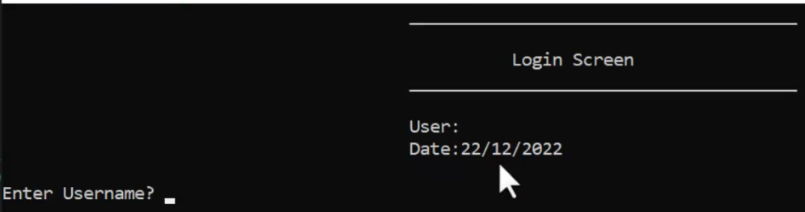

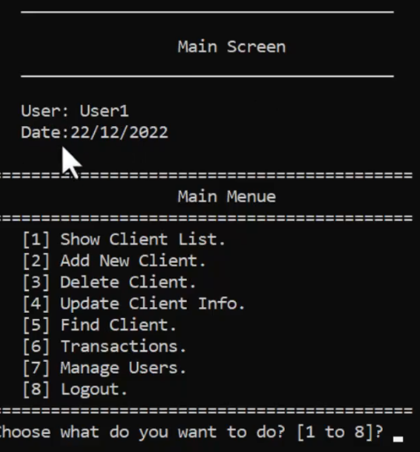

اعملها في كل الشاشات

**Solution**

|  |
| --- |
| #pragma once  #include<iostream>  #include"Global.h"  #include"clsDate.h"  using namespace std;  class clsScreen  {  protected:  static void _DrawScreenHeader(string Title,string SubTitle) {    cout << "\t\t\t\t\t______________________________________";  cout << "\n\n\t\t\t\t\t " << Title;  if (SubTitle != "")  {  cout << "\n\t\t\t\t\t " << SubTitle;  }  cout << "\n\t\t\t\t\t______________________________________\n\n";  cout << "\n\t\t\t\t\tUser: " << CurrentUser.UserName << "\n";  cout << "\t\t\t\t\tDate: " << clsDate::DateToString(clsDate())  << "\n\n";  }  static bool CheckAccessRights(clsUser::enPermissions Permission)  {  if (!CurrentUser.CheckAccessPermission(Permission))  {  cout << "\t\t\t\t\t______________________________________";  cout << "\n\n\t\t\t\t\t Access Denied! Contact your Admin.";  cout << "\n\t\t\t\t\t______________________________________\n\n";  return false;  }  else  {  return true;  }  }  }; |

**Lock the System After 3 failed Logins**

عاوزين لو اليوزر عمل login غلط 3 مرات يطلع من السيستم

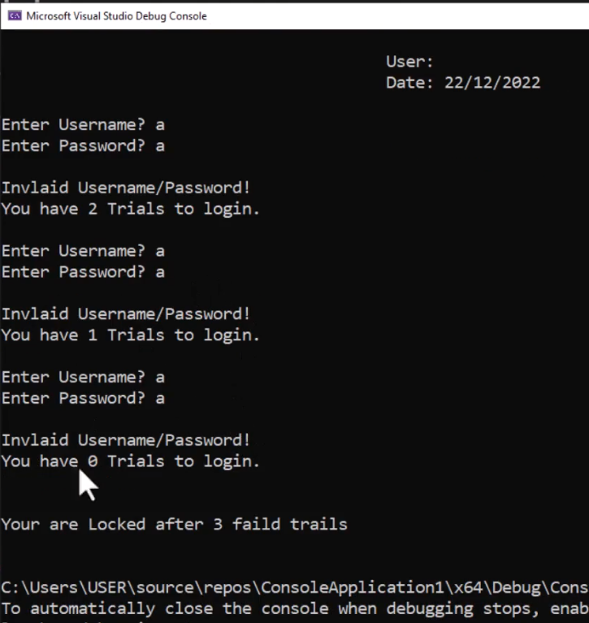

**Solution**

|  |
| --- |
| #pragma once  #include <iostream>  #include "clsScreen.h"  #include "clsUser.h"  #include <iomanip>  #include "clsMainScreen.h"  #include "Global.h"  class clsLoginScreen :protected clsScreen  {  private:  static bool _Login()  {  bool LoginFaild = false;  short FaildLoginCount = 0;  string Username, Password;  do  {  if (LoginFaild)  {  FaildLoginCount++;  cout << "\nInvlaid Username/Password!";  cout << "\nYou have " << (3 - FaildLoginCount)  << " Trial(s) to login.\n\n";  }  if (FaildLoginCount == 3)  {  cout << "\nYour are Locked after 3 faild trails \n\n";  return false;  }  cout << "Enter Username? ";  cin >> Username;  cout << "Enter Password? ";  cin >> Password;  CurrentUser = clsUser::Find(Username, Password);  LoginFaild = CurrentUser.IsEmpty();  } while (LoginFaild);  clsMainScreen::ShowMainMenue();  return true;  }  public:  static bool ShowLoginScreen()  {  system("cls");  _DrawScreenHeader("\t Login Screen","");  return _Login();  }  }; |
| #include <iostream>  #include "clsLoginScreen.h"  int main()  {  while (true)  {  if (!clsLoginScreen::ShowLoginScreen())  {  break;  }  }  return 0;  } |

**Register Logins In a Log File**

محتاجين نعمل ملف يكون فيه كل تاريخ ووقت كل عملية دخول علي السيستم

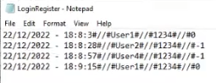

**Solution**

ده اللي زودناه في كلاس ال date

|  |
| --- |
| static string GetSystemDateTimeString()  {  //system datetime string  time_t t = time(0);  tm* now = localtime(&t);  short Day, Month, Year, Hour, Minute, Second;  Year = now->tm_year + 1900;  Month = now->tm_mon + 1;  Day = now->tm_mday;  Hour = now->tm_hour;  Minute = now->tm_min;  Second = now->tm_sec;  return (to_string(Day) + "/" + to_string(Month) + "/"  + to_string(Year) + " - "  + to_string(Hour) + ":" + to_string(Minute)  + ":" + to_string(Second));  } |

وده اللي زودناه في كلاس ال user

|  |
| --- |
| //private functions  string _PrepareLogInRecord(string Seperator = "#//#")  {  string LoginRecord = "";  LoginRecord += clsDate::GetSystemDateTimeString() + Seperator;  LoginRecord += UserName + Seperator;  LoginRecord += PassWord + Seperator;  LoginRecord += to_string(Permissions);  return LoginRecord;  }  //public functions  void RegisterLogIn()  {  string stDataLine = _PrepareLogInRecord();  fstream MyFile;  MyFile.open("LoginRegister.txt", ios::out | ios::app);  if (MyFile.is_open())  {  MyFile << stDataLine << endl;  MyFile.close();  }  } |

وده اللي زودناه في شاشة ال login

|  |
| --- |
| static bool _Login()  {  bool LoginFaild = false;  short FaildLoginCount = 0;  string Username, Password;  do  {  if (LoginFaild)  {  FaildLoginCount++;  cout << "\nInvlaid Username/Password!";  cout << "\nYou have " << (3 - FaildLoginCount)  << " Trial(s) to login.\n\n";  }  if (FaildLoginCount == 3)  {  cout << "\nYour are Locked after 3 faild trails \n\n";  return false;  }  cout << "Enter Username? ";  cin >> Username;  cout << "Enter Password? ";  cin >> Password;  CurrentUser = clsUser::Find(Username, Password);  LoginFaild = CurrentUser.IsEmpty();  } while (LoginFaild);  CurrentUser.RegisterLogIn();  clsMainScreen::ShowMainMenue();  return true;  } |

وماتنساش السطر ده في كلاس ال user

#include"clsDate.h"

**Show Login Register Screen**

عاوزين نعمل شاشه تعرضلنا ال login

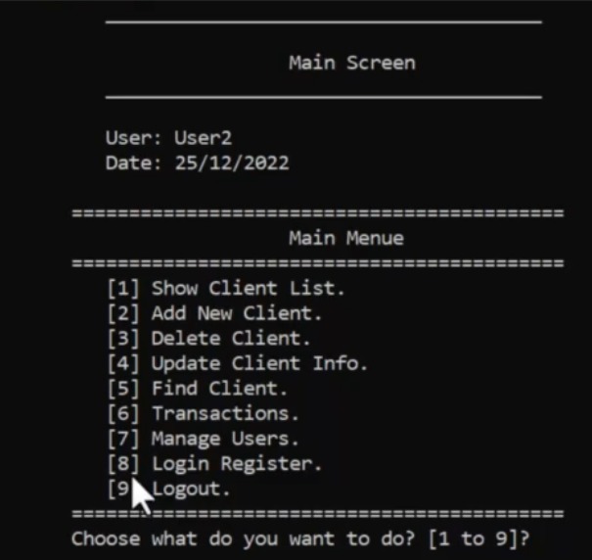

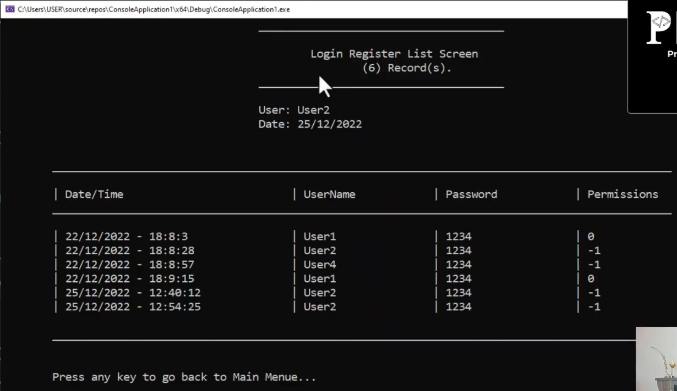

**Solution**

الفكره هنا انك بتجمع المتغيرات في structure داخل كلاس ال user

دي الاكواد اللي حصل فيها تعديل وهعلم عالتعديل

ده كلاس ال user

|  |
| --- |
| #pragma once  #include<iostream>  #include<fstream>  #include"clsPerson.h"  #include"clsString.h"  #include"clsDate.h"  #include <string>  using namespace std;  class clsUser:public clsPerson  {  private:  enum enMode {EmptyMode=0,UpdateMode=1,AddMode=2};  enMode _Mode;  string _UserName;  string _PassWord;  int _Permissions;  bool _MarkedForDelete = false;  struct stLoginRegisterRecord;  //private functions  static stLoginRegisterRecord _ConvertLoginRegisterLineToRecord(string Line, string Seperator = "#//#")  {  stLoginRegisterRecord LoginRegisterRecord;  vector <string> LoginRegisterDataLine = clsString::Split(Line, Seperator);  LoginRegisterRecord.DateTime = LoginRegisterDataLine[0];  LoginRegisterRecord.UserName = LoginRegisterDataLine[1];  LoginRegisterRecord.Password = LoginRegisterDataLine[2];  LoginRegisterRecord.Permissions = stoi(LoginRegisterDataLine[3]);  return LoginRegisterRecord;  }  string _PrepareLogInRecord(string Seperator = "#//#")  {  string LoginRecord = "";  LoginRecord += clsDate::GetSystemDateTimeString() + Seperator;  LoginRecord += UserName + Seperator;  LoginRecord += PassWord + Seperator;  LoginRecord += to_string(Permissions);  return LoginRecord;  }  static clsUser _ConvertLineToUserObject(string Line,string Seperator="#//#") {  vector<string>vUserData =clsString::Split(Line,Seperator);  clsUser User(enMode::UpdateMode, vUserData[0],vUserData[1], vUserData[2], vUserData[3], vUserData[4], vUserData[5], stoi(vUserData[6]));  return User;  }  static string _ConvertFromUserObjectToLine(clsUser User, string Seperaor = "#//#") {  return User.FirstName + Seperaor  + User.LastName + Seperaor  + User.Email + Seperaor  + User.Phone + Seperaor  + User.UserName + Seperaor  + User.PassWord + Seperaor  + to_string(User.Permissions);  }  static vector<clsUser> _LoadUsersDataFromFile() {  vector<clsUser>vUsers;  fstream MyFile;  MyFile.open("Users.txt",ios::in);  if (MyFile.is_open()) {  string Line = "";  while (getline(MyFile,Line)) {  vUsers.push_back(_ConvertLineToUserObject(Line));  }  MyFile.close();  }  return vUsers;  }  static void _SaveUsersDataToFile(vector<clsUser>vUsers) {  fstream MyFile;  MyFile.open("Users.txt", ios::out);  if (MyFile.is_open()) {  for (clsUser &User:vUsers) {  if (User._MarkedForDelete==false) {  MyFile << _ConvertFromUserObjectToLine(User) << endl;  }  }  MyFile.close();  }  }  static void _AddDataLineToFile(string stDataLine) {  fstream MyFile;  MyFile.open("Users.txt", ios::out | ios::app);  if (MyFile.is_open()) {  MyFile << stDataLine << endl;  MyFile.close();  }  }  void _Update() {  vector<clsUser>vUsers = _LoadUsersDataFromFile();  for (clsUser &User:vUsers) {  if (User.UserName==UserName) {  User = *this;  break;  }  }  _SaveUsersDataToFile(vUsers);  }  void _AddNew() {  _AddDataLineToFile(_ConvertFromUserObjectToLine(*this));  }  static clsUser _GetEmptyUserObject() {  return clsUser(enMode::EmptyMode, "", "", "", "", "", "", 0);  }  public:  enum enPermissions {  eAll = -1, pListClients = 1, pAddNewClient = 2, pDeleteClient = 4,  pUpdateClients = 8, pFindClient = 16, pTranactions = 32, pManageUsers = 64  };  struct stLoginRegisterRecord  {  string DateTime;  string UserName;  string Password;  int Permissions;  };  //Constructor  clsUser(enMode Mode,string FirstName,string LastName,string Email, string Phone,string UserName  ,string Password,int Permissions):clsPerson(FirstName,LastName,Email,Phone) {    this->_Mode = Mode;  this->_UserName = UserName;  this->_PassWord = Password;  this->_Permissions = Permissions;  }  //check Functions  bool IsEmpty() {  return (_Mode == enMode::EmptyMode);  }  bool MarkedForDelete() {  return _MarkedForDelete;  }  static bool IsUserExist(string UserName)  {  clsUser User = clsUser::Find(UserName);  return (!User.IsEmpty());  }  //setters  void set_UserName(string UserName) {  this->_UserName = UserName;  }  void set_PassWord(string PassWord) {  this->_PassWord = PassWord;  }  void set_Permissions(int Permissions) {  this->_Permissions = Permissions;  }  //Getters  string get_UserName() { return _UserName; }  string get_PassWord() { return _PassWord; }  int get_Permissions() { return _Permissions; }  //declspec  _declspec(property(get = get_UserName, put = set_UserName))string UserName;  _declspec(property(get = get_PassWord, put = set_PassWord))string PassWord;  _declspec(property(get = get_Permissions, put = set_Permissions))int Permissions;  //public functions  static clsUser Find(string UserName) {  fstream MyFile;  MyFile.open("Users.txt", ios::in);    if (MyFile.is_open()) {  string Line = "";  while (getline(MyFile,Line)) {  clsUser User = _ConvertLineToUserObject(Line);  if (User.UserName==UserName) {  MyFile.close();  return User;  }  }  MyFile.close();  }  return _GetEmptyUserObject();  }  static clsUser Find(string UserName,string PassWord) {  fstream MyFile;  MyFile.open("Users.txt", ios::in);  if (MyFile.is_open()) {  string Line = "";  while (getline(MyFile, Line)) {  clsUser User = _ConvertLineToUserObject(Line);  if (User.UserName == UserName&&User.PassWord==PassWord) {  MyFile.close();  return User;  }  }  MyFile.close();  }  return _GetEmptyUserObject();  }  enum enSaveResults { svFaildEmptyObject = 0, svSucceeded = 1, svFaildUserExists = 2 };  enSaveResults Save() {  switch (_Mode)  {  case clsUser::EmptyMode:  if (IsEmpty()) {  return svFaildEmptyObject;  }  break;  case clsUser::UpdateMode:  _Update();  return svSucceeded;  break;  case clsUser::AddMode:  if (clsUser::IsUserExist(this->UserName)) {  return enSaveResults::svFaildUserExists;  }  else {  _AddNew();  this->_Mode = UpdateMode;  return svSucceeded;  }  break;  default:  break;  }  }  bool Delete() {  vector<clsUser>vUsers=_LoadUsersDataFromFile();  for (clsUser& U : vUsers)  {  if (U.UserName == _UserName)  {  U._MarkedForDelete = true;  break;  }  }  _SaveUsersDataToFile(vUsers);  *this = _GetEmptyUserObject();  return true;  }  static clsUser GetAddNewUserObject(string UserName)  {  return clsUser(enMode::AddMode, "", "", "", "", UserName, "", 0);  }  static vector <clsUser> GetUsersList()  {  return _LoadUsersDataFromFile();  }  bool CheckAccessPermission(enPermissions Permission)  {  if (this->Permissions == enPermissions::eAll)  return true;  if ((Permission & this->Permissions) == Permission)  return true;  else  return false;  }  void RegisterLogIn()  {  string stDataLine = _PrepareLogInRecord();  fstream MyFile;  MyFile.open("LoginRegister.txt", ios::out | ios::app);  if (MyFile.is_open())  {  MyFile << stDataLine << endl;  MyFile.close();  }  }  static vector <stLoginRegisterRecord> GetLoginRegisterList()  {  vector <stLoginRegisterRecord> vLoginRegisterRecord;  fstream MyFile;  MyFile.open("LoginRegister.txt", ios::in);//read Mode  if (MyFile.is_open())  {  string Line;  stLoginRegisterRecord LoginRegisterRecord;  while (getline(MyFile, Line))  {  LoginRegisterRecord = _ConvertLoginRegisterLineToRecord(Line);  vLoginRegisterRecord.push_back(LoginRegisterRecord);  }  MyFile.close();  }  return vLoginRegisterRecord;  }  }; |

وده كود ال register screen

|  |
| --- |
| #pragma once  #include <iostream>  #include "clsScreen.h"  #include <iomanip>  #include <fstream>  #include "clsUser.h"  class clsLoginRegisterScreen :protected clsScreen  {  private:  static void PrintLoginRegisterRecordLine(clsUser::stLoginRegisterRecord LoginRegisterRecord)  {  cout << setw(8) << left << "" << "| " << setw(35) << left << LoginRegisterRecord.DateTime;  cout << "| " << setw(20) << left << LoginRegisterRecord.UserName;  cout << "| " << setw(20) << left << LoginRegisterRecord.Password;  cout << "| " << setw(10) << left << LoginRegisterRecord.Permissions;  }  public:  static void ShowLoginRegisterScreen()  {  vector <clsUser::stLoginRegisterRecord> vLoginRegisterRecord = clsUser::GetLoginRegisterList();  string Title = "\tLogin Register List Screen";  string SubTitle = "\t\t(" + to_string(vLoginRegisterRecord.size()) + ") Record(s).";  _DrawScreenHeader(Title, SubTitle);  cout << setw(8) << left << "" << "\n\t_______________________________________________________";  cout << "_________________________________________\n" << endl;  cout << setw(8) << left << "" << "| " << left << setw(35) << "Date/Time";  cout << "| " << left << setw(20) << "UserName";  cout << "| " << left << setw(20) << "Password";  cout << "| " << left << setw(10) << "Permissions";  cout << setw(8) << left << "" << "\n\t_______________________________________________________";  cout << "_________________________________________\n" << endl;  if (vLoginRegisterRecord.size() == 0)  cout << "\t\t\t\tNo Logins Available In the System!";  else  for (clsUser::stLoginRegisterRecord Record : vLoginRegisterRecord)  {  PrintLoginRegisterRecordLine(Record);  cout << endl;  }  cout << setw(8) << left << "" << "\n\t_______________________________________________________";  cout << "_________________________________________\n" << endl;  }  }; |

وده كود ال main menu screen

|  |
| --- |
| #pragma once  #include <iostream>  #include "clsScreen.h"  #include "clsInputValidate.h"  #include <iomanip>  #include "clsClientListScreen.h"  #include "clsAddNewClientScreen.h"  #include "clsDeleteClientScreen.h"  #include "clsTransactionsScreen.h"  #include "clsFindClientScreen.h"  #include "clsUpdateClientScreen.h"  #include "clsManageUsersScreen.h"  #include "Global.h"  #include "clsLoginRegisterScreen.h"  using namespace std;  class clsMainScreen :protected clsScreen  {  private:  enum enMainMenueOptions {  eListClients = 1, eAddNewClient = 2, eDeleteClient = 3,  eUpdateClient = 4, eFindClient = 5, eShowTransactionsMenue = 6,  eManageUsers = 7, eLoginRegister=8,eExit = 9  };  static short _ReadMainMenueOption()  {  cout << setw(37) << left << "" << "Choose what do you want to do? [1 to 9]? ";  short Choice = clsInputValidate::ReadShortNumberBetween(1, 9, "Enter Number between 1 to 9? ");  return Choice;  }  static void _GoBackToMainMenue()  {  cout << setw(37) << left << "" << "\n\tPress any key to go back to Main Menue...\n";  system("pause>0");  ShowMainMenue();  }  static void _ShowAllClientsScreen()  {  // cout << "\nClient List Screen Will be here...\n";  clsClientListScreen::ShowClientsList();  }  static void _ShowAddNewClientsScreen()  {  // cout << "\nAdd New Client Screen Will be here...\n";  clsAddNewClientScreen::ShowAddNewClientScreen();  }  static void _ShowDeleteClientScreen()  {  //cout << "\nDelete Client Screen Will be here...\n";  clsDeleteClientScreen::ShowDeleteClientScreen();  }  static void _ShowUpdateClientScreen()  {  //cout << "\nUpdate Client Screen Will be here...\n";  clsUpdateClientScreen::ShowUpdateClientScreen();    }  static void _ShowFindClientScreen()  {  // cout << "\nFind Client Screen Will be here...\n";  clsFindClientScreen::ShowFindClientScreen();  }  static void _ShowTransactionsMenue()  {  // cout << "\nTransactions Menue Will be here...\n";  clsTransactionsScreen::ShowTransactionsMenue();  }  static void _ShowManageUsersMenue()  {  // cout << "\nUsers Menue Will be here...\n";  clsManageUsersScreen::ShowManageUsersMenue();  }  static void _ShowLoginRegisterScreen() {  // cout << "\nLogin Register Menue Will be here...\n";  clsLoginRegisterScreen::ShowLoginRegisterScreen();  }  /* static void _ShowEndScreen()  {  cout << "\nEnd Screen Will be here...\n";  }*/  static void _Logout()  {  CurrentUser = clsUser::Find("", "");  //then it will go back to main function.  }  static void _PerfromMainMenueOption(enMainMenueOptions MainMenueOption)  {  switch (MainMenueOption)  {  case enMainMenueOptions::eListClients:  {  system("cls");  _ShowAllClientsScreen();  _GoBackToMainMenue();  break;  }  case enMainMenueOptions::eAddNewClient:  system("cls");  _ShowAddNewClientsScreen();  _GoBackToMainMenue();  break;  case enMainMenueOptions::eDeleteClient:  system("cls");  _ShowDeleteClientScreen();  _GoBackToMainMenue();  break;  case enMainMenueOptions::eUpdateClient:  system("cls");  _ShowUpdateClientScreen();  _GoBackToMainMenue();  break;  case enMainMenueOptions::eFindClient:  system("cls");  _ShowFindClientScreen();  _GoBackToMainMenue();  break;  case enMainMenueOptions::eShowTransactionsMenue:  system("cls");  _ShowTransactionsMenue();  _GoBackToMainMenue();  break;  case enMainMenueOptions::eManageUsers:  system("cls");  _ShowManageUsersMenue();  _GoBackToMainMenue();  break;  case enMainMenueOptions::eLoginRegister:  system("cls");  _ShowLoginRegisterScreen();  _GoBackToMainMenue();  break;  case enMainMenueOptions::eExit:  system("cls");  _Logout();  //Login();  break;  }  }  public:  static void ShowMainMenue()  {  system("cls");  _DrawScreenHeader("\t\tMain Screen","");  cout << setw(37) << left << "" << "===========================================\n";  cout << setw(37) << left << "" << "\t\t\tMain Menue\n";  cout << setw(37) << left << "" << "===========================================\n";  cout << setw(37) << left << "" << "\t[1] Show Client List.\n";  cout << setw(37) << left << "" << "\t[2] Add New Client.\n";  cout << setw(37) << left << "" << "\t[3] Delete Client.\n";  cout << setw(37) << left << "" << "\t[4] Update Client Info.\n";  cout << setw(37) << left << "" << "\t[5] Find Client.\n";  cout << setw(37) << left << "" << "\t[6] Transactions.\n";  cout << setw(37) << left << "" << "\t[7] Manage Users.\n";  cout << setw(37) << left << "" << "\t[8] Login Register.\n";  cout << setw(37) << left << "" << "\t[9] Logout.\n";  cout << setw(37) << left << "" << "===========================================\n";  _PerfromMainMenueOption((enMainMenueOptions)_ReadMainMenueOption());  }  }; |

**Permission to Show Log Register Screen**

عاوزين نضيف صلاحيه للوصول لشاشة ال login register

**Solution**

ده التعديل علي كلاس ال user

|  |
| --- |
| enum enPermissions {  eAll = -1, pListClients = 1, pAddNewClient = 2, pDeleteClient = 4,  pUpdateClients = 8, pFindClient = 16, pTranactions = 32, pManageUsers = 64  ,pLoginRegister=128  }; |

وده التعديل علي شاشه ال update user وال add user

|  |
| --- |
| static int _ReadPermissionsToSet()  {  int Permissions = 0;  char Answer = 'n';  cout << "\nDo you want to give full access? y/n? ";  cin >> Answer;  if (Answer == 'y' || Answer == 'Y')  {  return -1;  }  cout << "\nDo you want to give access to : \n ";  cout << "\nShow Client List? y/n? ";  cin >> Answer;  if (Answer == 'y' || Answer == 'Y')  {  Permissions += clsUser::enPermissions::pListClients;  }  cout << "\nAdd New Client? y/n? ";  cin >> Answer;  if (Answer == 'y' || Answer == 'Y')  {  Permissions += clsUser::enPermissions::pAddNewClient;  }  cout << "\nDelete Client? y/n? ";  cin >> Answer;  if (Answer == 'y' || Answer == 'Y')  {  Permissions += clsUser::enPermissions::pDeleteClient;  }  cout << "\nUpdate Client? y/n? ";  cin >> Answer;  if (Answer == 'y' || Answer == 'Y')  {  Permissions += clsUser::enPermissions::pUpdateClients;  }  cout << "\nFind Client? y/n? ";  cin >> Answer;  if (Answer == 'y' || Answer == 'Y')  {  Permissions += clsUser::enPermissions::pFindClient;  }  cout << "\nTransactions? y/n? ";  cin >> Answer;  if (Answer == 'y' || Answer == 'Y')  {  Permissions += clsUser::enPermissions::pTranactions;  }  cout << "\nManage Users? y/n? ";  cin >> Answer;  if (Answer == 'y' || Answer == 'Y')  {  Permissions += clsUser::enPermissions::pManageUsers;  }  cout << "\nShow Login Register? y/n? ";  cin >> Answer;  if (Answer == 'y' || Answer == 'Y')  {  Permissions += clsUser::enPermissions::pLoginRegister;  }  return Permissions;  } |

وده التعديل علي شاشة ال login register

|  |
| --- |
| static void ShowLoginRegisterScreen()  {  if (!CheckAccessRights(clsUser::enPermissions::pLoginRegister))  {  return;// this will exit the function and it will not continue  } |

**Transfer Screen**

عاوزين نعمل في قايمة ال transactions خاصية اننا نحول من حساب عيل لحساب عميل تاني

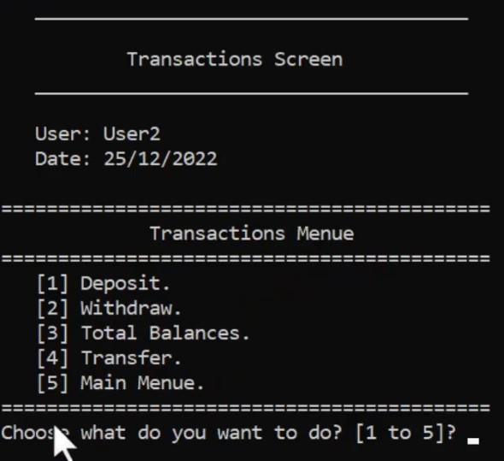

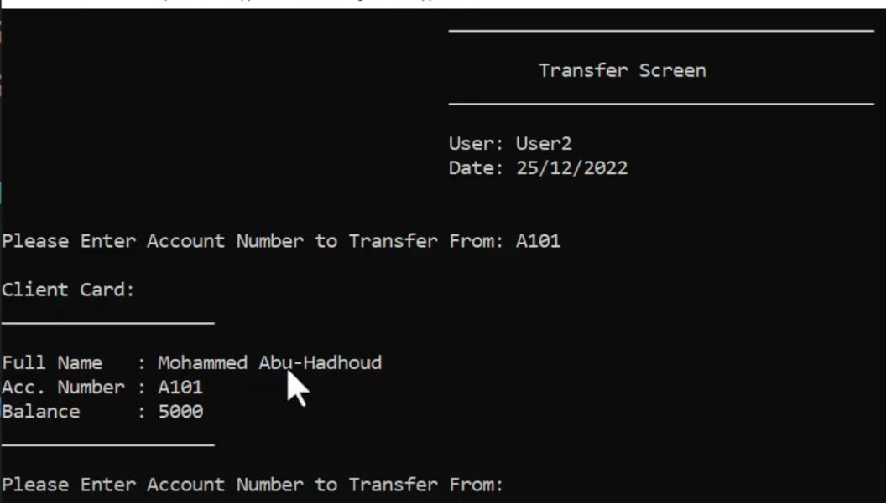

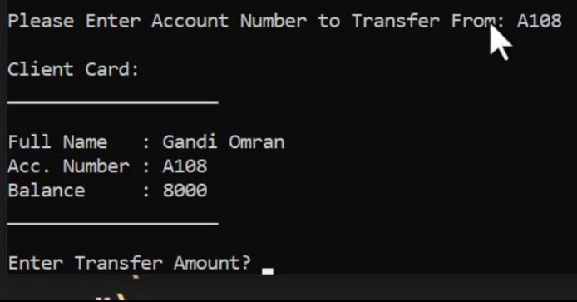

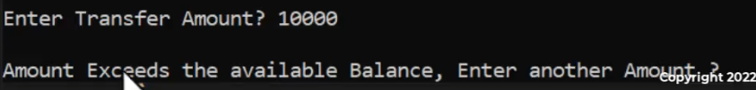

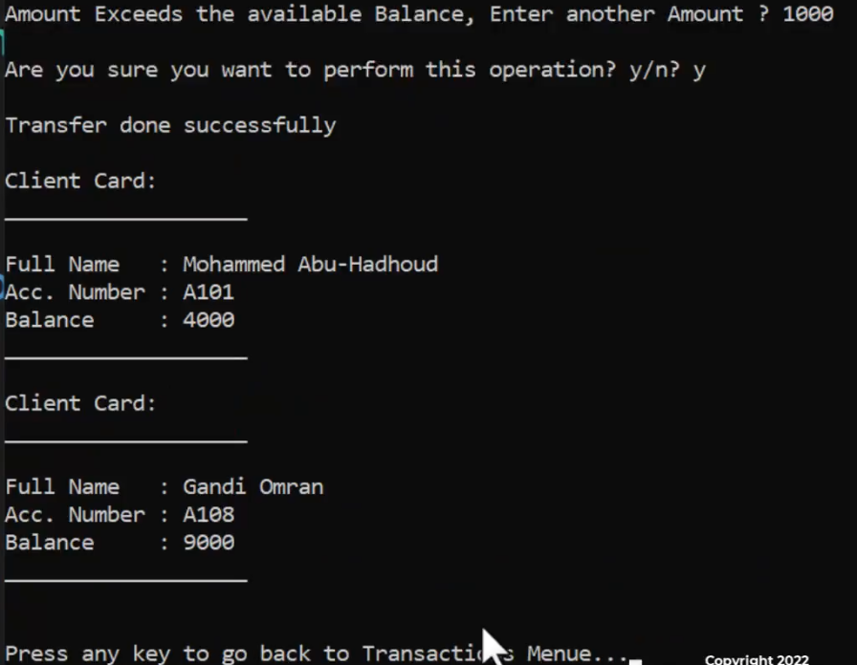

**Solution**

ده التعديل علي ال clsBankClient

|  |
| --- |
| bool Transfer(float Amount, clsBankClient& DestinationClient)  {  if (Amount > AccountBalance)  {  return false;  }  Withdraw(Amount);  DestinationClient.Deposit(Amount);  return true;  } |

ده كود شاشة ال transfer

|  |
| --- |
| #pragma once  #include <iostream>  #include "clsScreen.h"  #include "clsPerson.h"  #include "clsBankClient.h"  #include "clsInputValidate.h"  class clsTransferScreen :protected clsScreen  {  private:  static void _PrintClient(clsBankClient Client)  {  cout << "\nClient Card:";  cout << "\n___________________\n";  cout << "\nFull Name : " << Client.get_FullName();  cout << "\nAcc. Number : " << Client.get_AccountNumber();  cout << "\nBalance : " << Client.AccountBalance;  cout << "\n___________________\n";  }  static string _ReadAccountNumber()  {  string AccountNumber;  cout << "\nPlease Enter Account Number to Transfer From: ";  AccountNumber = clsInputValidate::ReadString();  while (!clsBankClient::IsClientExist(AccountNumber))  {  cout << "\nAccount number is not found, choose another one: ";  AccountNumber = clsInputValidate::ReadString();  }  return AccountNumber;  }  static float ReadAmount(clsBankClient SourceClient)  {  float Amount;  cout << "\nEnter Transfer Amount? ";  Amount = clsInputValidate::ReadFloatNumber();  while (Amount > SourceClient.AccountBalance)  {  cout << "\nAmount Exceeds the available Balance, Enter another Amount ? ";  Amount = clsInputValidate::ReadDblNumber();  }  return Amount;  }  public:  static void ShowTransferScreen()  {  _DrawScreenHeader("\tTransfer Screen","");  clsBankClient SourceClient = clsBankClient::Find(_ReadAccountNumber());  _PrintClient(SourceClient);  clsBankClient DestinationClient = clsBankClient::Find(_ReadAccountNumber());  _PrintClient(DestinationClient);  float Amount = ReadAmount(SourceClient);  cout << "\nAre you sure you want to perform this operation? y/n? ";  char Answer = 'n';  cin >> Answer;  if (Answer == 'Y' || Answer == 'y')  {  if (SourceClient.Transfer(Amount, DestinationClient))  {  cout << "\nTransfer done successfully\n";  }  else  {  cout << "\nTransfer Faild \n";  }  }  _PrintClient(SourceClient);  _PrintClient(DestinationClient);  }  }; |

ودي التعديلات علي كود قايمة ال transactions

|  |
| --- |
| enum enTransactionsMenueOptions {  eDeposit = 1, eWithdraw = 2,  eShowTotalBalance = 3,eTransfer=4 ,eShowMainMenue = 5  }; |
| static void _ShowTransferScreen()  {  clsTransferScreen::ShowTransferScreen();  } |
| case enTransactionsMenueOptions::eTransfer:  {  system("cls");  _ShowTransferScreen();  _GoBackToTransactionsMenue();  break;  } |
| static void ShowTransactionsMenue()  {  if (!CheckAccessRights(clsUser::enPermissions::pTranactions))  {  return;// this will exit the function and it will not continue  }  system("cls");  _DrawScreenHeader("\t Transactions Screen","");  cout << setw(37) << left << "" << "===========================================\n";  cout << setw(37) << left << "" << "\t\t Transactions Menue\n";  cout << setw(37) << left << "" << "===========================================\n";  cout << setw(37) << left << "" << "\t[1] Deposit.\n";  cout << setw(37) << left << "" << "\t[2] Withdraw.\n";  cout << setw(37) << left << "" << "\t[3] Total Balances.\n";  cout << setw(37) << left << "" << "\t[4] Transfer.\n";  cout << setw(37) << left << "" << "\t[5] Main Menue.\n";  cout << setw(37) << left << "" << "===========================================\n";  _PerformTransactionsMenueOption((enTransactionsMenueOptions)ReadTransactionsMenueOption());  } |

**Create Transfer Log**

عايزين نخزن عمليات التحويل بين الحسابات في ملف

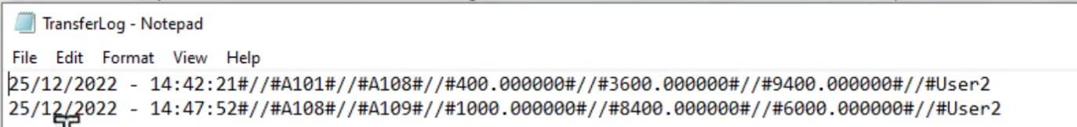

البيانات بالترتيب (التاريخ والوقت – المحول منه-المحول اليه – قيمة التحويل – رصيد المحول منه بعد التحويل – رصيد المحول اليه بعد التحويل- اليوزر اللي عمل التحويل)

**Solution**

ده التعديل علي ال clsBankClient

|  |
| --- |
| string _PrepareTransferLogRecord(float Amount, clsBankClient DestinationClient,  string UserName, string Seperator = "#//#")  {  string TransferLogRecord = "";  TransferLogRecord += clsDate::GetSystemDateTimeString() + Seperator;  TransferLogRecord += get_AccountNumber() + Seperator;  TransferLogRecord += DestinationClient.get_AccountNumber() + Seperator;  TransferLogRecord += to_string(Amount) + Seperator;  TransferLogRecord += to_string(AccountBalance) + Seperator;  TransferLogRecord += to_string(DestinationClient.AccountBalance) + Seperator;  TransferLogRecord += UserName;  return TransferLogRecord;  }  void _RegisterTransferLog(float Amount, clsBankClient DestinationClient, string UserName)  {  string stDataLine = _PrepareTransferLogRecord(Amount, DestinationClient, UserName);  fstream MyFile;  MyFile.open("TransferLog.txt", ios::out | ios::app);  if (MyFile.is_open())  {  MyFile << stDataLine << endl;  MyFile.close();  }  } |
| bool Transfer(float Amount, clsBankClient& DestinationClient, string UserName)  {  if (Amount > AccountBalance)  {  return false;  }  Withdraw(Amount);  DestinationClient.Deposit(Amount);  _RegisterTransferLog(Amount, DestinationClient, UserName);  return true;  } |

وده التعديل علي شاشة ال transfer

|  |
| --- |
| if (SourceClient.Transfer(Amount, DestinationClient, CurrentUser.UserName)) |

**Show Transfers Log Screen**

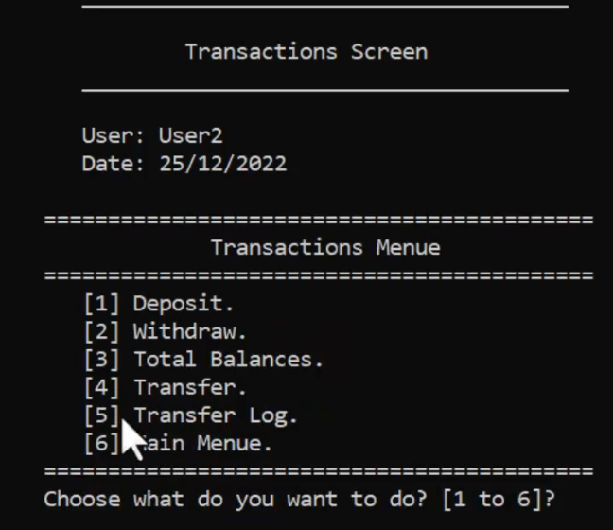

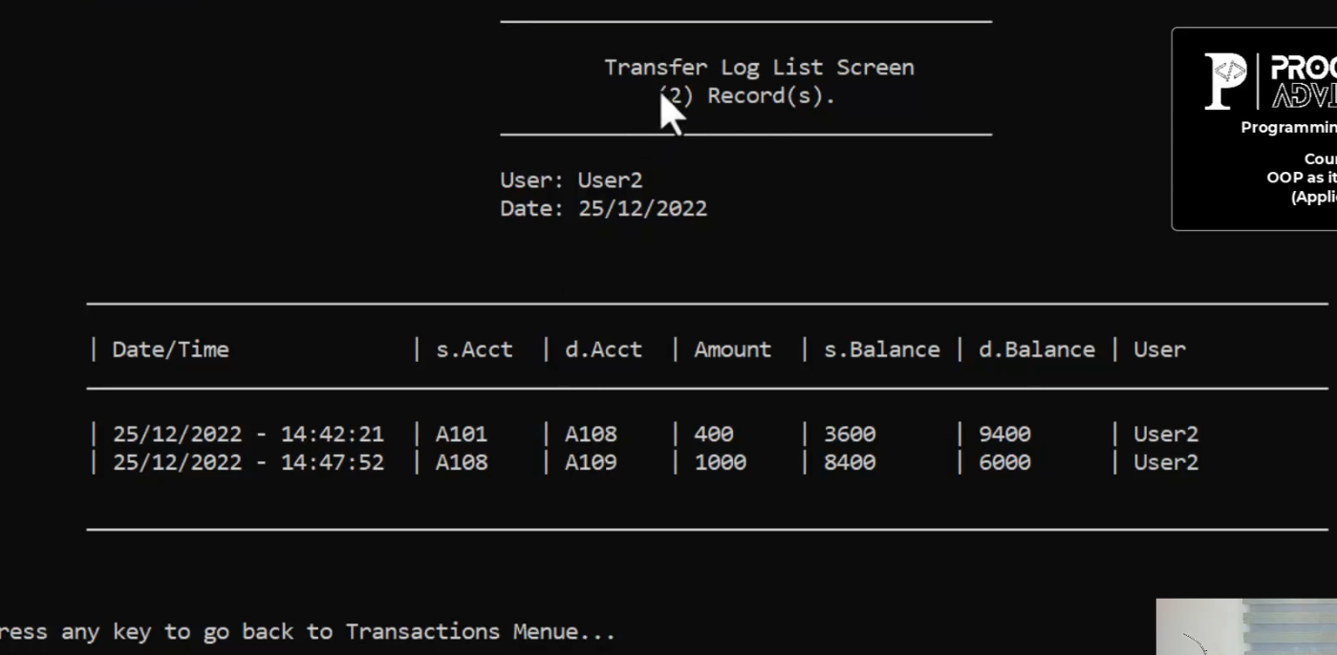

**Solution**

ده التعديل علي bank client

|  |
| --- |
| static stTrnsferLogRecord _ConvertTransferLogLineToRecord(string Line, string Seperator = "#//#")  {  stTrnsferLogRecord TrnsferLogRecord;  vector <string> vTrnsferLogRecordLine = clsString::Split(Line, Seperator);  TrnsferLogRecord.DateTime = vTrnsferLogRecordLine[0];  TrnsferLogRecord.SourceAccountNumber = vTrnsferLogRecordLine[1];  TrnsferLogRecord.DestinationAccountNumber = vTrnsferLogRecordLine[2];  TrnsferLogRecord.Amount = stod(vTrnsferLogRecordLine[3]);  TrnsferLogRecord.srcBalanceAfter = stod(vTrnsferLogRecordLine[4]);  TrnsferLogRecord.destBalanceAfter = stod(vTrnsferLogRecordLine[5]);  TrnsferLogRecord.UserName = vTrnsferLogRecordLine[6];  return TrnsferLogRecord;  }  public :  struct stTrnsferLogRecord  {  string DateTime;  string SourceAccountNumber;  string DestinationAccountNumber;  float Amount;  float srcBalanceAfter;  float destBalanceAfter;  string UserName;  }; |
| static vector <stTrnsferLogRecord> GetTransfersLogList()  {  vector <stTrnsferLogRecord> vTransferLogRecord;  fstream MyFile;  MyFile.open("TransfersLog.txt", ios::in);//read Mode  if (MyFile.is_open())  {  string Line;  stTrnsferLogRecord TransferRecord;  while (getline(MyFile, Line))  {  TransferRecord = _ConvertTransferLogLineToRecord(Line);  vTransferLogRecord.push_back(TransferRecord);  }  MyFile.close();  }  return vTransferLogRecord;  } |

ده التعديل علي قايمة ال transactions

|  |
| --- |
| enum enTransactionsMenueOptions {  eDeposit = 1, eWithdraw = 2,  eShowTotalBalance = 3, eTransfer = 4, eTransferLog = 5,  eShowMainMenue = 6  }; |
| static short ReadTransactionsMenueOption()  {  cout << setw(37) << left << "" << "Choose what do you want to do? [1 to 6]? ";  short Choice = clsInputValidate::ReadShortNumberBetween(1, 6, "Enter Number between 1 to 6? ");  return Choice;  } |
| static void _ShowTransferLogScreen()  {  //cout << "\n Transfer Screen will be here.\n";  clsTransferLogScreen::ShowTransferLogScreen();  } |
| case enTransactionsMenueOptions::eTransferLog:  {  system("cls");  _ShowTransferLogScreen();  _GoBackToTransactionsMenue();  break;  } |
| static void ShowTransactionsMenue()  {  if (!CheckAccessRights(clsUser::enPermissions::pTranactions))  {  return;// this will exit the function and it will not continue  }  system("cls");  _DrawScreenHeader("\tTransactions Screen","");  cout << setw(37) << left << "" << "===========================================\n";  cout << setw(37) << left << "" << "\t\t Transactions Menue\n";  cout << setw(37) << left << "" << "===========================================\n";  cout << setw(37) << left << "" << "\t[1] Deposit.\n";  cout << setw(37) << left << "" << "\t[2] Withdraw.\n";  cout << setw(37) << left << "" << "\t[3] Total Balances.\n";  cout << setw(37) << left << "" << "\t[4] Transfer.\n";  cout << setw(37) << left << "" << "\t[5] Transfer Log.\n";  cout << setw(37) << left << "" << "\t[6] Main Menue.\n";  cout << setw(37) << left << "" << "===========================================\n";  _PerformTransactionsMenueOption((enTransactionsMenueOptions)ReadTransactionsMenueOption());  } |

ده كود شاشة ال transfer log

|  |
| --- |
| #pragma once  #include <iostream>  #include "clsScreen.h"  #include <iomanip>  #include <fstream>  #include "clsBankClient.h"  class clsTransferLogScreen :protected clsScreen  {  private:  static void PrintTransferLogRecordLine(clsBankClient::stTrnsferLogRecord TransferLogRecord)  {  cout << setw(8) << left << "" << "| " << setw(23) << left << TransferLogRecord.DateTime;  cout << "| " << setw(8) << left << TransferLogRecord.SourceAccountNumber;  cout << "| " << setw(8) << left << TransferLogRecord.DestinationAccountNumber;  cout << "| " << setw(8) << left << TransferLogRecord.Amount;  cout << "| " << setw(10) << left << TransferLogRecord.srcBalanceAfter;  cout << "| " << setw(10) << left << TransferLogRecord.destBalanceAfter;  cout << "| " << setw(8) << left << TransferLogRecord.UserName;  }  public:  static void ShowTransferLogScreen()  {  vector <clsBankClient::stTrnsferLogRecord> vTransferLogRecord = clsBankClient::GetTransfersLogList();  string Title = "\tTransfer Log List Screen";  string SubTitle = "\t (" + to_string(vTransferLogRecord.size()) + ") Record(s).";  _DrawScreenHeader(Title, SubTitle);  cout << setw(8) << left << "" << "\n\t_______________________________________________________";  cout << "_________________________________________\n" << endl;  cout << setw(8) << left << "" << "| " << left << setw(23) << "Date/Time";  cout << "| " << left << setw(8) << "s.Acct";  cout << "| " << left << setw(8) << "d.Acct";  cout << "| " << left << setw(8) << "Amount";  cout << "| " << left << setw(10) << "s.Balance";  cout << "| " << left << setw(10) << "d.Balance";  cout << "| " << left << setw(8) << "User";  cout << setw(8) << left << "" << "\n\t_______________________________________________________";  cout << "_________________________________________\n" << endl;  if (vTransferLogRecord.size() == 0)  cout << "\t\t\t\tNo Transfers Available In the System!";  else  for (clsBankClient::stTrnsferLogRecord Record : vTransferLogRecord)  {  PrintTransferLogRecordLine(Record);  cout << endl;  }  cout << setw(8) << left << "" << "\n\t_______________________________________________________";  cout << "_________________________________________\n" << endl;  }  }; |

**Encrypt Password In File**

عاوز يشفر الباسورد اللي في ملف ال user.txt

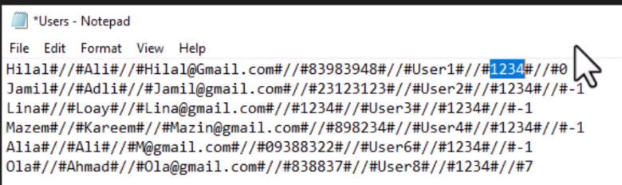

لو الباسوورد مثلا 1234 انت تخزنه علي انه مثلا 4567 بس جوه السيستم تتعامل معاه علي انه 1234 وتعمل الحوار ده في كل ملف محفوظ فيه الباسورد

**Solution**

كل اللي هتعمله انك هتيجي عند أي FUNCTION بتخزن باسورد وتعمله ENCRYPT

وتيجي عند أي FUNCTION بتقرا الباسورد من الملف وتعمله DECRYPT

ده التعديل علي كلاس ال UTIL

|  |
| --- |
| static string EncryptText(string Text, short EncryptionKey = 2)  {  for (int i = 0; i <= Text.length(); i++)  {  Text[i] = char((int)Text[i] + EncryptionKey);  }  return Text;  }  static string DecryptText(string Text, short EncryptionKey = 2)  {  for (int i = 0; i <= Text.length(); i++)  {  Text[i] = char((int)Text[i] - EncryptionKey);  }  return Text;  } |

وده التعديل علي كلاس ال USER

|  |
| --- |
| //private functions  static stLoginRegisterRecord _ConvertLoginRegisterLineToRecord(string Line, string Seperator = "#//#")  {  stLoginRegisterRecord LoginRegisterRecord;  vector <string> LoginRegisterDataLine = clsString::Split(Line, Seperator);  LoginRegisterRecord.DateTime = LoginRegisterDataLine[0];  LoginRegisterRecord.UserName = LoginRegisterDataLine[1];  LoginRegisterRecord.Password = clsUtil::DecryptText(LoginRegisterDataLine[2]);  LoginRegisterRecord.Permissions = stoi(LoginRegisterDataLine[3]);  return LoginRegisterRecord;  }  string _PrepareLogInRecord(string Seperator = "#//#")  {  string LoginRecord = "";  LoginRecord += clsDate::GetSystemDateTimeString() + Seperator;  LoginRecord += UserName + Seperator;  //here we encypt store the encrypted Password not the real one.  LoginRecord += clsUtil::EncryptText(PassWord) + Seperator;  LoginRecord += to_string(Permissions);  return LoginRecord;  }  static clsUser _ConvertLineToUserObject(string Line,string Seperator="#//#") {  vector<string> vUserData;  vUserData = clsString::Split(Line, Seperator);  return clsUser(enMode::UpdateMode, vUserData[0], vUserData[1], vUserData[2],  vUserData[3], vUserData[4], clsUtil::DecryptText(vUserData[5]), stoi(vUserData[6]));  }  static string _ConvertFromUserObjectToLine(clsUser User, string Seperator = "#//#") {  string UserRecord = "";  UserRecord += User.FirstName + Seperator;  UserRecord += User.LastName + Seperator;  UserRecord += User.Email + Seperator;  UserRecord += User.Phone + Seperator;  UserRecord += User.UserName + Seperator;  //here we encypt store the encrypted Password not the real one.  UserRecord += clsUtil::EncryptText(User.PassWord) + Seperator;  UserRecord += to_string(User.Permissions);  return UserRecord;  } |

**Abstract Class/Interface Practical Example**

ال interface وال abstract class هوا عقد بين أستاذ محمد أبو هدهود وبينك ك developer

ولازم تلبي كل الشروط الموجوده فيه لو ماعملتش الشروط دي ال compiler مش هيعمل compile للكود

لو جيت قولتلك ان كلاس ال person يكون عندي send fax و send emails و send sms

الثقه بيني وبينك موجوده بس ممكن تغلط في انك ماتكتبش الاسامي بالطريقه اللي اناعايزها او تعمل parameters مش من النوع اللي انا عايزه او تديها اسامي غلط

هنا مثلا انا عملت ال interface ده

|  |
| --- |
| #pragma once  #include <iostream>  #include <string>  using namespace std;  class InterfaceCommunication  {  public:  virtual void SendEmail(string Title, string Body) = 0;  virtual void SendFax(string Title, string Body) = 0;  virtual void SendSMS(string Title, string Body) = 0;  }; |

أي حد هيورث منه لازم يعمل implementation لل functions اللي موجوده فيه زي كده

|  |
| --- |
| #pragma once  #include<iostream>  #include "InterfaceCommunication.h"  using namespace std;  class clsPerson :public InterfaceCommunication  {  private:  string _FirstName;  string _LastName;  string _Email;  string _Phone;  public:  //constructors  clsPerson(string FirstName,string LastName,string Email,string Phone) {  this->_FirstName = FirstName;  this->_LastName = LastName;  this->_Email = Email;  this->_Phone = Phone;  }  //setters  void set_FirstName (string FirstName) { this->_FirstName = FirstName; }  void set_LastName (string LastName) { this->_LastName = LastName; }  void set_Email(string Email) { this->_Email = Email; }  void set_Phone(string Phone) { this->_Phone = Phone; }  //getters  string get_FirstName() { return this->_FirstName; }  string get_LastName() { return this->_LastName; }  string get_Email() { return this->_Email; }  string get_Phone() { return this->_Phone; }  string get_FullName() { return this->_FirstName+" "+ this->_LastName; }  //declspec  __declspec(property(get = get_FirstName, put = set_FirstName))string FirstName;  __declspec(property(get = get_LastName, put = set_LastName))string LastName;  __declspec(property(get = get_Email, put = set_Email))string Email;  __declspec(property(get = get_Phone, put = set_Phone))string Phone;  //person functions  void Print()  {  cout << "\nInfo:";  cout << "\n___________________";  cout << "\nFirstName: " << this->_FirstName;  cout << "\nLastName : " << this->_LastName;  cout << "\nFull Name: " << this->get_FullName();  cout << "\nEmail : " << this->_Email;  cout << "\nPhone : " << this->_Phone;  cout << "\n___________________\n";  }  /////////////////implementation of interface    void SendEmail(string Title, string Body)  {  }  void SendFax(string Title, string Body)  {  }  void SendSMS(string Title, string Body)  {  }  }; |

**Project Overview**

هنعمل مشروع صغير عباره عن currency exchange بس هيكون من ضمن مشروع البنك

هيديك رؤية عنه بس ماتطبقش غير من الدرس اللي بعده

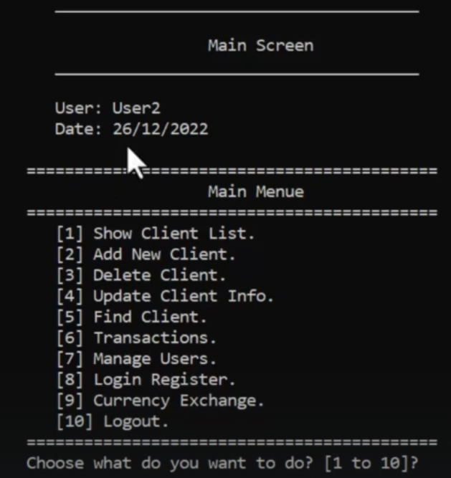

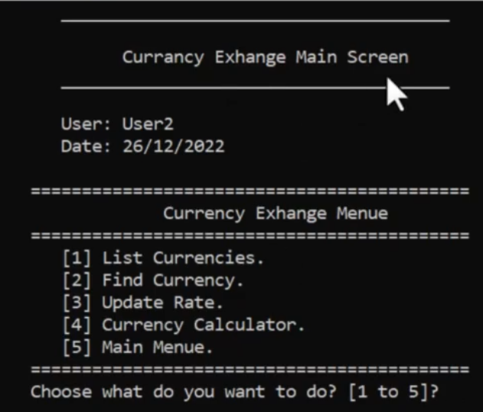

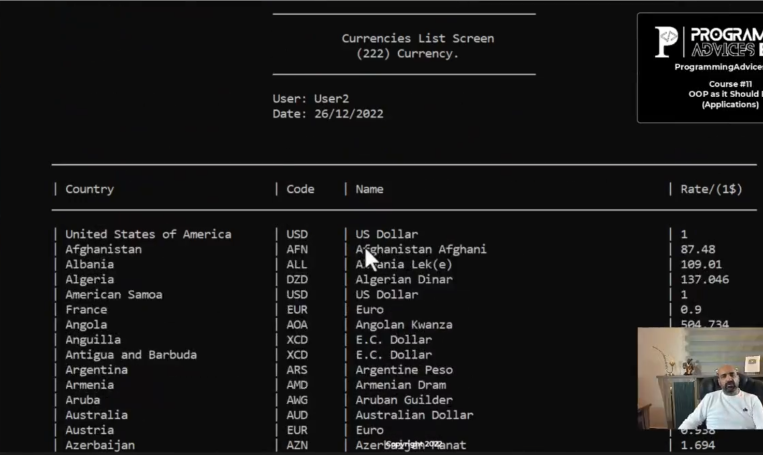

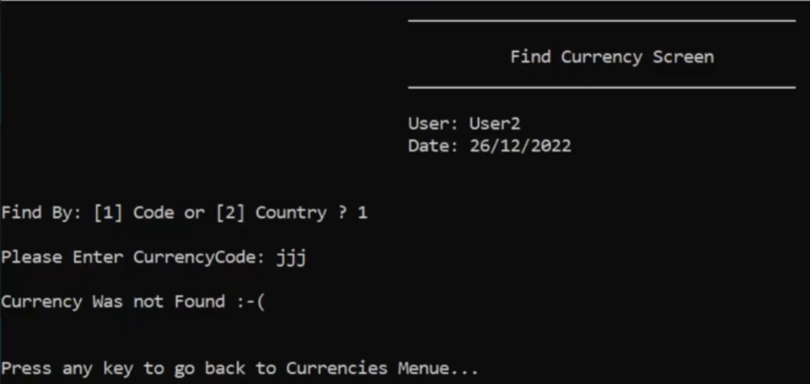

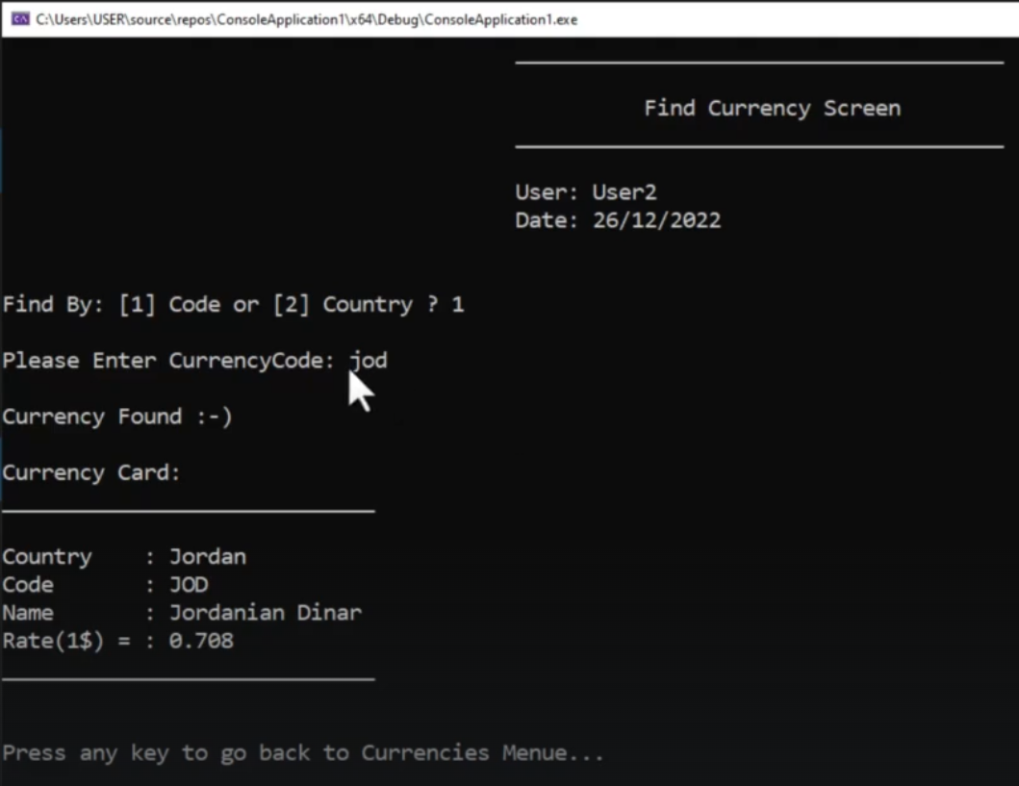

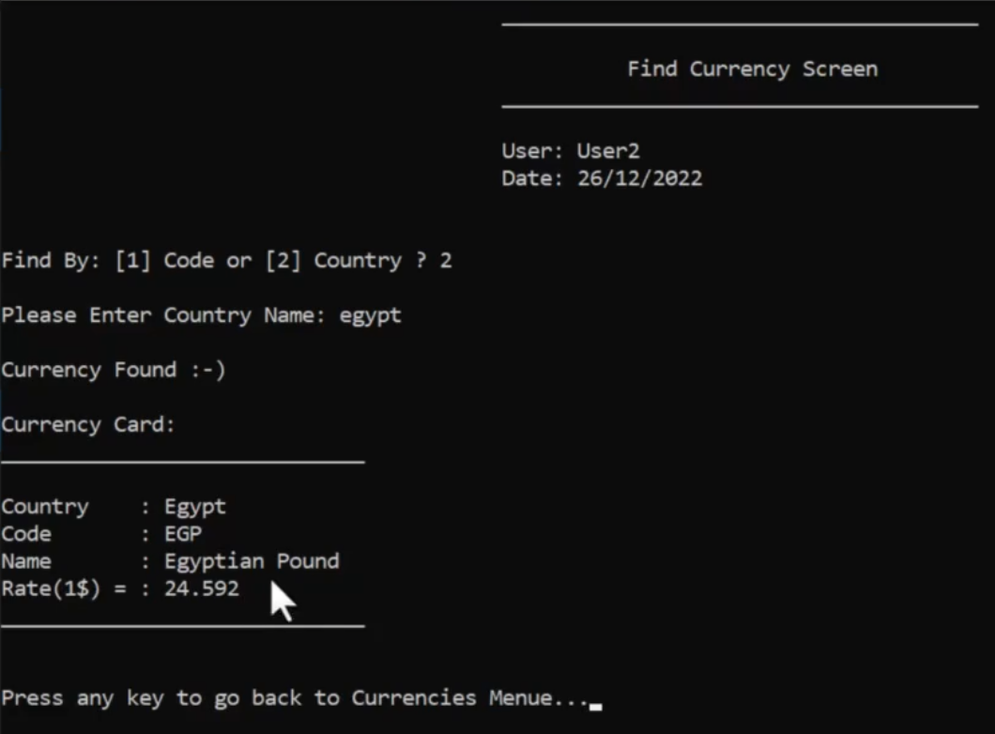

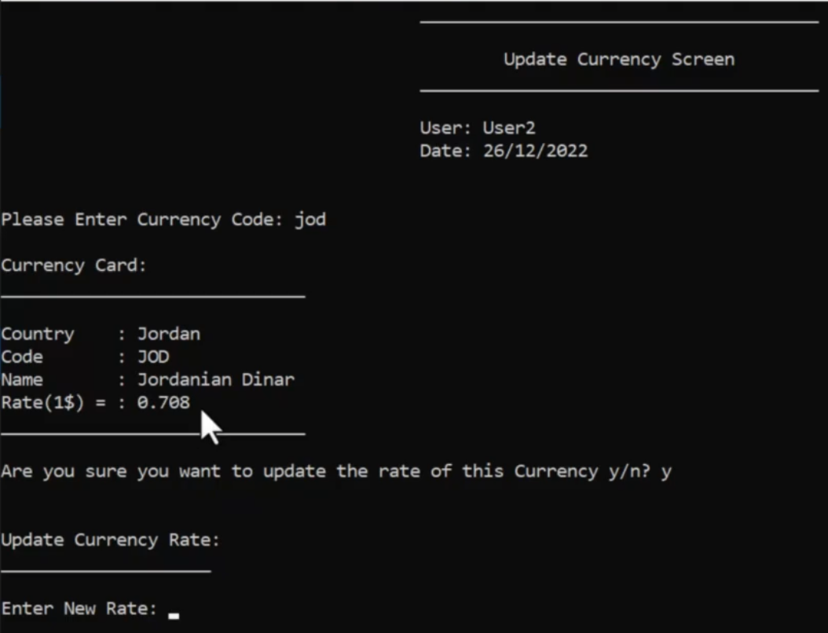

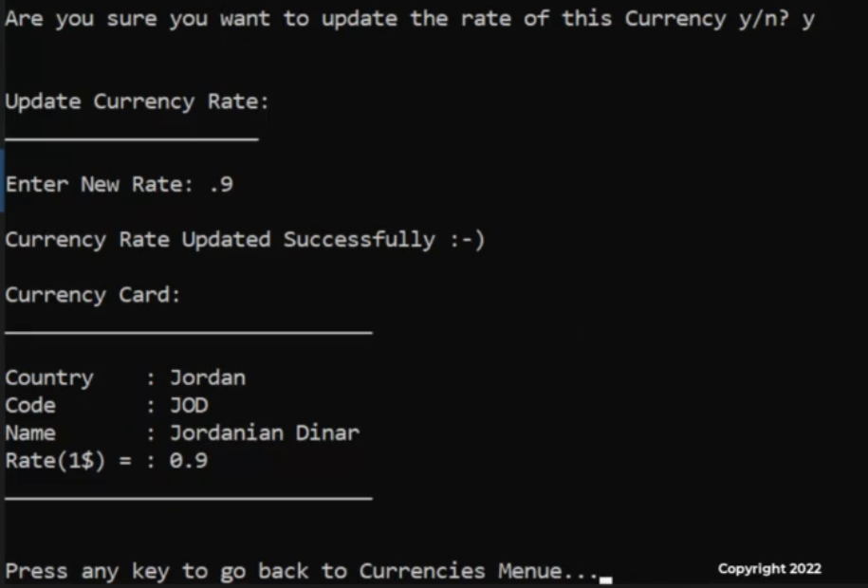

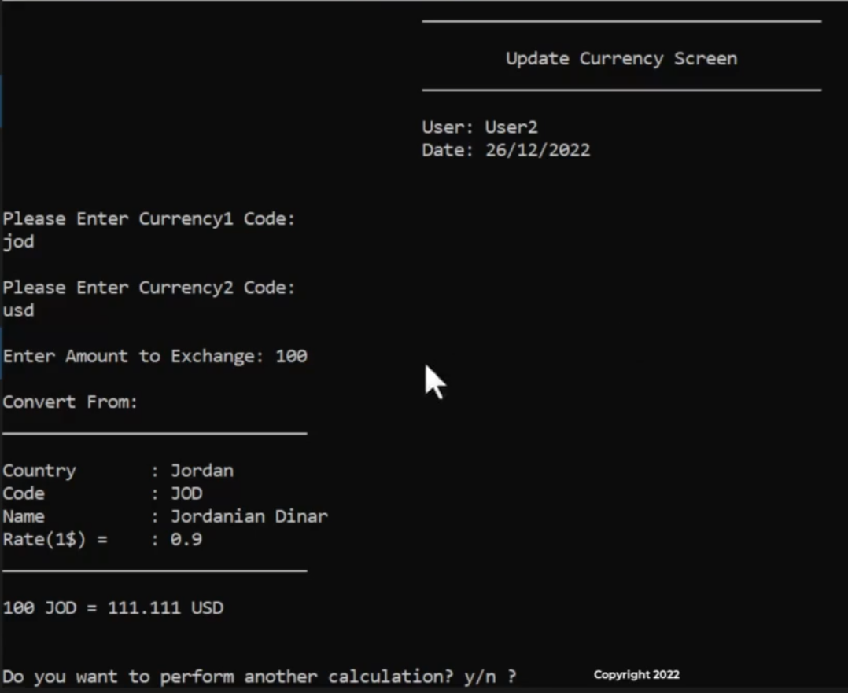

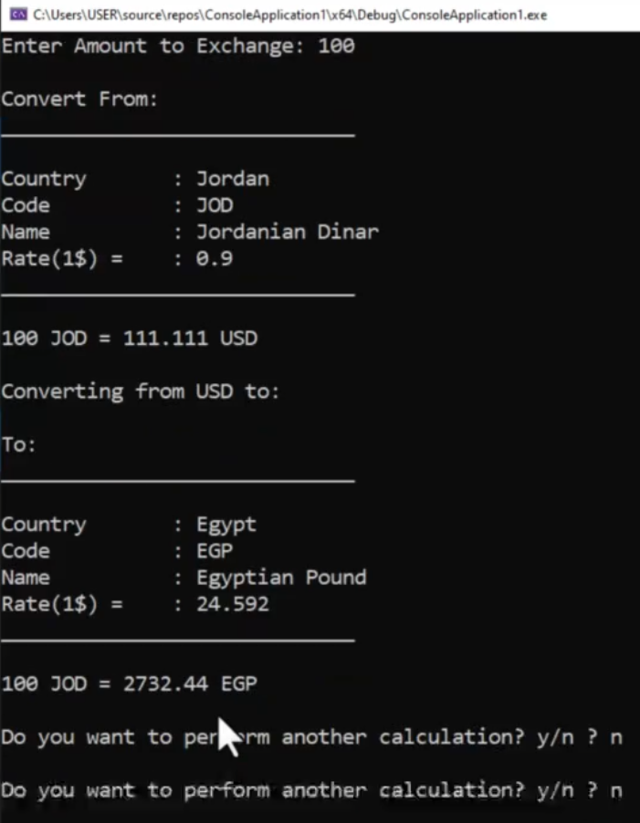

**Prepare Currency Object**

هنعمل كلاس ال currency

ده شكل ملف ال text اللي فيه الداتا بتاعت اسعار العملات

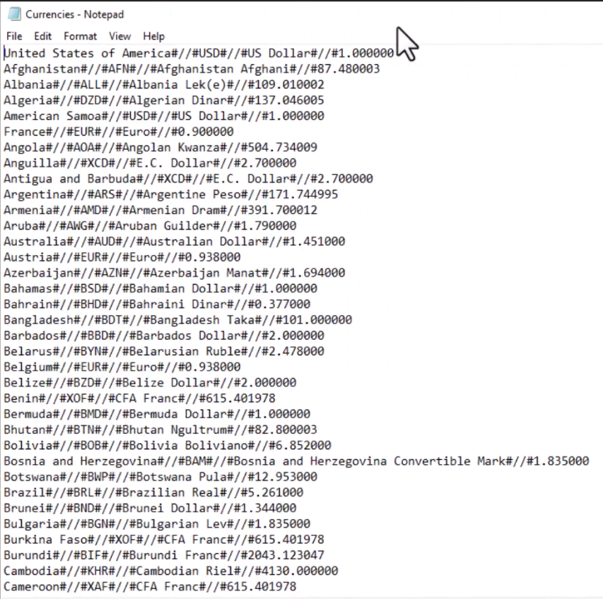

الملف عباره عن اسم الدوله وكود العمله واسم العمله وسعر التحويل

كل المطلوب مني هنا اني اعدل ال rate مش عايز اعدل حاجه تانيه

ده كلاس ال currency

|  |
| --- |
| #pragma once  #include<iostream>  #include<fstream>  #include <vector>  #include"clsString.h"  #include <string>  using namespace std;  class clsCurrency  {  private:  enum enMode { EmptyMode=0,UpdateMode=1};  //private variables  enMode _Mode;  string _Country;  string _CurrencyCode;  string _CrruncyName;  float _Rate;  //private functions  static clsCurrency _ConvertLineToCurrencyObject(string Line, string Seperator = "#//#") {  vector<string> vCurrencyData=clsString::Split(Line,Seperator);  return clsCurrency(enMode::UpdateMode,vCurrencyData[0],vCurrencyData[1],vCurrencyData[2],stof(vCurrencyData[3]));  }  static string _ConvertCurrencyObjectToLine(clsCurrency Currency,string Seperator="#//#") {  return Currency.get_Country() + Seperator  + Currency.get_CurrencyCode() + Seperator  + Currency.get_CurrencyName() + Seperator  + to_string(Currency.get_Rate());  }  static vector<clsCurrency> _LoadCurrencysDataFromFile() {  vector<clsCurrency> vCurrencys;  fstream MyFile;  MyFile.open("Currencies.txt", ios::in);  if (MyFile.is_open()) {  string Line;    while (getline(MyFile,Line)) {  vCurrencys.push_back(_ConvertLineToCurrencyObject(Line));  }  MyFile.close();  }  return vCurrencys;  }  static void _SaveCurrencyDataToFile(vector<clsCurrency> vCurrencys) {  fstream MyFile;  MyFile.open("Currencies.txt",ios::out);  if (MyFile.is_open()) {  for (clsCurrency Currency:vCurrencys) {  MyFile << _ConvertCurrencyObjectToLine(Currency) << endl;  }  MyFile.close();  }  }  void _Update() {  vector<clsCurrency>vCurrencys = _LoadCurrencysDataFromFile();  for (clsCurrency &Currency:vCurrencys) {  if (Currency.get_CurrencyCode()==this->_CurrencyCode) {  Currency = *this;  }  }  _SaveCurrencyDataToFile(vCurrencys);  }  static clsCurrency getEmptyCurrencyObject() {  return clsCurrency(enMode::EmptyMode,"","","",0);  }  public:  //constructors  clsCurrency(enMode Mode,string Country,string CurrencyCode,string currencyName,float Rate) {  this->_Mode = Mode;  this->_Country = Country;  this->_CurrencyCode = CurrencyCode;  this->_CrruncyName = currencyName;  this->_Rate = Rate;  }  //setters  void UpdateRate(float Rate) { this->_Rate = Rate;  _Update();  };  //getters  enMode get_Mode() { return this->_Mode; }  string get_Country(){ return this->_Country; }  string get_CurrencyCode() { return this->_CurrencyCode; }  string get_CurrencyName() { return this->_CrruncyName; }  float get_Rate() { return this->_Rate; }  //Public functions  bool IsEmpty() { return (this->_Mode==enMode::EmptyMode); }  static clsCurrency FindByCode(string CurrencyCode) {  CurrencyCode = clsString::UpperAllString(CurrencyCode);  fstream Myfile;  Myfile.open("Currencies.txt",ios::in);  if (Myfile.is_open()) {  string Line;  while (getline(Myfile,Line)) {  clsCurrency Currency= _ConvertLineToCurrencyObject(Line);  if (Currency.get_CurrencyCode() ==CurrencyCode ) {  Myfile.close();  return Currency;  }  }  }  return getEmptyCurrencyObject();  }  static clsCurrency FindByCountry(string Country) {  Country = clsString::UpperAllString(Country);  fstream Myfile;  Myfile.open("Currencies.txt", ios::in);  if (Myfile.is_open()) {  string Line;  while (getline(Myfile, Line)) {  clsCurrency Currency = _ConvertLineToCurrencyObject(Line);  if (clsString::UpperAllString(Currency.get_Country()) == Country) {  Myfile.close();  return Currency;  }  }  }  return getEmptyCurrencyObject();  }  static bool IsCurrencyExist(string CurrencyCode) {  clsCurrency c1 = FindByCode(CurrencyCode);  return (!c1.IsEmpty());  }  static vector<clsCurrency> GetCurrenciesList() {  return _LoadCurrencysDataFromFile();  }    }; |

وهنا بنجرب الكود في ال main كبدايه

|  |
| --- |
| #include <iostream>  #include "clsCurrency.h"  static void _PrintCurrency(clsCurrency Currency)  {  cout << "\nCurrency Card:\n";  cout << "_____________________________\n";  cout << "\nCountry : " << Currency.get_Country();  cout << "\nCode : " << Currency.get_CurrencyCode();  cout << "\nName : " << Currency.get_CurrencyName();  cout << "\nRate(1$) = : " << Currency.get_Rate();  cout << "\n_____________________________\n";  }  int main()  {  clsCurrency Currency1 = Currency1.FindByCode("jod");  if (Currency1.IsEmpty())  {  cout << "\nCurrency Is Not Found!\n";  }  else  {  _PrintCurrency(Currency1);  }  clsCurrency Currency2 = Currency2.FindByCountry("Egypt");  if (Currency2.IsEmpty())  {  cout << "\nCurrency Is Not Found!\n";  }  else  {  _PrintCurrency(Currency2);  }  cout << "Currency1 after updating Rate:\n";  Currency1.UpdateRate(0.71);  _PrintCurrency(Currency1);  return 0;  } |

**Currency Main Screen**

عايزين نضيف قايمة ال currency للشاشه الرئيسيه

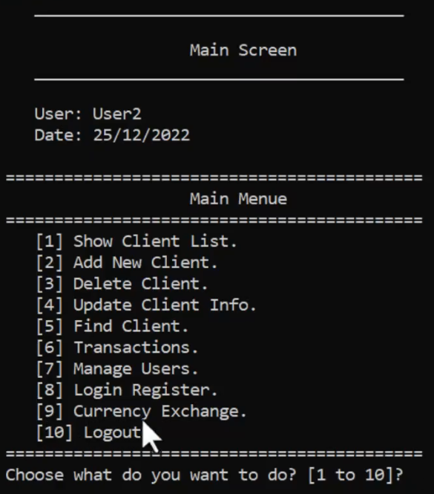

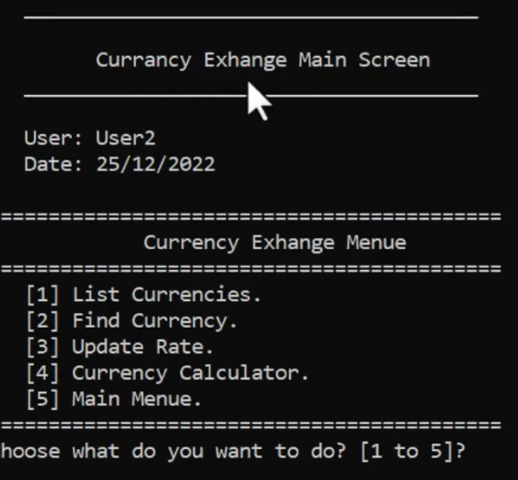

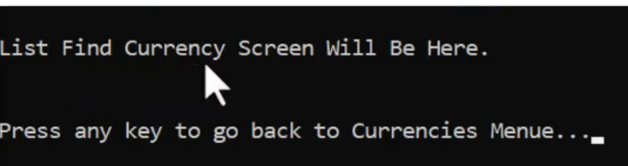

**Solution**

ده كود شاشة ال currency exchange

|  |
| --- |
| #pragma once  #include <iostream>  #include "clsScreen.h"  #include "clsInputValidate.h"  #include <iomanip>  using namespace std;  class clsCurrencyExchangeMainScreen :protected clsScreen  {  private:  enum enCurrenciesMainMenueOptions {  eListCurrencies = 1, eFindCurrency = 2, eUpdateCurrencyRate = 3,  eCurrencyCalculator = 4, eMainMenue = 5  };  static short ReadCurrenciesMainMenueOptions()  {  cout << setw(37) << left << "" << "Choose what do you want to do? [1 to 5]? ";  short Choice = clsInputValidate::ReadShortNumberBetween(1, 5, "Enter Number between 1 to 5? ");  return Choice;  }  static void _GoBackToCurrenciesMenue()  {  cout << "\n\nPress any key to go back to Currencies Menue...";  system("pause>0");  ShowCurrenciesMenue();  }  static void _ShowCurrenciesListScreen()  {  cout << "\nCurriencies List Screen Will Be Here.\n";  }  static void _ShowFindCurrencyScreen()  {  cout << "\nFind Currency Screen Will Be Here.\n";  }  static void _ShowUpdateCurrencyRateScreen()  {  cout << "\nUpdate Currency Rate Screen Will Be Here.\n";  }  static void _ShowCurrencyCalculatorScreen()  {  cout << "\nCurrency Calculator Screen Will Be Here.\n";  }  static void _PerformCurrenciesMainMenueOptions(enCurrenciesMainMenueOptions CurrenciesMainMenueOptions)  {  switch (CurrenciesMainMenueOptions)  {  case enCurrenciesMainMenueOptions::eListCurrencies:  {  system("cls");  _ShowCurrenciesListScreen();  _GoBackToCurrenciesMenue();  break;  }  case enCurrenciesMainMenueOptions::eFindCurrency:  {  system("cls");  _ShowFindCurrencyScreen();  _GoBackToCurrenciesMenue();  break;  }  case enCurrenciesMainMenueOptions::eUpdateCurrencyRate:  {  system("cls");  _ShowUpdateCurrencyRateScreen();  _GoBackToCurrenciesMenue();  break;  }  case enCurrenciesMainMenueOptions::eCurrencyCalculator:  {  system("cls");  _ShowCurrencyCalculatorScreen();  _GoBackToCurrenciesMenue();  break;  }  case enCurrenciesMainMenueOptions::eMainMenue:  {  //do nothing here the main screen will handle it :-) ;  }  }  }  public:  static void ShowCurrenciesMenue()  {  system("cls");  _DrawScreenHeader(" Currancy Exhange Main Screen","");  cout << setw(37) << left << "" << "===========================================\n";  cout << setw(37) << left << "" << "\t\t Currency Exhange Menue\n";  cout << setw(37) << left << "" << "===========================================\n";  cout << setw(37) << left << "" << "\t[1] List Currencies.\n";  cout << setw(37) << left << "" << "\t[2] Find Currency.\n";  cout << setw(37) << left << "" << "\t[3] Update Rate.\n";  cout << setw(37) << left << "" << "\t[4] Currency Calculator.\n";  cout << setw(37) << left << "" << "\t[5] Main Menue.\n";  cout << setw(37) << left << "" << "===========================================\n";  _PerformCurrenciesMainMenueOptions((enCurrenciesMainMenueOptions)ReadCurrenciesMainMenueOptions());  }  }; |

ده كود شاشة ال main screen

|  |
| --- |
| #pragma once  #include <iostream>  #include "clsScreen.h"  #include "clsInputValidate.h"  #include "clsClientListScreen.h"  #include "clsAddNewClientScreen.h"  #include "clsDeleteClientScreen.h"  #include "clsUpdateClientScreen.h"  #include "clsFindClientScreen.h"  #include "clsTransactionsScreen.h"  #include "clsManageUsersScreen.h"  #include "clsLoginScreen.h"  #include "Global.h"  #include "clsLoginRegisterScreen.h"  #include "clsCurrencyExchangeMainScreen.h"  using namespace std;  class clsMainScreen :protected clsScreen  {  private:  enum enMainMenueOptions {  eListClients = 1, eAddNewClient = 2, eDeleteClient = 3,  eUpdateClient = 4, eFindClient = 5, eShowTransactionsMenue = 6,  eManageUsers = 7, eLoginRegister = 8, eCurrncyExchange = 9, eExit = 10  };  static short _ReadMainMenueOption()  {  cout << setw(37) << left << "" << "Choose what do you want to do? [1 to 10]? ";  short Choice = clsInputValidate::ReadShortNumberBetween(1, 10, "Enter Number between 1 to 10? ");  return Choice;  }  static void _GoBackToMainMenue()  {  cout << setw(37) << left << "" << "\n\tPress any key to go back to Main Menue...\n";  system("pause>0");  ShowMainMenue();  }  static void _ShowAllClientsScreen()  {  // cout << "\nClient List Screen Will be here...\n";  clsClientListScreen::ShowClientsList();  }  static void _ShowAddNewClientsScreen()  {  // cout << "\nAdd New Client Screen Will be here...\n";  clsAddNewClientScreen::ShowAddNewClientScreen();  }  static void _ShowDeleteClientScreen()  {  //cout << "\nDelete Client Screen Will be here...\n";  clsDeleteClientScreen::ShowDeleteClientScreen();  }  static void _ShowUpdateClientScreen()  {  //cout << "\nUpdate Client Screen Will be here...\n";  clsUpdateClientScreen::ShowUpdateClientScreen();  }  static void _ShowFindClientScreen()  {  // cout << "\nFind Client Screen Will be here...\n";  clsFindClientScreen::ShowFindClientScreen();  }  static void _ShowTransactionsMenue()  {  // cout << "\nTransactions Menue Will be here...\n";  clsTransactionsScreen::ShowTransactionsMenue();  }  static void _ShowManageUsersMenue()  {  // cout << "\nUsers Menue Will be here...\n";  clsManageUsersScreen::ShowManageUsersMenue();  }  static void _ShowLoginRegisterScreen()  {  // cout << "\nLogin Register Will be here...\n";  clsLoginRegisterScreen::ShowLoginRegisterScreen();  }  static void _ShowCurrencyExchangeMainScreen()  {  clsCurrencyExchangeMainScreen::ShowCurrenciesMenue();  }  static void _Logout()  {  CurrentUser = clsUser::Find("", "");  //then it will go back to main function.  }  static void _PerfromMainMenueOption(enMainMenueOptions MainMenueOption)  {  switch (MainMenueOption)  {  case enMainMenueOptions::eListClients:  {  system("cls");  _ShowAllClientsScreen();  _GoBackToMainMenue();  break;  }  case enMainMenueOptions::eAddNewClient:  system("cls");  _ShowAddNewClientsScreen();  _GoBackToMainMenue();  break;  case enMainMenueOptions::eDeleteClient:  system("cls");  _ShowDeleteClientScreen();  _GoBackToMainMenue();  break;  case enMainMenueOptions::eUpdateClient:  system("cls");  _ShowUpdateClientScreen();  _GoBackToMainMenue();  break;  case enMainMenueOptions::eFindClient:  system("cls");  _ShowFindClientScreen();  _GoBackToMainMenue();  break;  case enMainMenueOptions::eShowTransactionsMenue:  system("cls");  _ShowTransactionsMenue();  _GoBackToMainMenue();  break;  case enMainMenueOptions::eManageUsers:  system("cls");  _ShowManageUsersMenue();  _GoBackToMainMenue();  break;  case enMainMenueOptions::eLoginRegister:  system("cls");  _ShowLoginRegisterScreen();  _GoBackToMainMenue();  break;  case enMainMenueOptions::eCurrncyExchange:  system("cls");  _ShowCurrencyExchangeMainScreen();  _GoBackToMainMenue();  break;  case enMainMenueOptions::eExit:  system("cls");  _Logout();  break;  }  }  public:  static void ShowMainMenue()  {  system("cls");  _DrawScreenHeader("\t\tMain Screen","");  cout << setw(37) << left << "" << "===========================================\n";  cout << setw(37) << left << "" << "\t\t\tMain Menue\n";  cout << setw(37) << left << "" << "===========================================\n";  cout << setw(37) << left << "" << "\t[1] Show Client List.\n";  cout << setw(37) << left << "" << "\t[2] Add New Client.\n";  cout << setw(37) << left << "" << "\t[3] Delete Client.\n";  cout << setw(37) << left << "" << "\t[4] Update Client Info.\n";  cout << setw(37) << left << "" << "\t[5] Find Client.\n";  cout << setw(37) << left << "" << "\t[6] Transactions.\n";  cout << setw(37) << left << "" << "\t[7] Manage Users.\n";  cout << setw(37) << left << "" << "\t[8] Login Register.\n";  cout << setw(37) << left << "" << "\t[9] Currency Exchange.\n";  cout << setw(37) << left << "" << "\t[10] Logout.\n";  cout << setw(37) << left << "" << "===========================================\n";  _PerfromMainMenueOption((enMainMenueOptions)_ReadMainMenueOption());  }  }; |

**Currencies List Screen**

عاوزين نعمل شاشة list currencies

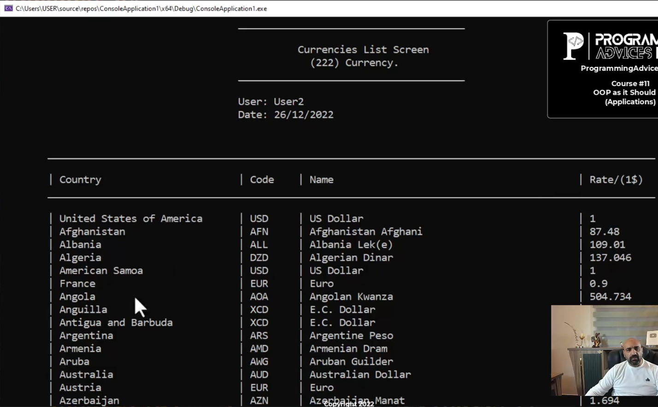

**Solution**

ده كود الشاشه

|  |
| --- |
| #pragma once  #include <iostream>  #include "clsScreen.h"  #include "clsCurrency.h"  #include <iomanip>  class clsListCurrenciesScreen :protected clsScreen  {  private:  static void PrintCurrencyRecordLine(clsCurrency Currency)  {  cout << setw(8) << left << "" << "| " << setw(30) << left << Currency.get_Country();  cout << "| " << setw(8) << left << Currency.get_CurrencyCode();  cout << "| " << setw(45) << left << Currency.get_CurrencyName();  cout << "| " << setw(10) << left << Currency.get_Rate();  }  public:  static void ShowCurrenciesList()  {  vector <clsCurrency> vCurrencys = clsCurrency::GetCurrenciesList();  string Title = "\t Currencies List Screen";  string SubTitle = "\t (" + to_string(vCurrencys.size()) + ") Currency.";  _DrawScreenHeader(Title, SubTitle);  cout << setw(8) << left << "" << "\n\t_______________________________________________________";  cout << "_______________________________________________\n" << endl;  cout << setw(8) << left << "" << "| " << left << setw(30) << "Country";  cout << "| " << left << setw(8) << "Code";  cout << "| " << left << setw(45) << "Name";  cout << "| " << left << setw(10) << "Rate/(1$)";  cout << setw(8) << left << "" << "\n\t_______________________________________________________";  cout << "_______________________________________________\n" << endl;  if (vCurrencys.size() == 0)  cout << "\t\t\t\tNo Currencies Available In the System!";  else  for (clsCurrency Currency : vCurrencys)  {  PrintCurrencyRecordLine(Currency);  cout << endl;  }  cout << setw(8) << left << "" << "\n\t_______________________________________________________";  cout << "_______________________________________________\n" << endl;  }  }; |

وده التعديل علي كود القايمه

|  |
| --- |
| static void _ShowCurrenciesListScreen()  {  // cout << "\nCurriencies List Screen Will Be Here.\n";  clsListCurrenciesScreen::ShowCurrenciesList();  } |

**Find Currency**

عاوزين نعمل شاشة ال find currency

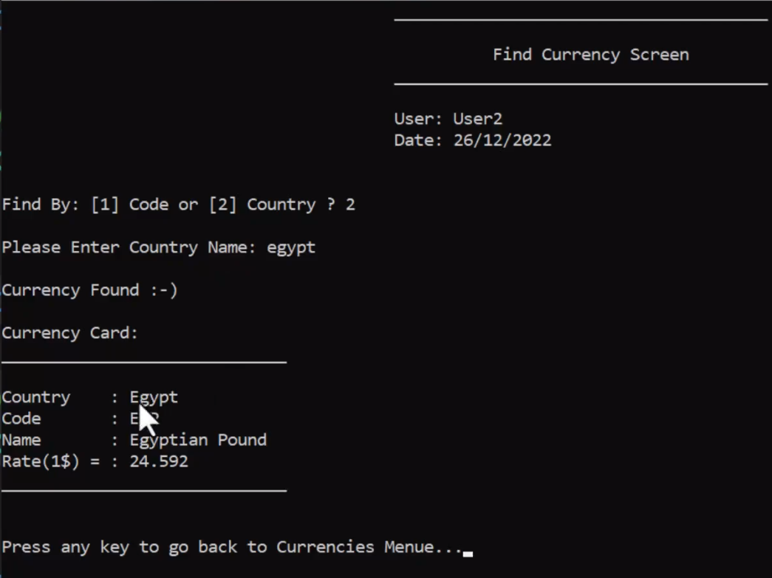

**Solution**

ده كود الشاشه

|  |
| --- |
| #pragma once  #include <iostream>  #include "clsScreen.h"  #include "clsCurrency.h"  #include "clsInputValidate.h"  class clsFindCurrencyScreen :protected clsScreen  {  private:  static void _PrintCurrency(clsCurrency Currency)  {  cout << "\nCurrency Card:\n";  cout << "_____________________________\n";  cout << "\nCountry : " << Currency.get_Country();  cout << "\nCode : " << Currency.get_CurrencyCode();  cout << "\nName : " << Currency.get_CurrencyName();  cout << "\nRate(1$) = : " << Currency.get_Rate();  cout << "\n_____________________________\n";  }  static void _ShowResults(clsCurrency Currency)  {  if (!Currency.IsEmpty())  {  cout << "\nCurrency Found :-)\n";  _PrintCurrency(Currency);  }  else  {  cout << "\nCurrency Was not Found :-(\n";  }  }  public:  static void ShowFindCurrencyScreen()  {  _DrawScreenHeader("\t Find Currency Screen","");  cout << "\nFind By: [1] Code or [2] Country ? ";  short Answer = 1;  cin >> Answer;  if (Answer == 1)  {  string CurrencyCode;  cout << "\nPlease Enter CurrencyCode: ";  CurrencyCode = clsInputValidate::ReadString();  clsCurrency Currency = clsCurrency::FindByCode(CurrencyCode);  _ShowResults(Currency);  }  else  {  string Country;  cout << "\nPlease Enter Country Name: ";  Country = clsInputValidate::ReadString();  clsCurrency Currency = clsCurrency::FindByCountry(Country);  _ShowResults(Currency);  }  }  }; |

وده التعديل علي كود القايمه

|  |
| --- |
| static void _ShowFindCurrencyScreen()  {  // cout << "\nFind Currency Screen Will Be Here.\n";  clsFindCurrencyScreen::ShowFindCurrencyScreen();  } |

**Update Currency Rate**

عاوزين نعمل شاشة ال update

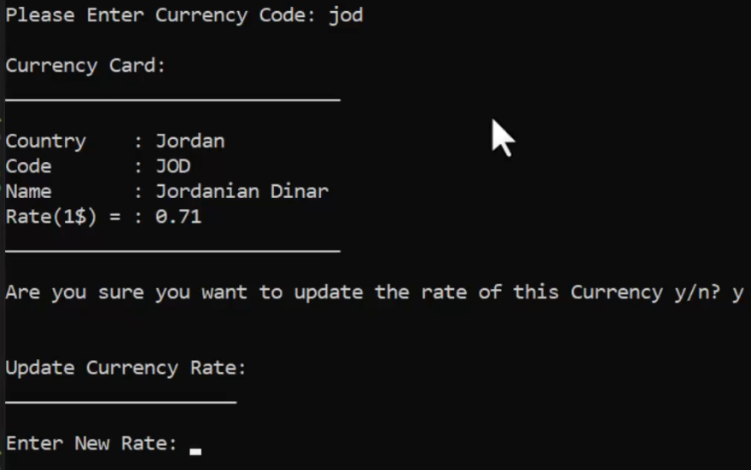

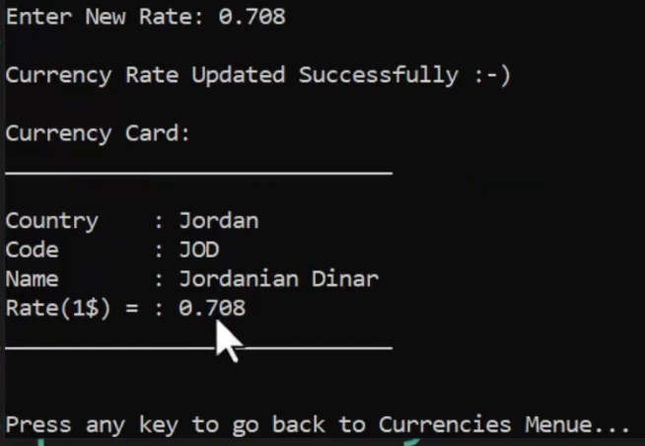

**Solution**

ده كود الشاشه

|  |
| --- |
| #pragma once  #include <iostream>  #include "clsScreen.h"  #include "clsCurrency.h"  #include "clsInputValidate.h"  class clsUpdateCurrencyRateScreen :protected clsScreen  {  private:  static float _ReadRate()  {  cout << "\nEnter New Rate: ";  float NewRate = 0;  NewRate = clsInputValidate::ReadFloatNumber();  return NewRate;  }  static void _PrintCurrency(clsCurrency Currency)  {  cout << "\nCurrency Card:\n";  cout << "_____________________________\n";  cout << "\nCountry : " << Currency.get_Country();  cout << "\nCode : " << Currency.get_CurrencyCode();  cout << "\nName : " << Currency.get_CurrencyName();  cout << "\nRate(1$) = : " << Currency.get_Rate();  cout << "\n_____________________________\n";  }  public:  static void ShowUpdateCurrencyRateScreen()  {  _DrawScreenHeader("\tUpdate Currency Screen","");  string CurrencyCode = "";  cout << "\nPlease Enter Currency Code: ";  CurrencyCode = clsInputValidate::ReadString();  while (!clsCurrency::IsCurrencyExist(CurrencyCode))  {  cout << "\nCurrency is not found, choose another one: ";  CurrencyCode = clsInputValidate::ReadString();  }  clsCurrency Currency = clsCurrency::FindByCode(CurrencyCode);  _PrintCurrency(Currency);  cout << "\nAre you sure you want to update the rate of this Currency y/n? ";  char Answer = 'n';  cin >> Answer;  if (Answer == 'y' || Answer == 'Y')  {  cout << "\n\nUpdate Currency Rate:";  cout << "\n____________________\n";  Currency.UpdateRate(_ReadRate());  cout << "\nCurrency Rate Updated Successfully :-)\n";  _PrintCurrency(Currency);  }  }  }; |

ده التعديل علي القايمه

|  |
| --- |
| static void _ShowUpdateCurrencyRateScreen()  {  // cout << "\nUpdate Currency Rate Screen Will Be Here.\n";  clsUpdateCurrencyRateScreen::ShowUpdateCurrencyRateScreen();  } |

**Currency Calculator Screen**

عاوزين نعمل شاشة بتحول من أي عمله لاي عمله

لو حولت من دينار لجنيه بتحول من دينار لدولار وبعدين من دولار لجنيه

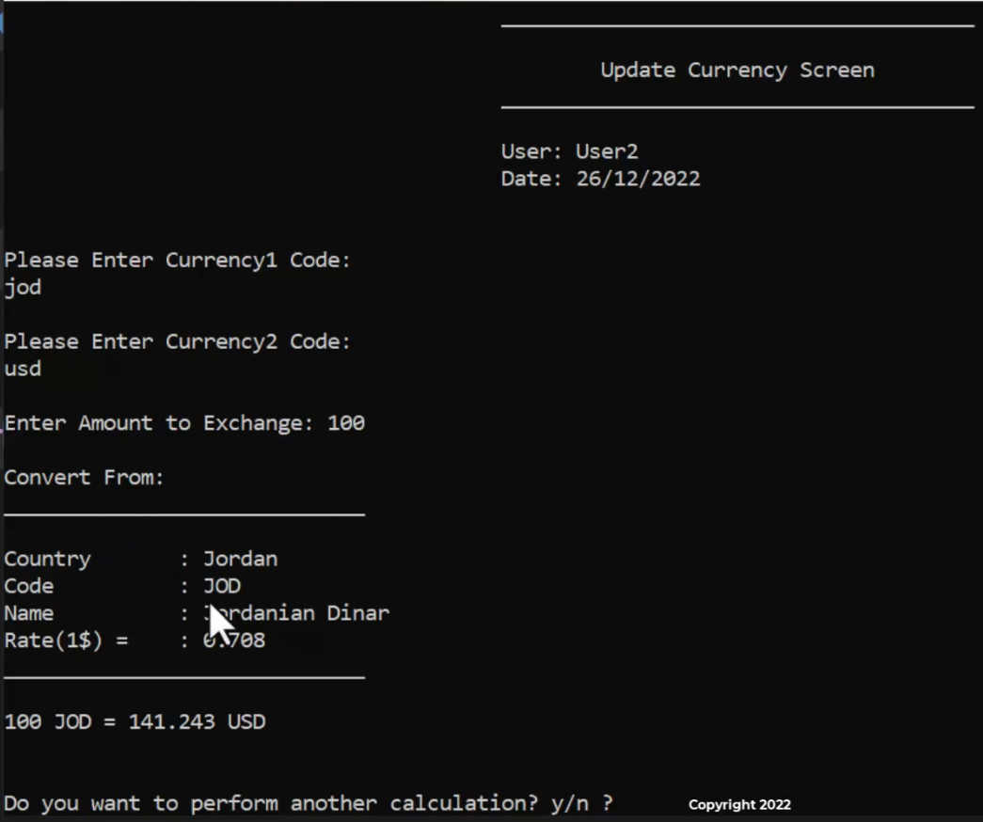

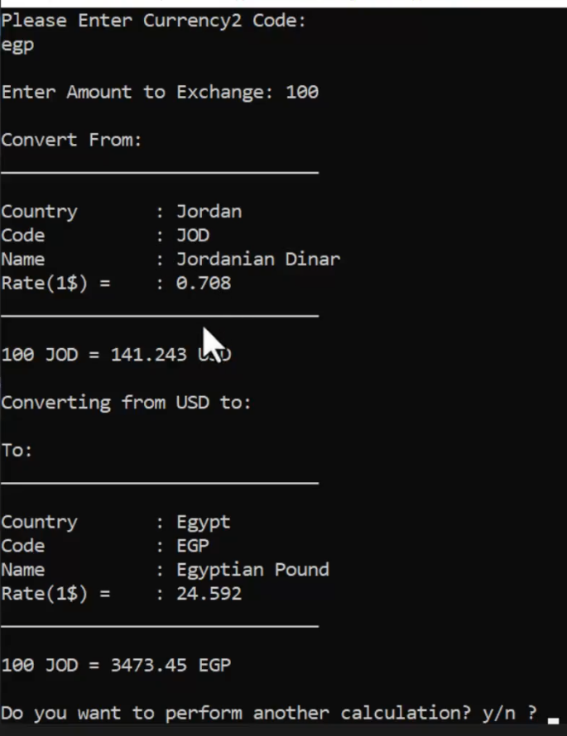

**Solution**

ده اللي زودناه علي كلاس ال clsCurrency

|  |
| --- |
| float ConvertToUSD(float Amount)  {  return (float)(Amount / get_Rate());  }  float ConvertToOtherCurrency(float Amount, clsCurrency Currency2)  {  float AmountInUSD = ConvertToUSD(Amount);  if (Currency2.get_CurrencyCode() == "USD")  {  return AmountInUSD;  }  return (float)(AmountInUSD * Currency2.get_Rate());  } |

ده كود الشاشه

|  |
| --- |
| #pragma once  #include <iostream>  #include "clsScreen.h"  #include "clsCurrency.h"  #include "clsInputValidate.h"  class clsCurrencyCalculatorScreen :protected clsScreen  {  private:  static float _ReadAmount()  {  cout << "\nEnter Amount to Exchange: ";  float Amount = 0;  Amount = clsInputValidate::ReadFloatNumber();  return Amount;  }  static clsCurrency _GetCurrency(string Message)  {  string CurrencyCode;  cout << Message << endl;  CurrencyCode = clsInputValidate::ReadString();  while (!clsCurrency::IsCurrencyExist(CurrencyCode))  {  cout << "\nCurrency is not found, choose another one: ";  CurrencyCode = clsInputValidate::ReadString();  }  clsCurrency Currency = clsCurrency::FindByCode(CurrencyCode);  return Currency;  }  static void _PrintCurrencyCard(clsCurrency Currency, string Title = "Currency Card:")  {  cout << "\n" << Title << "\n";  cout << "_____________________________\n";  cout << "\nCountry : " << Currency.get_Country();  cout << "\nCode : " << Currency.get_CurrencyCode();  cout << "\nName : " << Currency.get_CurrencyName();  cout << "\nRate(1$) = : " << Currency.get_Rate();  cout << "\n_____________________________\n\n";  }  static void _PrintCalculationsResults(float Amount, clsCurrency Currency1, clsCurrency Currency2)  {  _PrintCurrencyCard(Currency1, "Convert From:");  float AmountInUSD = Currency1.ConvertToUSD(Amount);  cout << Amount << " " << Currency1.get_CurrencyCode()  << " = " << AmountInUSD << " USD\n";  if (Currency2.get_CurrencyCode() == "USD")  {  return;  }  cout << "\nConverting from USD to:\n";  _PrintCurrencyCard(Currency2, "To:");  float AmountInCurrrency2 = Currency1.ConvertToOtherCurrency(Amount, Currency2);  cout << Amount << " " << Currency1.get_CurrencyCode()  << " = " << AmountInCurrrency2 << " " << Currency2.get_CurrencyCode();  }  public:  static void ShowCurrencyCalculatorScreen()  {  char Continue = 'y';  while (Continue == 'y' || Continue == 'Y')  {  system("cls");  _DrawScreenHeader("\tUpdate Currency Screen","");  clsCurrency CurrencyFrom = _GetCurrency("\nPlease Enter Currency1 Code: ");  clsCurrency CurrencyTo = _GetCurrency("\nPlease Enter Currency2 Code: ");  float Amount = _ReadAmount();  _PrintCalculationsResults(Amount, CurrencyFrom, CurrencyTo);  cout << "\n\nDo you want to perform another calculation? y/n ? ";  cin >> Continue;  }  }  }; |

وده التعديل علي القايمه

|  |
| --- |
| case enCurrenciesMainMenueOptions::eCurrencyCalculator:  {  system("cls");  _ShowCurrencyCalculatorScreen();  _GoBackToCurrenciesMenue();  break;  } |

**Template Functions**

ال template functions بتوفر عليك كتابه الكود فلو عندك مثلا function اسمها max مره بتاخد int ومره float ومره short بدل ماتكتب الكودر 3 او اربع مرات

قالك لا انت تكتب الكود مره واحده وال data type تخليه variable

طريقتها انك تكتب كلمة template وبعدها العلامتين دول <> وبينهم بتكتب typename وبعدها بتكتب T ودي بتعبر عن ال data type اللي خليناه متغير وبعدين T وبتكتب ال function عادي بس أي parameter بتاخدها هتكون من النوع T

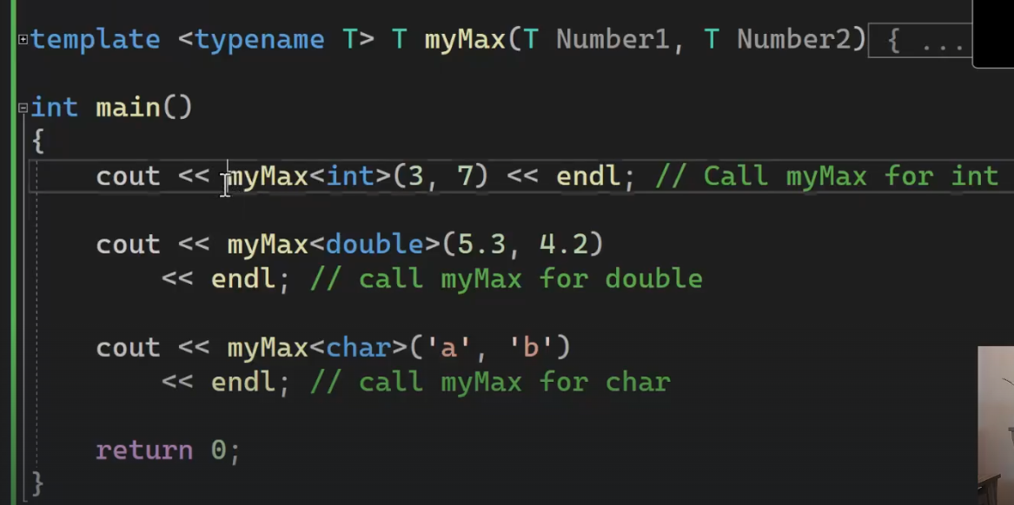

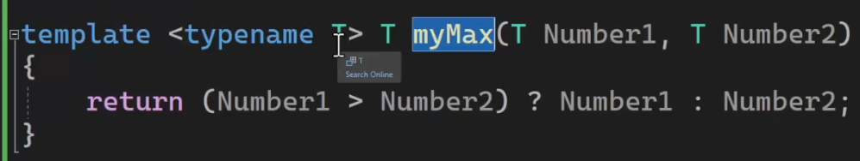

**Template Classes**

زي ماعرفت انك تقدر تخلي نوع ال function الكلاس برضه تقدر تخلي المتغيرات اللي جواه من نوع متغير

ومثال عليها هوا ال vector لما كنت بتعرفه كنت بتعرف النوع بين اقواس <>

طريقته انك بتيجي قبل الكلاس وبتكتب template <class T> واي متغير بيجيلك بتعرفه من النوع t

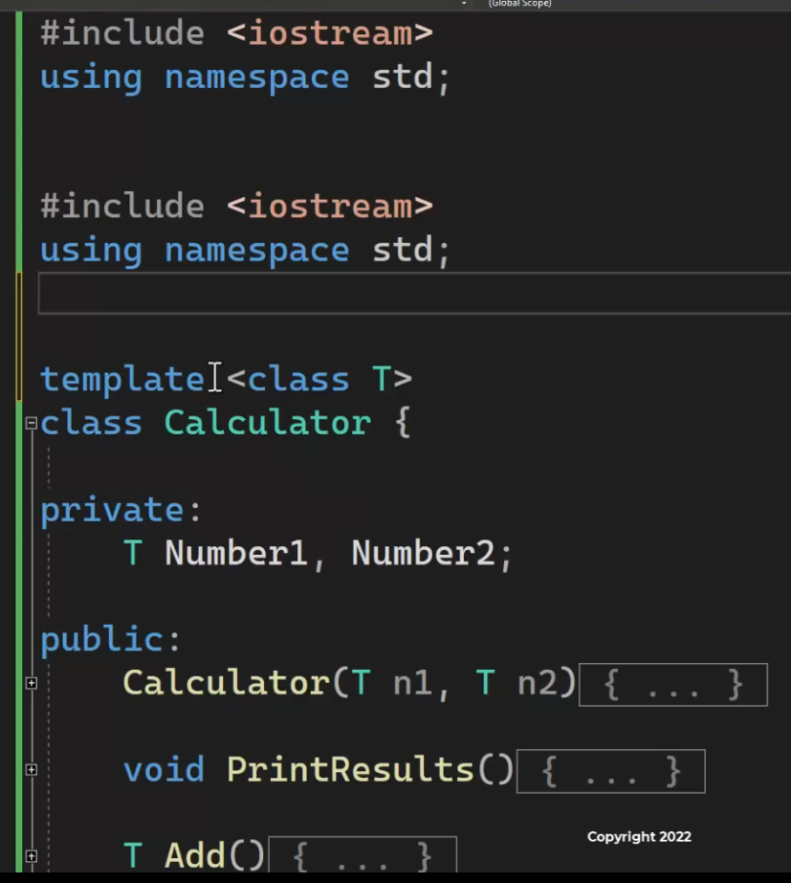

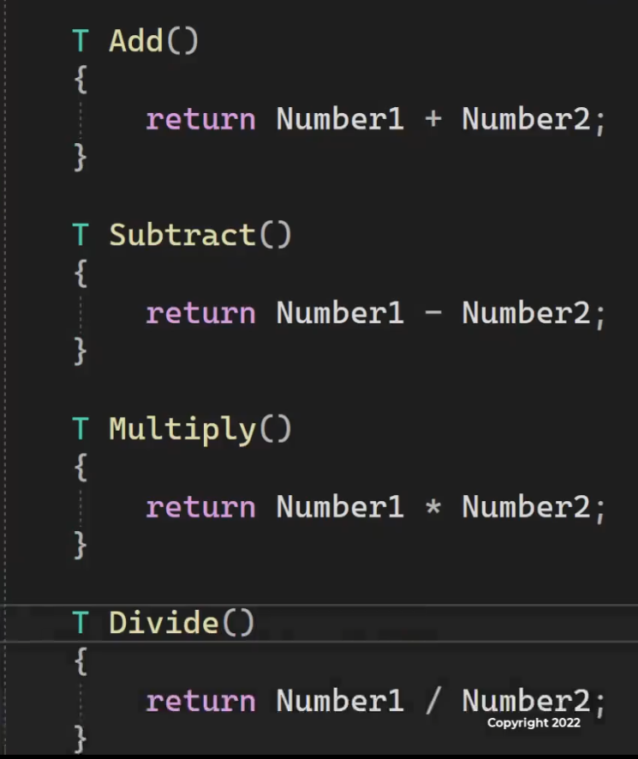

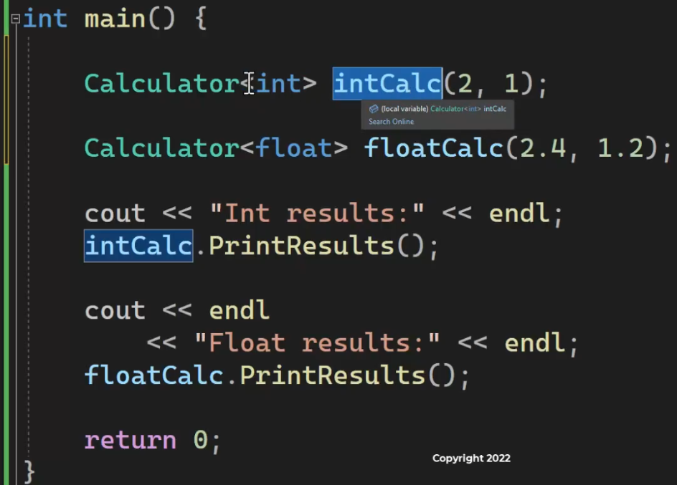

**Homework**

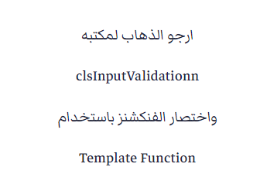

|  |
| --- |
| #pragma once  #include <iostream>  #include <string>  #include "clsString.h"  #include "clsDate.h"  class clsInputValidateTemplate  {  public:  template<typename T> static bool IsNumberBetween(T Number, T From, T To)  {  if (Number >= From && Number <= To)  return true;  else  return false;  }  static bool IsDateBetween(clsDate Date, clsDate From, clsDate To)  {  //Date>=From && Date<=To  if ((clsDate::IsDate1AfterDate2(Date, From) || clsDate::IsDate1EqualDate2(Date, From))  &&  (clsDate::IsDate1BeforeDate2(Date, To) || clsDate::IsDate1EqualDate2(Date, To))  )  {  return true;  }  //Date>=To && Date<=From  if ((clsDate::IsDate1AfterDate2(Date, To) || clsDate::IsDate1EqualDate2(Date, To))  &&  (clsDate::IsDate1BeforeDate2(Date, From) || clsDate::IsDate1EqualDate2(Date, From))  )  {  return true;  }  return false;  }  template<typename T>static T ReadNumber(string ErrorMessage = "Invalid Number, Enter again\n")  {  T Number;  while (!(cin >> Number)) {  cin.clear();  cin.ignore(numeric_limits<streamsize>::max(), '\n');  cout << ErrorMessage;  }  return Number;  }  template<typename T>static T ReadNumberBetween(T From, T To, string ErrorMessage = "Number is not within range, Enter again:\n")  {  T Number = ReadShortNumber();  while (!IsNumberBetween(Number, From, To))  {  cout << ErrorMessage;  Number = ReadShortNumber();  }  return Number;  }  static bool IsValideDate(clsDate Date)  {  return clsDate::IsValidDate(Date);  }  static string ReadString()  {  string S1 = "";  // Usage of std::ws will extract allthe whitespace character  getline(cin >> ws, S1);  return S1;  }  }; |

**Organize Your Classes**

هنا ده شكل الملفات عندي

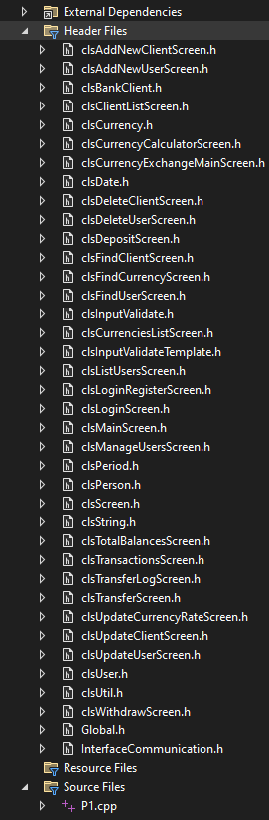

عشان ادور علي ملف فيهم بتعب

قالك انك ممكن تقسمهم وترتبهم عادي

بتعمل كليك يمين علي ال HEADER FILES وبتختار add>>new filter



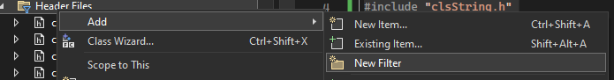

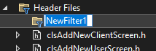

بعد كده بتسميه وبتسحب الكلاس وبترميه فيه بالماوس

وبتقدر تعمل filter جوه ال filter

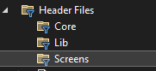

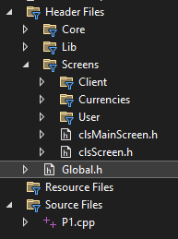

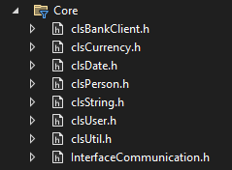

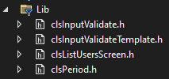

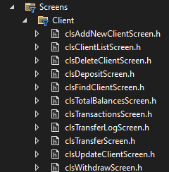

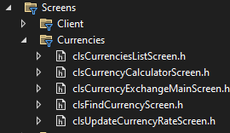

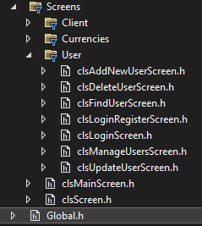

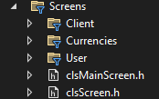

**END**